Chapter 4 - Ecology
1. [1 mark]
Two populations of the same fish species were fed different diets to investigate the effect of differing nutrition on their growth. What is an appropriate method to determine the significance of a resulting difference?
A. Calculate the mean for each population
B. Calculate the standard deviation for each population
C. Graph the results
D. Perform a t-test

Markscheme
D
2. [1 mark]
Which process has the greatest relative role in transferring carbon?
A. Decomposition
B. Combustion
C. Photosynthesis
D. Cell respiration

Markscheme
C
3. [1 mark]
What contributes to the enhanced greenhouse effect?
A. Ozone from violent thunderstorms
B. Carbon particles in diesel engine exhaust
C. Methane from agricultural sources
D. Carbon dioxide from active volcanoes around the world

Markscheme
C
4. [1 mark]
What is the highest level of taxa for Acacia tortilis?
A. Acacia
B. Tortilis
C. Fabaceae
D. Angiospermophyta

Markscheme
D
5. [1 mark]
Which statement describes the term species?A. Members of the same ecological communityB. Organisms that reproduce together to produce fertile offspringC. Organisms of the same type in a populationD. The first word in the binomial name of an organism

Markscheme
B
6. [1 mark]
The following statements refer to a pyramid of energy.
I. Some material is not assimilated by each trophic level.II. Energy transformations are never 100 % efficient.III. Heat is lost during photosynthesis.
Which of the statements give the reason why a pyramid of energy is narrower at the top than at the bottom?A. I onlyB. I and II onlyC. II and III onlyD. I, II and III

Markscheme
B
7. [1 mark]
The table shows the monthly CO concentrations in mg L taken at two monitoring stations.
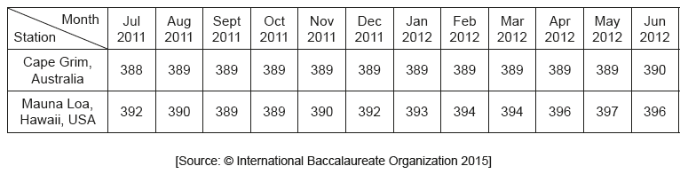
What is directly indicated by the data?A. CO concentration in the atmosphere varies from place to place.B. Cape Grim is less affected by global warming than Mauna Loa.C. CO creates a greenhouse effect at both locations.D. The standard deviation for Cape Grim is higher than standard deviation for Mauna Loa.

Markscheme
A
8. [1 mark]
Which hypothesis is supported by evidence from ecological research?
A. Decomposers are the final stage in the food chain.
B. Producers depend upon consumers more than on decomposers.
C. Decomposers help to recycle energy from food chains.
D. Producers use nutrients that decomposers help to recycle.

Markscheme
D
9. [1 mark]
What contributes to the enhanced greenhouse effect?
A. Ozone from violent thunderstorms
B. Carbon particles in diesel engine exhaust
C. Methane from agricultural sources
D. Carbon dioxide from active volcanoes around the world

Markscheme
C
10. [1 mark]
What is the best definition of the greenhouse effect in the Earth’s atmosphere?A. A naturally occurring effect by which shorter wavelength radiation is trappedB. A naturally occurring effect by which longer wavelength radiation is trappedC. An effect of pollution by which shorter wavelength radiation is trappedD. An effect of pollution by which longer wavelength radiation is trapped

Markscheme
B
11. [1 mark]
Human activity leading to the emission of greenhouse gases may be a cause of global warming.According to the precautionary principle, what should be done about greenhouse gas emission?A. Analyse historical records from monitoring stations to see the trends in carbon dioxide emissionsB. Obtain more evidence by carrying out research on greenhouse gas emissionC. Take measures to lower greenhouse gas emission without further evidenceD. Develop strategies for coping with higher global temperatures

Markscheme
C
12. [1 mark]
The table shows the monthly CO concentrations in mg L– taken at two monitoring stations.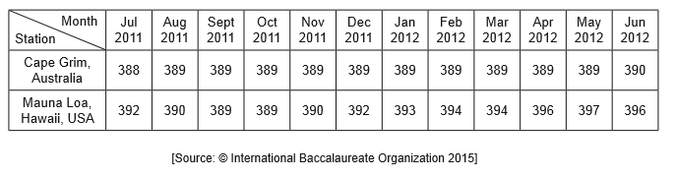
What is directly indicated by the data?
A. CO concentration in the atmosphere varies from place to place.B. Cape Grim is less affected by global warming than Mauna Loa.C. CO creates a greenhouse effect at both locations.D. The standard deviation for Cape Grim is higher than standard deviation for Mauna Loa.

Markscheme
A
13. [1 mark]
The image shows an Arctic food web.
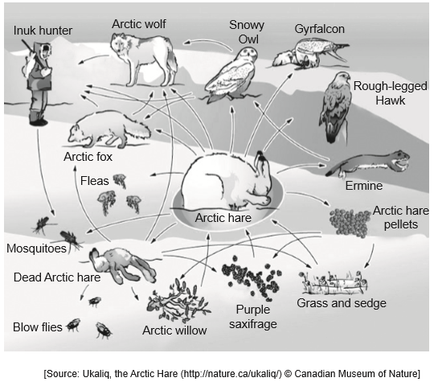
What is the role of the Arctic hare?
A. DetritivoreB. Primary consumerC. Secondary consumerD. Saprotroph

Markscheme
B
14. [1 mark]
What is a population?A. Organisms of the same genus living in an ecosystemB. Organisms living together and interacting in the same habitatC. Organisms of a species living together in the same areaD. Organisms that can breed together

Markscheme
C
15. [1 mark]
Which pair of statements is correct?
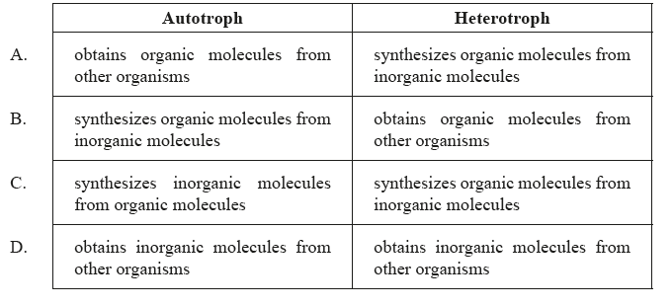

Markscheme
B
16. [1 mark]
What are examples of greenhouse gases?A. Ethane and ozoneB. Methane and nitrogenC. Methane and carbon dioxideD. Ethane and oxygen

Markscheme
C
17. [1 mark]
What is an ecosystem?
A. An environment in which an organism normally livesB. A group of organisms of the same species inhabiting an areaC. A group of populations living and interacting with each other in an areaD. A community and its abiotic environment

Markscheme
D
18. [1 mark]
What term can be used to describe clams that eat decaying plant matter?
A. DetritivoresB. Tertiary consumersC. SaprotrophsD. Decomposers

Markscheme
A
19. [1 mark]
At each trophic level energy is lost. How is this energy regained by the ecosystem?
A. HeatB. NutrientsC. PhotosynthesisD. Recycling

Markscheme
C
20. [1 mark]
In ecosystems the amount of energy that passes from one trophic level to the next is called the conversion efficiency. What is the average conversion efficiency from primary to secondary consumers in most ecosystems?
A. 1 %B. 10 %C. 50 %D. 90 %

Markscheme
B
21. [1 mark]
Global warming caused by the enhanced greenhouse effect is likely to have major consequences for arctic ecosystems. Which of the following are likely to occur in the arctic if the Earth’s surface temperature rises?
I. Decreased rates of decomposition of detritus
II. Increased range of predators from temperate regions
III. Increase in numbers of pest species and pathogens
A. I and II onlyB. I and III onlyC. II and III onlyD. I, II and III

Markscheme
C
22. [1 mark]
The diagram is a representation of a carbon cycle. Which arrow will reduce the greenhouse effect?
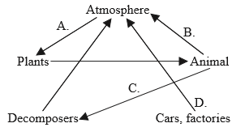

Markscheme
A
23. [1 mark]
The diagram shows a pyramid of energy for a wetland environment. What units would be appropriate for the values shown?
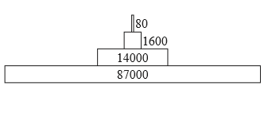
A. kg yr B. kJ m yr C. J m D. mg dry mass m

Markscheme
B
24. [1 mark]
What is the mode of nutrition of midge larva?
A. AutotrophB. DetritivoreC. HeterotrophD. Saprotroph

Markscheme
C
25. [1 mark]
Which represents a correct food chain from this web?
A. stickleback → midge larva → unicellular algaeB. ciliates → Daphnia → stickleback → dragonfly nymphC. diatom → midge larva → caddisfly larva → sticklebackD. filamentous algae → mayfly nymph → leech → stickleback

Markscheme
C
26. [1 mark]
In a pond, two species of fish feed on insects and worms. The insects feed on the green plants that live in the water. What constitutes a population in this ecosystem?
A. All the living organisms B. All the animals C. All the fish D. All the fish of one species

Markscheme
D
27. [1 mark]
What is recycled in an ecosystem?
A. Nitrogen, carbon and energy are all recycled. B. Nitrogen and carbon are recycled but not energy. C. Nitrogen is recycled but not carbon or energy. D. Nitrogen, carbon and energy are not recycled.

Markscheme
B
28. [1 mark]
What best describes the mode of nutrition of a heterotroph?
A. It ingests only non-living organic matter. B. It obtains organic molecules from other organisms. C. It synthesizes its organic molecules from inorganic substances. D. It produces its organic molecules from chemical reactions using light.

Markscheme
B
29. [1 mark]
The energy passing from the detritivores to the predatory invertebrates in this food web is 14 000 kJ m year.
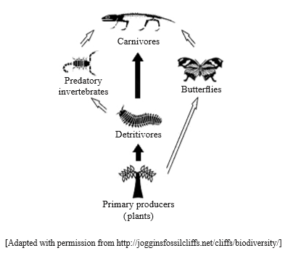
Approximately how much energy (in kJ m year) passes from the predatory invertebrates to the carnivores?
A. 140 B. 1400 C. 14 000 D. 140 000

Markscheme
B
30. [1 mark]
What do records from the twentieth and twenty-first century show about the concentration of carbon dioxide in the atmosphere?
A. An upward trend with annual fluctuations B. An upward trend with no annual fluctuations C. Annual fluctuations but no overall trend D. Random fluctuations and no overall trend

Markscheme
A
31. [1 mark]
The fungus Calocera viscosa obtains its nutrients from decaying conifer trees. Which pair of terms describes C. viscosa’s nutrition?
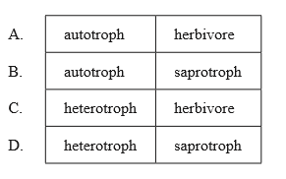

Markscheme
D
32. [1 mark]
What is an example of the precautionary principle?
A. Avoiding cigarettes as they increase the chances of lung cancer B. Reducing carbon dioxide emissions as they may cause global warming C. Avoiding strong sunlight as it increases the chances of skin cancer D. Reducing cod fishing to increase fish stocks

Markscheme
B
33. [1 mark]
What best describes the mode of nutrition of a heterotroph?
A. It ingests only non-living organic matter. B. It obtains organic molecules from other organisms. C. It synthesizes its organic molecules from inorganic substances. D. It produces its organic molecules from chemical reactions using light.

Markscheme
B
34. [1 mark]
The energy passing from the detritivores to the predatory invertebrates in this food web is 14 000 kJ m year. Approximately how much energy (in kJ m year) passes from the predatory invertebrates to the carnivores?
A. 140
B. 1400
C. 14 000
D. 140 000

Markscheme
B
35. [1 mark]
To which trophic level do the butterflies belong?
A. Producers B. Primary consumers C. Secondary consumers D. Tertiary consumers

Markscheme
B
36. [1 mark]
Which of the following trophic groups include fungi?
A. Detritivores B. Autotrophs C. Saprotrophs D. Producers

Markscheme
C
37. [1 mark]
Which term best defines a group of populations living and interacting with each other in an area?
A. Ecology B. Community C. Species D. Ecosystem

Markscheme
B
38. [1 mark]
Which of the following is the best definition of a population?
A. A group of individuals that can interbreed and produce fertile offspring B. The number of individuals of the same species in a given area C. A group of species living and interacting with each other in a given area D. The total number of individuals in a given area

Markscheme
B
39. [1 mark]
Which of the following ecological units includes abiotic factors?
A. A community B. An ecosystem C. A population D. A trophic level

Markscheme
B
40. [1 mark]
Which group of organisms in the carbon cycle converts carbon into a form that is available to primary consumers?
A. Decomposers B. Saprotrophs C. Detritus feeders D. Producers

Markscheme
D
41. [1 mark]
What is a community?
A. A group of organisms living and interacting in the same trophic level B. A group of populations living and interacting in a food chain C. A group of organisms of the same species living and interacting in an ecosystem D. A group of populations living and interacting in an area

Markscheme
D
42. [1 mark]
What are the units of a pyramid of energy?
A. kJ m yr B. kJ m yr C. J m s D. J m s

Markscheme
A
43. [1 mark]
What is a potential consequence of the rise in global temperatures on the Arctic ecosystem?
A. Increased exposure to UV light B. Increased rate of decomposition of detritus C. Decreased success of pest species D. Increase in the ice habitat available to polar bears

Markscheme
B
44. [1 mark]
What will happen to the food web above if the sea otter disappears?
A. Large fish increase and sea urchins decrease. B. Abalones increase and sharks increase. C. Sea urchins increase and kelps decrease. D. Sea stars decrease and sharks increase.

Markscheme
C
45. [1 mark]
Which organism in this food web is both a secondary and tertiary consumer?
A. Large crab B. Small herbivorous fish C. Shark D. Microscopic planktonic algae

Markscheme
A
46. [1 mark]
Which gas will enhance the greenhouse effect if released into the atmosphere?
A. Hydrogen B. Oxide of nitrogen C. Oxygen D. Nitrogen

Markscheme
B
47. [1 mark]
Zoophobas morio is an insect. Its larvae feed on bat feces in caves in Guatemala. What type of organism is a Zoophobas morio larva?A. AutotrophB. ConsumerC. DetritivoreD. Saprotroph

Markscheme
C
48. [1 mark]
Global warming threatens the survival of Arctic foxes. Which of the following factors could be involved?
I. Competition with other fox species spreading northII. Reduction in numbers of prey species of Arctic foxesIII. Decrease in oxygen availability to Arctic foxes
A. I onlyB. I and II onlyC. II and III onlyD. I, II and III

Markscheme
B
49. [1 mark]
How is energy passed from one trophic level to the next?
I. FoodII. LightIII. Heat
A. I onlyB. I and II onlyC. II and III onlyD. I, II and III

Markscheme
A
50. [1 mark]
The following diagram shows part of a food web from Yellowstone Park.
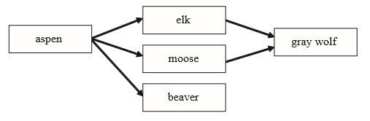
What would be the short-term effects on the populations of the other species if the gray wolf were exterminated?
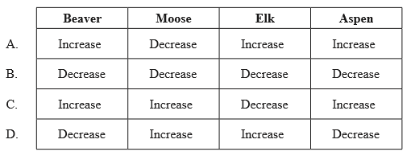

Markscheme
D
51. [1 mark]
Why do food chains in an ecosystem rarely contain more than five organisms?
A. Nutrients are recycled by the decomposers back to the producers. B. Nutrients are lost from the ecosystem when organisms die. C. The conversion of food into growth by an organism is not very efficient. D. Energy is recycled by the decomposers back to the producers.

Markscheme
C
52. [1 mark]
Slime moulds (Acrasiomycota) are protoctists. They feed on decaying organic matter, bacteria and protozoa.
Which of the terms describes their nutrition?
I. Detritivore II. Autotroph III. Heterotroph
A. I only B. I and II only C. I and III only D. I, II and III

Markscheme
C
53. [1 mark]
The scarlet cup fungus (Sarcoscypha coccinea) obtains its nutrition from decaying wood by releasing digestive enzymes into the wood and absorbing the digested products.
Which of the following terms describe(s) the fungus?
I. Autotroph II. Heterotroph III. Saprotroph
A. III onlyB. II and III onlyC. I and III onlyD. I, II and III

Markscheme
B
54a. [2 marks]
Describe what is meant by a food chain.

Markscheme
a. food chain shows feeding/trophic relationships;b. showing which organism/animal eats which organism;c. showing the flow of energy from producer/autotroph to top consumer/top carnivore / through trophic levels;
54b. [1 mark]
Identify a food chain with four or more organisms from the forest food web.

Markscheme
example from the food web with four or more organisms, given in proper sequence with arrows showing flow of energy in the correct direction and starting with a producer.Award [0] if any organism in the food chain is not in the web diagram.
54c. [1 mark]
Deduce the trophic level of each organism identified in your food chain from (b)(i).

Markscheme
correct trophic levels
eg: raspberry bush⎯⎯→chickadee ⎯⎯→bull snake⎯⎯→mountain lion producer primary secondary tertiary consumer consumer consumer
Accept ECF for mistakes in previous part. Do not accept “trophic level 1” etc.
54d. [1 mark]
State one reason that the population of mountain lions is smaller than the populations of other animals in the food web.

Markscheme
mountain lions/highest trophic level receives less energy as energy is lost at each level / mountain lions are larger than other animals and require more (smaller) individuals for food.
55a. [1 mark]
State the trend in the surface area of sea ice in the Southern Ocean around Antarctica.

Markscheme
increasing/positive trend/correlation;
55b. [2 marks]
Distinguish between changes in the surface area of sea ice in the Arctic and Antarctica.

Markscheme
a. in the Arctic ocean the surface area of sea ice has declined whereas in Antarctica the surface area has increased;b. the rate of change is greater for the Arctic than for Antarctica;c. there are greater fluctuations in the surface area of sea ice in Antarctica than in the Arctic;For mp a, it is acceptable if there is no comparative term such as “whereas” or “but”;
55c. [3 marks]
Discuss the data as evidence of global warming.

Markscheme
a. change / decrease / melting of sea ice is expected with global warming;b. decrease of sea ice in Arctic is supportive evidence of global warming;c. increase in sea ice in Antarctic is not supportive evidence of global warming;d. Antarctic increase / both changes may be associated with climate change (caused by global warming);e. global warming does not affect all areas in the same way / global warming has complex effects;f. data is inconsistent/inconclusive / data on its own does not establish cause and effect / not over a very long period of time;
55d. [2 marks]
Describe the trends in the length of the sea ice season around the Antarctic Peninsula and in the Ross Sea.

Markscheme
One mark for correct description of the trend off the Antarctic Peninsula and one mark for correct description for the Ross Sea; accept correct statements other than those listed in the scheme but do not award a mark for contradictions; marks can be awarded for correct statements about the sea ice season for Antarctica overall; Some students are referring to moving South in the Ross Sea when it isclear that they are moving North. If you can discern their intention, then give the BOD on this;
Antarctic Peninsula:a. decrease/stable at the base of the peninsula / decrease in the area of the penguin colonies/West of the tip / increase/+1 above and below the peninsula / variable pattern;
Ross Sea:b. sea ice is increasing / +1 in the Ross Sea / area below / North of the Ross Sea / lower Ross Sea / Southern part of Ross Sea/closest to the South pole is stable/no change to the length of the sea ice season / variable pattern;
55e. [3 marks]
Analyse the trends in colony size of the Adélie penguins in relation to the changes in the sea ice.

Markscheme
a. (off AP) sea ice season has declined as has penguin population;b. colony 2 and 3 sea ice season has not declined and population increased;c. colony 3 increase in population and growing length of sea ice season;d. colony 2 has stable / increasing numbers and sea ice season is not changing;e. colony size and sea ice season length/area are correlated;f. Population numbers for colony 1 and 3 the same at start of study but both experience a big (opposite change);
Accept answers that refer to “sea ice” or “sea ice area”.
55f. [3 marks]
Discuss the use of Adélie penguins in studying the effects of global warming.

Markscheme
a. global warming leads to climate / environmental change; eg temperature change / ice meltingb. stable ice associated with stable population / no climate change;c. ice changes associated with population changes;d. changes in penguin population size can indicate climate change / global warming;e. example of how climate change can alter population; eg prey availability / habitat loss;f. not all species will be affected in the same way (so care needed in applying conclusions more widely)g. there is information on changes of population over the past 35 000 years;
56a. [2 marks]
Describe how a transect can be used to investigate the distribution of plant species in this ecosystem.

Markscheme
a. random positioning of the transect;b. transect is a line stretched over an area of study;c. samples taken/species present recorded at regular intervals along the transect;d. used to investigate effect of an abiotic variable/named example;
56b. [2 marks]
The vegetation shown here has developed as a result of primary succession. Outline the changes that take place in the abiotic environment during primary succession.

Markscheme
a. rocks begin to break down;b. minerals begin to accumulate;c. soil begins to develop;d. water retention increases;e. erosion of soil is reduced (by rhizoids and roots);
56c. [2 marks]
Outline the abiotic factors that affect the distribution of plant species in an ecosystem.

Markscheme
The question asks for an outline but most candidates have given a list of factors without a reason. Therefore award [1] for every two factors listed or [1] for each qualified factor.
water (distribution) for turgor/biochemical reactions/photosynthesis;mineral / inorganic content / salinity of soil/water;temperature (max, min, range, seasonal changes) / altitude;light (intensity, duration, wavelength) for photosynthesis;pH (range, average, changes) of soil/water;wind (direction, strength);
57a. [3 marks]
(i) Label the diagram to complete the food web for the organisms in the table above.
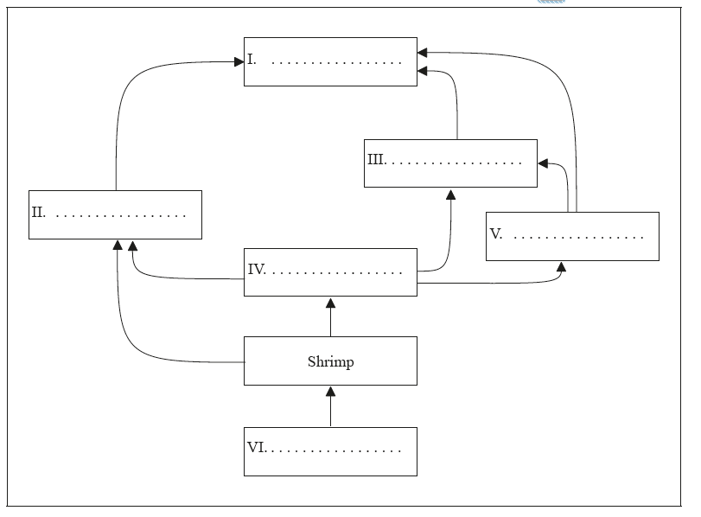
(ii) Deduce the trophic level of Artic cod.

Markscheme
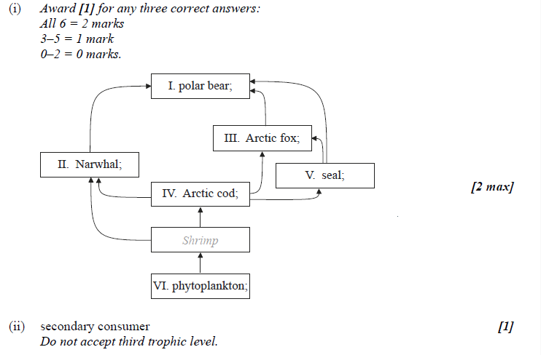
57b. [2 marks]
Distinguish between the movement of energy and nutrients in an ecosystem.

Markscheme
energy moves through/enters and leaves ecosystems / need a constant source of energy;
nutrients cycled between biotic and abiotic environment/in cycles such as C/N;
58a. [2 marks]
Outline the role of saprotrophic bacteria in the treatment of sewage.

Markscheme
sewage trickled over bed of rocks with (biofilm of) saprotrophs and oxygen added;
saprotrophic bacteria feed on/break down organic matter (found in sewage);
transforming it into harmless/re-usable products/ 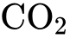, 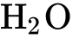, ammonia;
58b. [3 marks]
Explain the formation of methane from biomass.

Markscheme
bioreactor with anaerobic conditions;
bacteria convert organic matter into organic acids/alcohol/acetate/ and 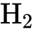;
methanogenic bacteria produce methane from breakdown of acetate/ and ;
(Accept correct word or chemical equations)
59a. [2 marks]
Distinguish between autotrophs and heterotrophs.

Markscheme
autotrophs make their own food/organic molecules/organic matter and heterotrophs feed on/obtain their food/organic molecules from other organisms;autotrophs use/require inorganic molecules/CO and heterotrophs require (complex) organic molecules;
59b. [1 mark]
Define saprotroph.

Markscheme
an organism that lives on/in non-living/dead (organic) matter and secretes digestive enzymes/digestive juices into it / OWTTE
59c. [1 mark]
State an external feature that is different in:
Cnidaria and Mollusca.

Markscheme
Cnidaria have radial symmetry while Mollusca have bilateral symmetry;Cnidaria have tentacles/nematocysts/stinging cells while Mollusca do not;Mollusca (may) have a (hard) shell while Cnidaria do not;Mollusca have a mouth and anus while Cnidaria have only one opening;Mollusca have a muscular/large foot while Cnidaria do not;other valid external difference;
59d. [1 mark]
State an external feature that is different in:
Mollusca and Annelida.

Markscheme
Annelida are segmented while Mollusca are not (visibly segmented);Annelida may have bristles/chetae/chaetae while Mollusca do not;Mollusca (may) have a (hard) shell while Annelida do not;Mollusca have a muscular/large foot while Annelida do not;other valid external difference;
60. [3 marks]
Discuss the definition of the term species.

Markscheme
a. meaning of species has changed over time / no longer just based on morphological features/phenotype;b. species members also resemble each other in physiology/biochemistry/DNA sequences/use of habitat/behaviour;c. but species can evolve and features change/species gradually split up;d. definition now based on ability to interbreed/produce viable, fertile offspring;e. gene flow among populations of the species maintains the species’ uniqueness;f. some interspecific hybrids are fertile making categorization difficult;g. further accurate discussion point about species definition;
61. [2 marks]
One of the distinguishing features of the Archaea is that they are capable of inhabiting extreme environments such as extreme temperatures or anoxic conditions. Outline other extreme environments inhabited by the Archaea.

Markscheme
a. high salinity (halophiles);b. example of high salinity (eg Dead Sea, Great Salt Lake Utah);c. extreme pH (acidophiles/alkalinophiles);d. high pressure (barophiles) / deep oceans;
62a. [1 mark]
The greenhouse effect is a naturally occurring process.
State one greenhouse gas.

Markscheme
carbon dioxide / methane / oxides of nitrogen / water vapour / ozone / CFCs
62b. [2 marks]
The greenhouse effect is a naturally occurring process.
Explain how radiation of different wavelengths is involved in the greenhouse effect

Markscheme
incoming shorter-wave radiation/UV/visible passes through Earth’s atmosphere;converted to longer-wave radiation/heat/infrared;atmosphere absorbs/traps longer-wave radiation/infrared/heat; Answers can be given in the form of an annotated diagram.Answers must specify long wave/infrared/heat and short wave radiation.
62c. [2 marks]
The enhanced greenhouse effect can cause a rise in atmospheric temperature.
Outline two consequences of a global temperature rise on arctic ecosystems.
1.
2.

Markscheme
increased rates of decomposition (of detritus in permafrost);expansion of the range of habitats available to temperate species;loss of ice habitat;changes in distribution of prey species affecting higher trophic levels;increased success of pest species/pathogens;rise in sea levels; Mark only the first two answers given.
62d. [1 mark]
The enhanced greenhouse effect can cause a rise in atmospheric temperature.
Outline one effect of a temperature rise on plants.

Markscheme
rate of photosynthesis increases as temperature increases;rate of transpiration increases as temperature increases;shift in plant distribution / OWTTE;
63a. [5 marks]
All organisms take in and also release carbon compounds. Draw a labelled diagram of the carbon cycle.

Markscheme
CO in atmosphere/air;plants/producers linked to carbon in air/CO with arrow labeled photosynthesis;plants/consumers linked to animals/consumers with arrow labeled feeding;plants/producers and animals/consumers linked to carbon in air/CO with arrow labeled (cell) respiration;plants/producers and animals/consumers linked to decomposers/bacteria/fungi with arrow labeled death;decomposers/bacteria/fungi linked to carbon in air/CO with arrow labeled (cell) respiration;plants/producers connected to carbon in air/CO with arrow labeled combustion/forest fire;decomposers/bacteria/fungi linked to fossil fuels/coal/oil/natural gas with arrow labeled (partial) decomposition;fossil fuels/coal/oil/gas linked to carbon in air/CO with arrow labeledcombustion;
Award marking points only if arrows point in correct direction.
63b. [6 marks]
Describe how the rate of photosynthesis can be measured.

Markscheme
correct equation for photosynthesis in words or symbols;measure production of oxygen;example of method to measure oxygen production;(eg count bubbles from water plant/collect oxygen data per unit of time using electronic sensors/probes)measure uptake of CO;example of method; (eg method of measuring (aquatic) pH changes/shift per unit time)measure increase in biomass;example of method; (eg sample (dry) mass of crop before and after timed period)
not possible to measure water uptake since water is transpired/used in turgidity/many chemical processes;another valid method if concept of rate (measurements per time) is included;
63c. [7 marks]
Explain the mechanism of ventilation in humans.

Markscheme
air enters/exits lungs through trachea, bronchi and bronchioles;during inspiration/inhalation external intercostal muscles contract;causing ribs to move upwards/outwards;during inspiration diaphragm contracts/flattens;causes increase in volume of thorax/lungs;decrease in pressure allows air to enter (passively);during expiration internal intercostal muscles contract/external intercostal muscles relax;causing ribs to move down/in;diaphragm relaxes/returns to original domed position;abdominal muscles contract to push diaphragm up;causes decrease in volume of thorax/lungs;increase in pressure forces air out of lungs; Award [5 max] for inhalation or exhalation only.
(Plus up to [2] for quality)
64a. [6 marks]
Ecologists sometimes display data from an ecosystem using a diagram called a pyramid of energy. Describe what is shown in pyramids of energy.

Markscheme
a. pyramid of energy shows the flow of energy from one trophic level to the next (in a community);b. units of pyramids of energy are energy per unit area per unit time/kJ m yr ;c. bar width is proportional to the energy stored (in the biomass) in that trophic level;d. the first/lowest trophic level is producers;e. second level is primary consumers/herbivores;f. third level of secondary consumers/carnivores;g. only a small amount (10 to 20 %) of energy of one level is passed to the next;h. bar width/energy stored in the trophic level decreases (proportionally) as you go up each level;i. pyramid shows that there is a limit to the length of food chains; Award any of the above marking points to a correctly drawn and clearly labelled pyramid.
64b. [8 marks]
Explain the control of body temperature in humans.

Markscheme
a. normal body core temperature constant/36.5 to 37.5°C; (accept single values within this range)b. regulated by negative feedback/homeostatic mechanisms;c. hypothalamus is the centre of thermoregulation;d. hypothalamus sends impulses to the body to increase/decrease temperatures;e. release of sweat (by sweat glands in the skin) if skin temperature rises;f. evaporation of water cools the body; (concept of evaporation must be mentioned)g. heat is transferred by blood;h. transfer of heat from body core in blood to surface;i. if temperature rises, increased flow of blood/heat to the skin/vasodilation of skin blood vessels/arterioles; (do not accept veins, arteries or capillaries)j. if temperature drops, decreased flow of blood/heat to the skin/vasoconstriction of skin blood vessels/arterioles; (do not acceptveins, arteries or capillaries)k. shivering increases heat production (in muscles);l. example of one behavioural mechanism; (eg reducing activity (to lower body temperature) / reducing exposed surfaces (to reduce heat loss)
65a. [4 marks]
Outline how and where energy is stored in plants.

Markscheme
a. glucose (from photosynthesis) stored as starch;b. starch stored (as granules) in chloroplast/in plastids;c. (starch stored) in seeds/storage roots/stem tubers;d. stored as lipids/oils;e. (lipid/oils storage) in seeds;f. lipids store twice as much energy per gram as starch;
65b. [6 marks]
Ecologists sometimes display data from an ecosystem using a diagram called a pyramid of energy. Describe what is shown in pyramids of energy.

Markscheme
a. pyramid of energy shows the flow of energy from one trophic level to the next (in a community);b. units of pyramids of energy are energy per unit area per unit time/kJ m yr ;c. bar width is proportional to the energy stored (in the biomass) in that trophic level;d. the first/lowest trophic level is producers;e. second level is primary consumers/herbivores;f. third level of secondary consumers/carnivores;g. only a small amount (10 to 20 %) of energy of one level is passed to the next;h. bar width/energy stored in the trophic level decreases (proportionally) as you go up each level;i. pyramid shows that there is a limit to the length of food chains; Award any of the above marking points to a correctly drawn and clearly labelled pyramid.
65c. [8 marks]
Explain the control of body temperature in humans.

Markscheme
a. normal body core temperature constant/36.5 to 37.5°C; (accept single values within this range)b. regulated by negative feedback/homeostatic mechanisms;c. hypothalamus is the centre of thermoregulation;d. hypothalamus sends impulses to the body to increase/decrease temperatures;e. release of sweat (by sweat glands in the skin) if skin temperature rises;f. evaporation of water cools the body; (concept of evaporation must be mentioned)g. heat is transferred by blood;h. transfer of heat from body core in blood to surface;i. if temperature rises, increased flow of blood/heat to the skin/vasodilation of skin blood vessels/arterioles; (do not accept veins, arteries or capillaries)j. if temperature drops, decreased flow of blood/heat to the skin/vasoconstriction of skin blood vessels/arterioles; (do not accept veins, arteries or capillaries)k. shivering increases heat production (in muscles);l. example of one behavioural mechanism; (eg reducing activity (to lower body temperature) / reducing exposed surfaces (to reduce heat loss)
66a. [4 marks]
Define habitat, population, community and ecosystem.

Markscheme
habitat:the environment in which a species normally lives / the location of a living organism / OWTTE;
population:a group of organisms of the same species who live in the same/specific area at the same time/interact; (some reference to commonplace and time is required)
community:a group of populations/species living and interacting with each other in an area / OWTTE;
ecosystem:a community and its abiotic environment / OWTTE;
66b. [6 marks]
Outline how energy flows through an ecosystem.

Markscheme
producers/plants/autotrophs convert light energy into chemical energy/make food by photosynthesis;such as sugars/organic compounds;producers eaten by primary consumers, these by secondary consumers, (these by tertiary consumers)/energy moves up trophic levels;only a small percentage/10–20 % of the energy is passed along food chain;energy lost in the form of heat;energy lost by (cell) respiration;energy lost as not digested/lost in feces;energy lost through death of organisms;passed to detritivores/saprophytes/decomposers;energy is not recycled;
66c. [8 marks]
Discuss the benefits and possible harmful effects of altering species by one example of genetic modification.

Markscheme
DNA is universal (genes can be transferred among species);gene modification is the transfer of genetic material between species;named example; (e.g. glyphosate resistant crops)source of gene; (e.g. bacteria)function of gene; (e.g. resistance to herbicides)modified organisms; (e.g. soya beans)
argument in favour/benefit of named example; (e.g. increase in crop yield)argument in favour/benefit of named example; (e.g. reduction in use of herbicides)argument in favour/benefit of named example; (e.g. glyphosate breaks down into naturally occurring components so glyphosate resistant crops are justified)
argument against/risk of named example; (e.g. (application of) glyphosate could cause cancer in future)argument against/risk of named example; (e.g. could be transferred to wild plants)argument against/risk of named example; (e.g. genetically modified crops may cause allergies)
67a. [6 marks]
Describe the movement of energy and nutrients in an ecosystem.

Markscheme
ecosystem is a community and its abiotic environment;solar energy collected by autotrophs/plants (via photosynthesis);moves through trophic levels via food;only 5 to 20% transferred from one trophic level to next / never 100% efficient;lost as metabolic heat/organic waste;energy flow can be illustrated by pyramid shape;organisms absorb nutrients from food/environment;nutrients occur as complex organic matter in living organisms;after death, saprotrophic bacteria and fungi (decomposers) breakdown complex organic matter;breakdown products are simpler substances;absorbed into plants for resynthesis into complex organic matter/recycled;
67b. [8 marks]
Explain how sexual reproduction can eventually lead to evolution in offspring.

Markscheme
offspring vary in traits;variation results from sexual reproduction;independent assortment of alleles (during meiosis of spermatogenesis/ oogenesis) contributes to variation;meiosis is the cellular process that produces gametes;crossing over (during meiosis) increases variation;fertilization (combination of different genomes) contributes to variation;more offspring may be produced than the environment can hold;struggle for existence can occur;offspring whose traits best adapt them to environment will survive/survival of fittest;change in environment will lead to survivors with new/different traits;correct use of term natural selection/selective pressure;variation is heritable / over time more offspring born with new trait;change in gene pool;when entire population (of a species) exhibits new trait, evolution has occurred;
67c. [4 marks]
Using simple external recognition features, distinguish between the plant phyla bryophyta and angiospermophyta.

Markscheme
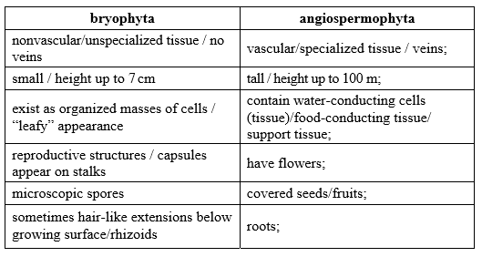
68a. [5 marks]
Describe the relationship between the rise in the concentration of atmospheric carbon dioxide and the enhanced greenhouse effect.

Markscheme
CO is a greenhouse gas;increases in CO increase/enhance the greenhouse effect;greenhouse effect is a natural phenomenon but not its increase;Earth receives short wave radiation from the sun;reradiated from Earth as longer wave radiation/infra red/heat;CO /greenhouse gases trap/absorb longer wave radiation/infra red/heat;global warming happened during same time/period as CO rise;CO concentration correlated (positively) with global temperature / global temperature increases as CO concentration increases;(causal) link accepted by most scientists;no proof that man-made increases in CO have caused global warming;
68b. [5 marks]
Outline the precautionary principle.

Markscheme
those proposing something must prove that it causes no harm;before they start to do it;objectors do not have to prove that there will be harm;activities that risk/threaten/may cause harm are banned;trials/tests must be done first;precautionary principle is applied when possible consequences are severe;precautionary principle should be used in the case of global warming;action should be taken to reduce CO emissions before proved it is the cause;another example of implementation of the precautionary principle;
68c. [8 marks]
Antibiotic resistance in bacteria is an example of evolution in response to environmental change. Using another example, explain how an environmental change can lead to evolution.

Markscheme
natural selection (in correct context); better-adapted individuals survive/more likely to survive;more reproduction/genes passed on by better adapted individuals;name of species; (accept even if remainder of answer is invalid)description of original/decreasing phenotype;type of environmental change that led to evolution;consequence of environmental changedescription of new/increasing phenotype;genetic basis of phenotypes;reason for new phenotype being better adapted;detail of reason for adaptedness of new phenotype;
The following has been provided as an example answer.great tit;bird that lays its eggs in spring;global warming/climate change;more caterpillars (on trees) in early spring;laying eggs earlier in spring;time of egg laying is (partly) genetically controlled;eggs laid early hatch at start of period of greatest food abundance;more young can be fed/young grow faster/fewer deaths;

Printed for Highland High School
© International Baccalaureate Organization 2017
International Baccalaureate® - Baccalauréat International® - Bachillerato Internacional®

