Chapter 5
1. [1 mark]
What is the highest level of taxa for Acacia tortilis?
A. Acacia
B. Tortilis
C. Fabaceae
D. Angiospermophyta

Markscheme
D
2. [1 mark]
Darwin described evolution as “descent with modification”. What would make evolution less probable?
A. Stable environment
B. Migration
C. Variation in offspring
D. Random mutation

Markscheme
A
3. [1 mark]
What is the biological definition of the term evolution?A. The changes shown by fossils over millions of yearsB. The transmission of favourable variations to offspringC. The cumulative change in the heritable characteristics of a populationD. The promotion of variation in a species by sexual reproduction

Markscheme
C
4. [1 mark]
Which example provides evidence of evolution?A. White wings of a peppered moth turn black in industrial areas.B. Antibiotic resistant bacteria replace non-resistant bacteria over time.C. Some Galapagos finches’ beaks become smaller during dry years.D. Polar bears are found in warmer latitudes following global warming.

Markscheme
B
5. [1 mark]
The photograph shows an animal of the species Eisenia fetida.
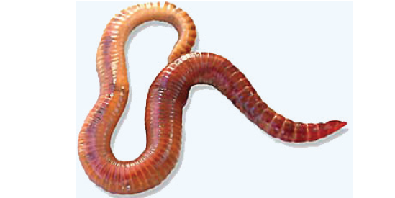
[Source: “Redwiggler1” by Mihai Duguleana; - Transferred from en.wikipedia to Commons.Licensed under Public Domain via Wikimedia Commons -https://commons.wikimedia.org/wiki/File:Redwiggler1.jpg#/media/File:Redwiggler1.jpg]
Which phylum does it belong to?A. CnidariaB. PlatyhelminthesC. AnnelidaD. Arthropoda

Markscheme
C
6. [1 mark]
Which example provides evidence of evolution?
A. White wings of a peppered moth turn black in industrial areas.B. Antibiotic resistant bacteria replace non-resistant bacteria over time.C. Some Galapagos finches’ beaks become smaller during dry years.D. Polar bears are found in warmer latitudes following global warming.

Markscheme
B
7. [1 mark]
What promotes natural selection?
I. Overpopulation
II. Competition
III. Variation
A. I and II onlyB. I and III onlyC. II and III onlyD. I, II and III

Markscheme
D
8. [1 mark]
What causes heritable variation in a species?
I. Muscle development through exerciseII. Increased rainfall in the ecosystemIII. Changes in the genome of the species
A. I and III onlyB. II onlyC. III onlyD. I, II and III

Markscheme
C
9. [1 mark]
Which phylum includes plants with rhizoids, spores that are produced in a capsule and a height below 0.5 metres?A. AngiospermophytaB. BryophytaC. ConiferophytaD. Filicinophyta

Markscheme
B
10. [1 mark]
What is accepted by scientists as evidence for evolution?
I. Similarities in bone structure between the wings of a bat and the fins of a porpoiseII. Changes in dog breeds caused by artificial selectionIII. Extinction of dinosaurs
A. I onlyB. I and II onlyC. I and III onlyD. I, II and III

Markscheme
B
11. [1 mark]
The long-term exposure of bacteria to antibiotics has led to the spread of resistant strains (for example, of Clostridium difficile). What is this an example of?
A. Convergent evolutionB. ImmunityC. Natural selectionD. Dominance

Markscheme
C
12. [1 mark]
To which phylum do organisms with exoskeleton, jointed appendages and segmented bodies belong?
A. MolluscaB. PoriferaC. ArthropodaD. Annelida

Markscheme
C
13. [1 mark]
Ranunculus repens and Hypericum repens both have yellow flowers. Which statement is true?
A. They are angiospermophytes. B. They are coniferophytes.C. They are members of the same species.D. They are members of the same genus.

Markscheme
A
14. [1 mark]
What distinguishes Annelida from Platyhelminthes?
A. Platyhelminthes have a segmented body but Annelida do not.B. Platyhelminthes reproduce sexually but Annelida do not.C. Platyhelminthes have radial symmetry but Annelida have bilateral symmetry.D. Annelida have both a mouth and an anus but Platyhelminthes do not.

Markscheme
D
15. [1 mark]
What features occur in all species of Angiospermophyta and Coniferophyta?
A. SeedsB. BarkC. ConesD. Flowers

Markscheme
A
16. [1 mark]
A biologist exploring an uninhabited island came across an unknown plant. She made the following notes:
• grows in a damp and shady corner of the island • has large feathery leaves with spore cases (sporangia) arranged on the underside• young leaves are tightly rolled up•has roots.
In what phylum should she classify this plant?
A. AngiospermophytaB. BryophytaC. ConiferophytaD. Filicinophyta

Markscheme
D
17. [1 mark]
What characteristics describe homologous structures?
A. They have the same ancestral origin but may have different functions. B. They have the same ancestral origin and always have the same function. C. They have different ancestral origins and may have different functions. D. They have different ancestral origins but always have the same function.

Markscheme
A
18. [1 mark]
Based on binomial nomenclature, which two species are most closely related?
I. Common barberry (Berberis vulgaris) II. Canadian bunchberry (Cornus canadensis) III. Smooth blackberry (Rubus canadensis) IV. Canadian barberry (Berberis canadensis)
A. I and IV B. II and III C. II and IV D. III and IV

Markscheme
A
19. [1 mark]
Based on binomial nomenclature, which two species are most closely related?
I. Common barberry (Berberis vulgaris) II. Canadian bunchberry (Cornus canadensis) III. Smooth blackberry (Rubus canadensis) IV. Canadian barberry (Berberis canadensis)
A. I and IV B. II and III C. II and IV D. III and IV

Markscheme
A
20. [1 mark]
Which organisms have flowers?
A. Bryophyta B. Porifera C. Angiospermophyta D. Cnidaria

Markscheme
C
21. [1 mark]
The following diagrams (not to scale) represent the fossilized forelimbs of three horses living at different times, none of which are alive today.
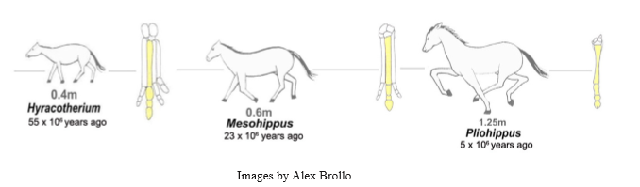
The diagrams provide evidence for which of the following?
A. Pentadactyl limb B. Domestication of animals C. Homologous structures D. Change in the characteristics of species

Markscheme
D
22. [1 mark]
What is evolution?
A A measure of the relative survival and reproductive success of an individual B. A cumulative change in the genetically controlled characteristics of a population C. A physical change during an organism’s life that is inherited by its offspring D. A random change in the proportions of alleles from generation to generation

Markscheme
B
23. [1 mark]
Two different trees have been classified as Pinus pinea and Pinus nigra. Which of the following statements is correct?
A. Both trees belong to the same class but a different genus. B. Both trees belong to the same family and same genus. C. The species name of both trees is Pinus. D. The family names are pinea and nigra.

Markscheme
B
24. [1 mark]
A collection of four animal specimens is observed and a dichotomous key is applied. Which specimen is an arthropod?
1. Non-segmented body ..............................go to 2 Segmented body .....................................go to 3 2. Body is not symmetrical...............................specimen A Body is symmetrical . . . . . . . . . . . . . . . . . . specimen B 3. Jointed appendages present........................specimen C Jointed appendages absent ........................specimen D
A. Specimen A B. Specimen B C. Specimen C D. Specimen D

Markscheme
C
25. [1 mark]
Which of the following represent homologous features?
A. Wings in birds and insects B. The appendix in humans and horses C. Fins in fish and wings in birds D. The striped coat of the zebra and the tiger

Markscheme
B
26. [1 mark]
Which of the following are used as evidence for evolution?
I. Homologous structures II. Selective breeding of domesticated animals III. Overproduction of offspring
A. I and II only B. I and III only C. II and III only D. I, II and III

Markscheme
A
27. [1 mark]
A poodle and a chihuahua are both dogs and classified as Canis familiaris. What conclusion can be made?
A. They belong to the same genus but not the same species. B. They are the same species but not the same genus. C. They are different species but can interbreed. D. They belong to the same genus and are the same species

Markscheme
D
28. [1 mark]
Which phylum does the plant below belong to?
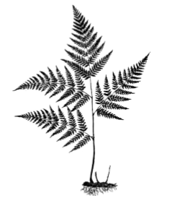
A. Angiospermophyta B. Bryophyta C. Coniferophyta D. Filicinophyta

Markscheme
D
29. [1 mark]
An animal has radial symmetry, a sac-like body with only one opening and tentacles with stinging structures. To which phylum does this animal belong?
A. Annelida B. Cnidaria C. Mollusca D. Porifera

Markscheme
B
30. [1 mark]
Charles Darwin used domesticated animals to provide evidence for evolution by natural selection. What is this evidence?A. Differences between breeds show that selection can cause species to change.B. The ancestors of domesticated animals can be found in the fossil record.C. Some domesticated animals die because the environment cannot support them all.D. Variation in domesticated animals is due to sexual reproduction.

Markscheme
A
31. [1 mark]
Ants, bees and wasps are classified in the same order. What can be deduced about these animals?A. They are classified in the same class.B. They are classified in different phyla.C. They are classified in the same family.D. They are classified in different kingdoms.

Markscheme
A
32. [1 mark]
Pseudolarix amabilis produces seeds but not flowers. Physcomitrella patens has leaves but not roots. To which groups do they belong?
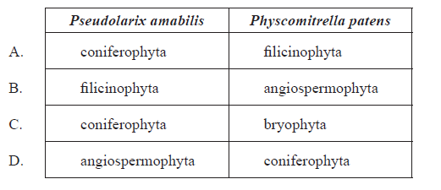

Markscheme
C
33. [1 mark]
Which process tends to reduce variety within a population?
A. Natural selectionB. Random fertilizationC. Independent assortmentD. Crossing over

Markscheme
A
34. [1 mark]
What is the mechanism of natural selection?
A. Any individuals in a population can be selected entirely by chance. B. After a change in the environment a species will evolve adaptations to the new conditions. C. If an adaptation to the environment is useful, an individual will develop it and pass it on to its offspring. D. Variations amongst individuals of a population are selected by a changing environment.

Markscheme
D
35. [1 mark]
Which of the organisms A–D, identified by the key below, represents an Annelid?
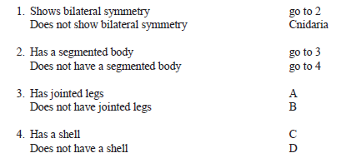

Markscheme
B
36. [1 mark]
To which group do sponges belong?
A. CnidariaB. FilicinophytaC. PoriferaD. Mollusca

Markscheme
C
37a. [1 mark]
Identify the phases labelled X and Y.
X:
Y:

Markscheme
X: plateau phase
Y: exponential growth / log phase
(both needed)
37b. [2 marks]
Outline how fossil records can provide evidence for evolution.

Markscheme
a. the sequence in which fossils appear matches the expected sequence of evolution;
b. comparisons with fossils and living organisms (morphology) shows change in characteristics from an ancestral form / OWTTE;
Vestigial organs and homologous structures are acceptable answers.
c. fossils of extinct species show that (evolutionary) change has occurred;
d. fossils can be dated with radioisotopes / geological depth/strata indicates (relative) age/date of organism;
e. can yield DNA for molecular clock analysis;
f. example of any of the above can earn one mark (eg: reptiles follow amphibians);
37c. [1 mark]
Distinguish between the terms genotype and phenotype.

Markscheme
genotype is the genetic make-up/set of alleles (of an organism) while phenotype is the characteristics (expressed/shown in an organism)
37d. [1 mark]
Outline a structural difference between the chromosomes of Helicobacter pylori and Homo sapiens.

Markscheme
chromosome from bacteria has no protein associated/naked DNA / bacteria is circular, H. sapiens is linear / (chromosomes of) H. sapiens are much bigger/have many more base pairs than bacteria
N.B.: Answer must refer to "chromosomes" not genomes of the two organisms.
37e. [1 mark]
Deduce the percentage of adenine in Oryza sativa if the proportion of guanine in that organism is 30 %.

Markscheme
20 %
37f. [1 mark]
Deduce the possible phenotypes of individual X.

Markscheme
A, B, AB and O
All four phenotypes must be shown to award the mark.
37g. [1 mark]
Describe ABO blood groups as an example of codominance.

Markscheme
allele Iand the allele Iare (co)dominant as they are both expressed in the heterozygote/AB type blood / OWTTE
38a. [1 mark]
State the infant mass relative to mother mass of Homo sapiens.

Markscheme
5.8(%)
Accept answers in the range of 5.7(%) and 5.9(%).
38b. [1 mark]
Outline the difference in infant mass relative to mother mass in extinct hominids and modern humans.

Markscheme
slightly less/similar (infant mass relative to mother mass) in extinct hominids than modern humans / vice versa
38c. [2 marks]
Suggest a hypothesis, based on evidence in the data, for when the shift to giving birth to larger infants occurred in the evolution of humans.

Markscheme
a. shift (to birthing larger infants) occurred with Australopithecus afarensis/after Ardipithicus ramidus;
b. infant mass relative to mother mass ratio lower in Ardipithecus ramidus than Australopithecus afarensis;
c. evidence limited since time lines not indicated/may be overlap;
38d. [1 mark]
Suggest one disadvantage of infants being born with a relatively large size in humans.

Markscheme
a. obstetric problems / difficulty giving birth / prenatal problems;
b. carrying/transporting a large infant could be difficult;
c. larger infants require more food;
39a. [1 mark]
Calculate the percentage of the total body mass made up by the human brain.

Markscheme
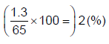
39b. [2 marks]
Compare the mass of human organs with the mass of other primate organs.

Markscheme
a. total organ mass (approximately) same for both;
b. very little difference in mass in heart/kidney/liver;
c. human brain has greater mass than the primate brain;
d. human gut has lower mass than the primate gut;
39c. [1 mark]
Using information from the table and the graph, identify the human organ which uses the greatest amount of energy per kilogram of body tissue.

Markscheme
heart
39d. [4 marks]
Explain the differences between the organ size of humans and other primates in terms of trends in human evolution and their causes.

Markscheme
a. brain size increased during hominid evolution / OWTTE;
b. change in diet from mostly vegetarian to more protein-rich/meat eating diets;
c. eating meat/protein allows larger brain growth / change in diet corresponds to the start of increase in hominid brain size;
d. larger brains require more energy;
e. larger gut necessary for plant material digestion;
f. smaller gut is sufficient for meat/cooked food;
40a. [1 mark]
On the cladogram, label with the letter C the point that shows the most recent common ancestor of Pambdelurion and Fuxianhuia.

Markscheme
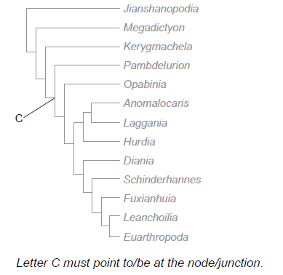
40b. [1 mark]
Identify which two species evolved most recently.

Markscheme
Leanchoilia and Euarthropoda
41. [2 marks]
Outline the process of adaptive radiation.

Markscheme
a. ancestral species occupies new environment / survives natural disaster;b. different members of the species are exposed to different selection pressures;c. gives rise to new species that share common structures adapted to new environment / occupy all niches;d. example of divergent evolution/homology;e. accept valid example eg Galapagos finches, vertebrate pentadactyl limb;
42a. [1 mark]
State the relationship between brain mass and maximum life span.

Markscheme
As brain mass increases life span increases / positive/direct relationship/correlation.
42b. [1 mark]
Identify the group with the widest range of brain mass.

Markscheme
Other placental mammals.
42c. [3 marks]
Compare the brain mass and life span of primates and marsupials.

Markscheme
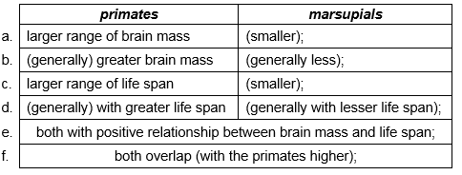
Do not accept answers stating only numerical values without comparative wording.
42d. [2 marks]
Discuss how a larger brain size and longer life span might have contributed to the evolution of these species.

Markscheme
a. larger brain size allows for higher intelligence/better cognition/more complex brain functions;b. more efficient food finding / escape from predators;c. longer life span favours parental care/survival for more reproduction;d. (these advantages) favour natural selection which leads to evolution;
43a. [3 marks]
The table shows certain characteristics present (+) or absent (–) in six organisms.
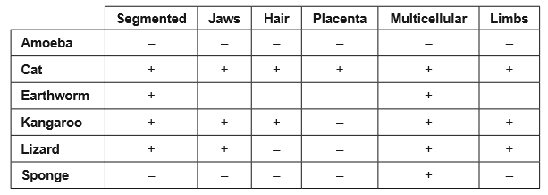
Using the data, label the cladogram with the names of the organisms.
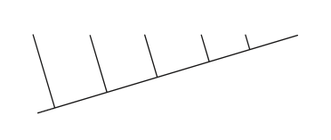

Markscheme
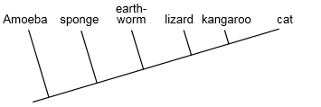
Award [1] for the correct position of any two organisms.Award [1 max] if the correct order is reversed horizontally (ie from cat on the left to Amoeba on the right).
43b. [2 marks]
A species is often defined as a group of similar individuals that interbreed in nature and produce fertile offspring. Discuss some problems with the use of this definition.

Markscheme
a. not all organisms can be defined in this way / does not take into account hybrids/ microorganisms/plants;b. (even if able to interbreed) may have differences in DNA/protein;c. does not apply to bacteria/other organisms that reproduce asexually;d. in sympatric/allopatric isolation members of the same species do not interbreed;e. (in some species) significant differences in morphology can occur within the same species eg: sexual dimorphism/metamorphosis/ring species; Accept any other correct answer.
44. [2 marks]
Outline two processes needed for the spontaneous origin of life on Earth.

Markscheme
non-living synthesis of organic molecules;
formation of polymers;
origin of self-replicating molecules;
packing of molecules into membranes/protobionts;
(Do not accept reference to reducing atmosphere unless part of a process)
45. [6 marks]
Explain the biochemical evidence for the common ancestry of organisms on Earth.

Markscheme
all organisms use DNA as genetic material;
same four (nucleotide) bases makes up DNA in all organisms;
number of mutations reflect differences between organisms;
all organisms use the same genetic code / minor differences;
genetic code is degenerate/OWTTE;
all organisms use the same 20 amino acids;
function of proteins constant between species;
protein/molecule examples; (eg hemoglobin, cytochrome, chlorophyll)
only left-handed amino acids have been observed in living organisms;
although right-handed amino acids will have been available;
only right-handed glucose/carbohydrates used in organisms;
similarities in glycolysis/metabolic pathways;
all use RNA/same enzymes in transcription/translation;
46a. [2 marks]
List two factors that could cause an increase in the size of an animal population.
1. ..................................................................2. ..................................................................

Markscheme
a. natality / increased birth rate;b. immigration;c. extra food/water / breeding sites;d. expanding habitat;e. lack of predators/disease/parasites / reduced death rate;
46b. [4 marks]
Outline how overpopulation of a species in a given environment may lead to evolution.

Markscheme
a. more are born than can survive;b. there is variety/variability in the offspring;c. competition for resources / struggle for survival / selection pressure;d. only the most able/adapted survive / survival of the fittest;e. the survivors reproduce and pass on genes;f. genes of less able/adapted are eliminated / change in the gene pool;g. natural selection occurs;
47a. [2 marks]
Parts of a dichotomous key to organisms A, B, C and D are shown. Design missing parts of the key using features visible in the following diagrams.
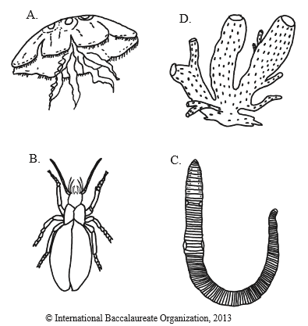
1.
Body with tentacles ................................................A
Body without tentacles ......................................... go to 2
2.
................................................................B
............................................................go to 3
3
.................................................................C
................................................................D

Markscheme
any visible characteristic that distinguishes between B and the rest; (eg. three pairs of legs/no legs)characteristic that distinguishes between C and D; (eg. body divided into many segments / body not divided into many segments)characteristic specific to C and different characteristic specific to D; (eg. C had cylinder shape and D has pores)
47b. [2 marks]
All of these organisms belong to the animal kingdom. State two structural differences between animal cells and plant cells

Markscheme
cell wall only in plant cells;starch granules only in plant cells;chloroplasts only in plant cells;centrioles only in animal cells;(large) vacuole in plant cells;
48. [2 marks]
Using the mammalian pentadactyl limb as an example, outline the process of adaptive radiation.

Markscheme
limb bone pattern of mammals shows the same basic arrangement;derived from common ancestor/homologous structures;common ancestral pattern adapted to different environment conditions;suitable example; (eg wing of bat adapted for flight and limbs of mole for digging)
49a. [2 marks]
Outline two possible consequences of global warming for organisms living in arctic ecosystems.

Markscheme
reduced space/habitat (for ice-dwelling species) / valid example;increased competition (from temperate species);arctic species forced to migrate (in search of suitable habitats/food);changes in patterns of (seasonal) migration;extinction of some species due to inability to adapt quickly/compete successfully;increased activity of decomposers;increased success of pest species including pathogens;changes in the distribution of prey species;
49b. [2 marks]
The changes that result from global warming may lead to evolution. Define evolution.

Markscheme
(cumulative) change in heritable/genetic characteristics of a population;new species arise from pre-existing species;change/adaptation of a population due to natural selection / descent with modification;
49c. [3 marks]
Explain how sexual reproduction promotes variation in a species.

Markscheme
sexual reproduction involves interbreeding/genetic material from two parents;new combinations of paternal and maternal chromosomes/alleles/genes / (random) fertilization;which leads to new genetic combinations/greater variation;meiosis creates a great variety of gametes;by crossing-over / by random orientation of alleles (during meiosis);
50. [3 marks]
Discuss the definition of the term species.

Markscheme
a species is a group of organisms with similar characteristics, which can interbreed and produce fertile offspring;sibling species may show similar characteristics but cannot interbreed (e.g. Pipistrelle bat in Britain);some pairs of species are different but can interbreed (e.g. ruddy duck and white headed duck/many plant species);some species always reproduce asexually so definition may not apply;some breed in zoos/captivity, but will not interbreed in nature;difficult to classify fossils as cannot decide if they could interbreed; Unfamiliar examples should be checked for accuracy using the internet.
51a. [1 mark]
Distinguish between innate and learned behaviour.

Markscheme
innate behaviour is independent of experience/environmental conditions/inheritedwhile learned behaviour is influenced by experience/environment / OWTTE
51b. [2 marks]
Distinguish between analogous and homologous structures.
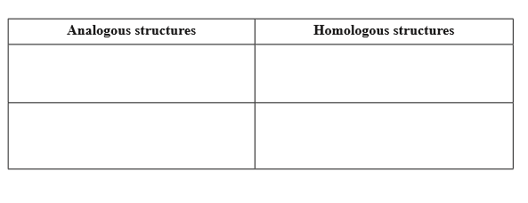

Markscheme
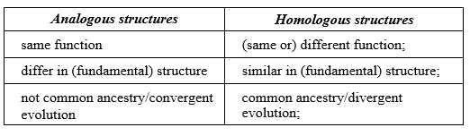
52a. [2 marks]
State a function of each of the following parts of the human brain.
(i) Cerebellum
(ii) Hypothalamus

Markscheme
(i) (coordinates) unconscious motor functions/balance and movement
(ii) (maintains) homeostasis/thermoregulation/appetite/thirst / coordinates endocrine systems / secretes hormones/regulating factors
52b. [1 mark]
Identify the two most closely related organisms.

Markscheme
(common) chimpanzee and bonobo
52c. [1 mark]
Identify the species to which the Bonobo is most distantly related.

Markscheme
gibbon
52d. [3 marks]
Describe one type of barrier that may exist between gene pools.

Markscheme
named barrier;description of its action;results in terms of gene pools;e.g.:behavioural barrier;different populations mate at different times of year thus preventing interbreeding;allele frequencies become different in the two gene pools/separates gene pools / sympatric speciation;
53a. [1 mark]
State the year in which G. fortis had the greatest change in relative beak size.

Markscheme
1977 / 1978 N.B. Some responses are interpreting this as a change between years.
53b. [3 marks]
Compare the trends in relative beak size of G. fortis and G. scandens.

Markscheme
both species increased (relative) beak size at the beginning of the study/ between the years 1973/1974 to 1977/1978;no similarity in trend for both species after 1977/1978/1979 / no relationship between the two species in the years of increase and decrease;more occurrence of decrease in (relative) beak size in G. fortis whereas G. scandens showed more increases in (relative) beak size;G. fortis shows wider fluctuation in (relative) beak size than G. scandens; Do not accept year by year comparisons.
53c. [2 marks]
Outline possible reasons for the trends in relative beak size in finches.

Markscheme
changes in environment/rainfall/ocean currents/migration / drought;change in food supply;hybridization/crossbreeding between species;natural selection / selection pressure;
54a. [1 mark]
Define the term clade.

Markscheme
a group of related organisms sharing a common ancestor / a group of organisms containing an ancestor and all of its descendants / OWTTE
54b. [2 marks]
Distinguish between analogous and homologous structures, giving an example of each.

Markscheme
homologous structures evolved from a common ancestor while analogous structures did not;example of homologous and example of analogous; (both needed)
54c. [2 marks]
The table below lists five animals along with four morphological characteristics. A plus sign (+) indicates that the animal has this characteristic while a minus sign (–) indicates that the characteristic is absent.
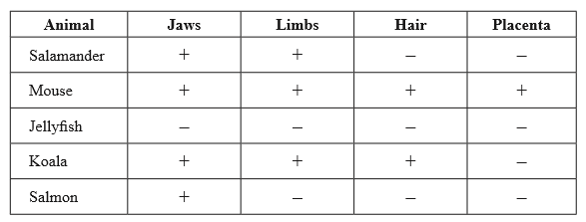
Based on the features above, a student constructed a cladogram. State the names of the organisms missing in the following cladogram.
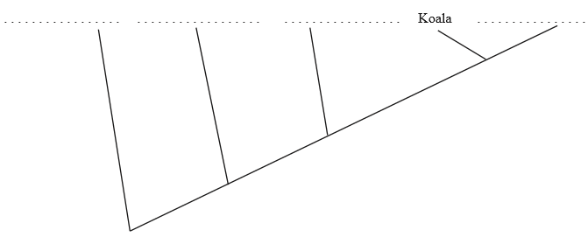

Markscheme
Two correct labels for [1].
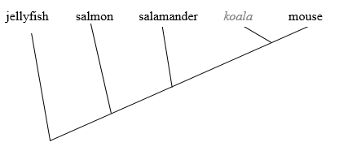
55a. [2 marks]
Distinguish between Archaea and Eukarya.

Markscheme
a. membrane-bound organelles present in Eukarya but absent in Archaea;
b. 70S ribosomes in Archaea whereas 80S ribosomes in (cytoplasm of) Eukarya;
c. nuclear envelope in Eukarya, not in Archaea;
d. introns are present in Eukarya but only in some genes of Archaea;
e. histone proteins present in all Eukarya but only in a few Archaea;
f. the membrane lipid structure is unbranched in Eukarya but branched in Archaea;
g. Archaea can inhabit extreme habitats while Eukarya cannot;
55b. [3 marks]
Label the parts of the cell walls in Gram-positive Eubacteria and Gram-negative Eubacteria shown below.
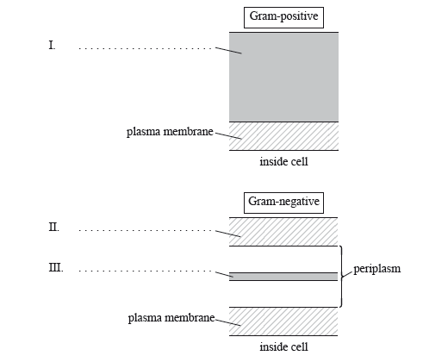

Markscheme
I. peptidoglycan;
II. outer membrane/layer of lipopolysaccharide and protein;
III. peptidoglycan;
56a. [3 marks]
Outline how variations in specific molecules can lead to phylogeny.

Markscheme
a. phylogeny is the evolutionary line of descent;
b. the study of similar molecules in two different species; (e.g. mitochondrial DNA / hemoglobin / Cytochrome c)
c. the greater the differences, the longer the time span since the two species had a common ancestor;
d. variation can be due to mutations;
e. mutations are chance events so caution must be taken when interpreting these;
56b. [2 marks]
Outline the value of classifying organisms.

Markscheme
a. organization of data helps to identify organisms;
b. suggests evolutionary links;
c. suggests the closeness of a relationship the more similar the characteristics are;
d. allows prediction of characteristics shared by members of a group;
57. [6 marks]
Explain the biochemical evidence for the common ancestry of living organisms.

Markscheme
DNA/RNA found in all living organisms/genetic code is universal;
amino acids all L- not D- isomers;
same 20 amino acids/proteins found in all living organisms;
involves comparing similarities and differences in the amino acid sequence of the same molecule;
e.g. hemoglobin;
involves comparing base sequences of variable regions of DNA;
e.g. mitochondrial DNA;
the more similar the base/amino acid sequence, the more closely related;
comparing amino acid sequences that result in the phenotype/comparing DNA sequences that result in the genotype;
evidence for molecular evolution in drug resistance;

Printed for Highland High School
© International Baccalaureate Organization 2017
International Baccalaureate® - Baccalauréat International® - Bachillerato Internacional®

