Chapter 6 Multiple Choice
1. [1 mark]
What structures in the small intestine transport most fats?
A. Collecting ducts
B. Capillaries
C. Veins
D. Lacteals

Markscheme
D
2. [1 mark]
What causes heart ventricles to fill with blood?
I. Atrial contraction
II. Closing of atrioventricular valves
III. Opening of semilunar valves
A. I only
B. I and II only
C. II and III only
D. III only

Markscheme
A
3. [1 mark]
Which is the correct statement concerning HIV and AIDS?
A. All HIV patients have AIDS.
B. HIV and AIDS are transmitted on the sex chromosomes.
C. All AIDS patients have HIV.
D. HIV and AIDS neutralize antibodies.

Markscheme
C
4. [1 mark]
How does the hypothalamus respond to a very high body temperature?
A. Increases muscle contraction
B. Stops receiving sensory input
C. Causes dilation of skin arterioles
D. Slows the heart rate

Markscheme
C
5. [1 mark]
What is a characteristic of type II diabetes?
A. Insufficient insulin
B. Insulin insensitivity
C. Excess glucagon
D. Low white blood cell count

Markscheme
B
6. [1 mark]
Which two hormones promote thickening of the endometrium?
A. FSH and LH
B. Estrogen and FSH
C. LH and estrogen
D. Progesterone and estrogen

Markscheme
D
7. [1 mark]
When the left ventricle is relaxed, what is the state of the valves?
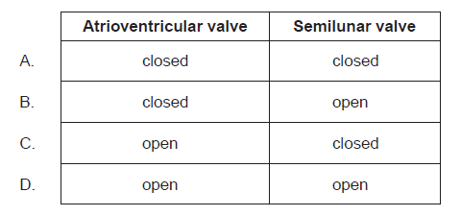

Markscheme
C
8. [1 mark]
What causes heart ventricles to fill with blood?
I. Atrial contraction
II. Closing of atrio-ventricular valves
III. Opening of semilunar valves
A. I only
B. I and II only
C. II and III only
D. III only

Markscheme
A
9. [1 mark]
What happens first when a neurotransmitter binds to a postsynaptic neuron?
A. Ions diffuse
B. Electrophoresis begins
C. Cachannels open
D. Repolarization

Markscheme
A
10. [1 mark]
What changes take place in the thorax during inhalation?
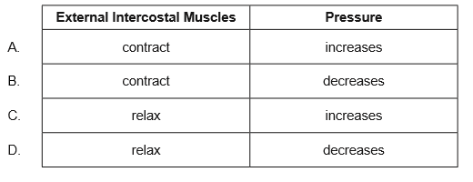

Markscheme
B
11. [1 mark]
What are functions of the stomach, small intestine and large intestine?
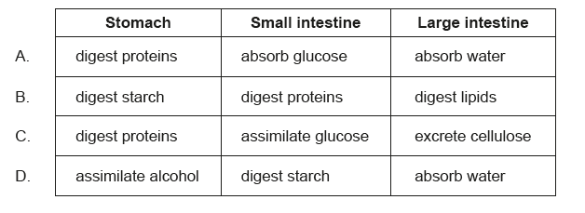

Markscheme
A
12. [1 mark]
The graph shows a correlation between the number of new cases of stomach cancer and vegetable consumption for women in Poland.
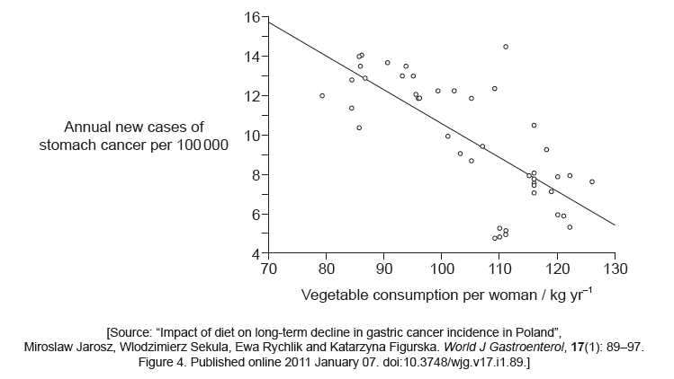
What can be stated from the graph?A. Vegetable consumption causes stomach cancerB. 68 % of the data are gathered around the trend lineC. Causality cannot be stated from the graph aloneD. Only that the correlation is positive

Markscheme
C
13. [1 mark]
What is a role of the coronary arteries?A. To supply information about blood temperature to the hypothalamusB. To supply the heart muscle with oxygen and nutrientsC. To carry blood away from the heartD. To monitor blood pH

Markscheme
B
14. [1 mark]
The image shows a section of the human respiratory system. Which letter identifies a bronchiole?
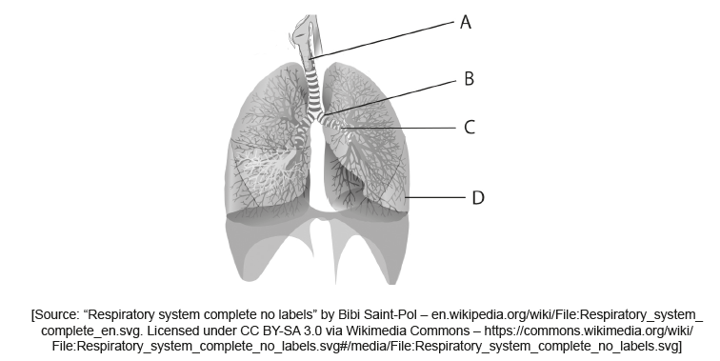

Markscheme
D
15. [1 mark]
What characterizes type I diabetes?A. It can be controlled by diet alone.B. Risk factors such as obesity increase its frequency.C. The alpha cells of the pancreas are destroyed, usually during adulthood.D. The beta cells of the pancreas are destroyed, usually during childhood.

Markscheme
D
16. [1 mark]
What is a feature of neurons?A. Relay neurons transmit impulses from motor to sensory neurons.B. The cell body of a motor neuron is in the CNS.C. Sensory neurons carry impulses away from the CNS.D. Relay neurons form synapses with receptors.

Markscheme
B
17. [1 mark]
What is a feature of the human circulatory system?A. The wall of the right ventricle of the heart is the thickest of the four chambers.B. The pulmonary artery and vena cava both carry deoxygenated blood.C. Valves are found in arteries and veins but not capillaries.D. Epinephrine acts on the pacemaker to reduce heart rate.

Markscheme
B
18. [1 mark]
Which describes the secretion of hormones in the pancreas in response to low levels of glucose in the blood?A. Secretion of glucagon from α cellsB. Secretion of glucagon from β cellsC. Secretion of insulin from α cellsD. Secretion of insulin from β cells

Markscheme
A
19. [1 mark]
Which hormone shows the greatest fall in blood concentration just before menstruation?A. FSH (follicle stimulating hormone)B. LH (luteinizing hormone)C. ProgesteroneD. Estrogen

Markscheme
C
20. [1 mark]
What are functions of the stomach, small intestine and large intestine?
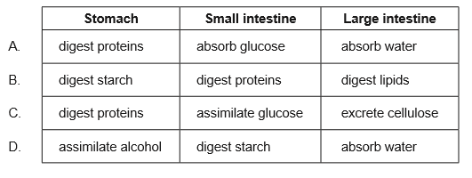

Markscheme
A
21. [1 mark]
What is a role of the coronary arteries?
A. To supply information about blood temperature to the hypothalamusB. To supply the heart muscle with oxygen and nutrientsC. To carry blood away from the heartD. To monitor blood pH

Markscheme
B
22. [1 mark]
What happens during synaptic transmission?
A. K enters the postsynaptic membrane.B. A neurotransmitter is absorbed through the presynaptic membrane.C. Na is released from the presynaptic membrane.D. A neurotransmitter binds to a postsynaptic membrane receptor.

Markscheme
D
23. [1 mark]
The graph is about defence against infectious disease.
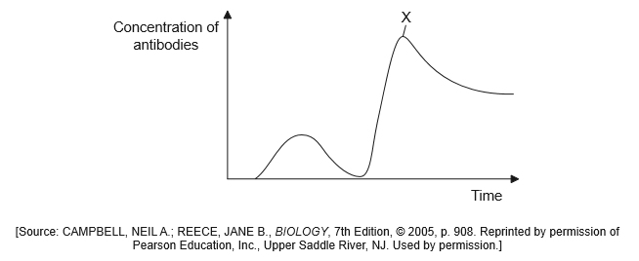
What is likely to be indicated by the letter X?
A. The increase in lymphocytes following HIV infectionB. The peak of the infectionC. The secondary response to a vaccineD. The first appearance of AIDS symptoms

Markscheme
C
24. [1 mark]
Which vessel carries deoxygenated blood from the heart to the lungs?A. Vena cavaB. Coronary veinC. Pulmonary arteryD. Pulmonary vein

Markscheme
C
25. [1 mark]
What role does the medulla of the brain have in controlling heart rate?A. To secrete adrenaline to speed up the heart.B. To stimulate myogenic heart muscle contraction.C. To block pacemaker activity.D. To adjust heart rate to changing blood pressure.

Markscheme
D
26. [1 mark]
Which is a long-term effect of the human immunodeficiency virus (HIV) on the immune system?A. Fewer bacterial infectionsB. Fewer active lymphocytesC. More antibody productionD. More antigen recognition

Markscheme
B
27. [1 mark]
During expiration, how does air pressure in the lungs compare with atmospheric pressure?A. Lung air pressure is greater than atmospheric pressure.B. Lung air pressure is less than atmospheric pressure.C. Lung air pressure starts below atmospheric pressure and rises above it.D. Lung air pressure starts above atmospheric pressure and falls below it.

Markscheme
A
28. [1 mark]
Where do motor neurons conduct impulses from and to?A. From effectors to the central nervous system.B. From receptors to the central nervous system.C. From neurons to other neurons.D. From the central nervous system to effectors.

Markscheme
D
29. [1 mark]
What are increasing levels of progesterone responsible for during the female menstrual cycle?A. Stimulating ovulationB. Development of the follicleC. Thickening of the endometriumD. Menstruation

Markscheme
C
30. [1 mark]
What are features of the enzyme amylase?
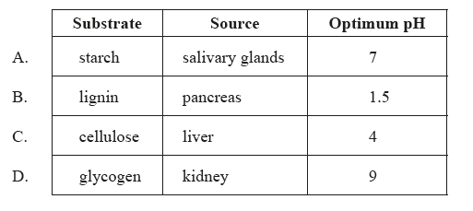

Markscheme
A
31. [1 mark]
Why are antibiotics effective against pathogenic bacteria?A. Bacteria have a high rate of mutationB. Bacterial cell processes are blockedC. Bacteria have a slow metabolismD. Bacteria assimilate antibiotics

Markscheme
B
32. [1 mark]
The diagram below shows the human heart.
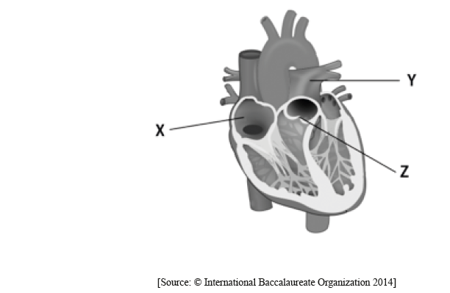
What structures are indicated by the labels X, Y and Z?
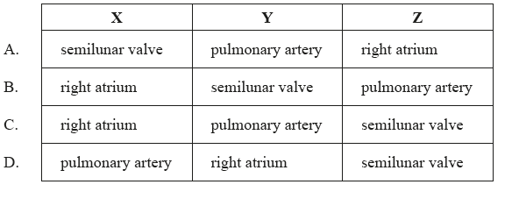

Markscheme
C
33. [1 mark]
The diagram below shows the changes in membrane potential during an action potential.
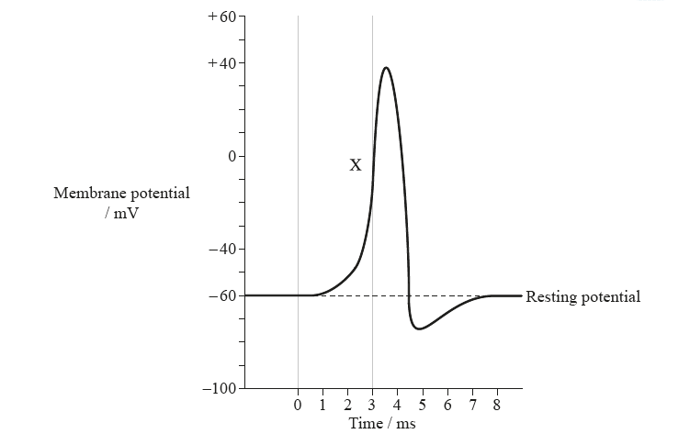
What best describes events indicated by the label X?
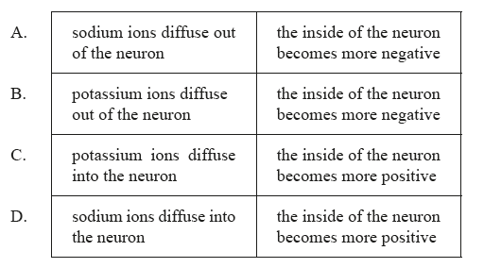

Markscheme
D
34. [1 mark]
The diagram below shows the female reproductive system.
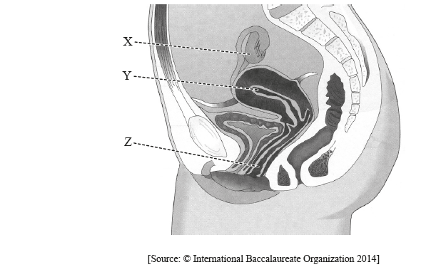
What are the structures indicated by X, Y and Z?
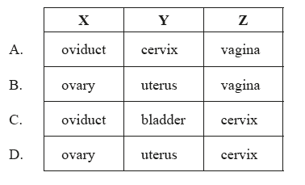

Markscheme
B
35. [1 mark]
What is the body’s response to low blood glucose levels?A. Alpha cells in the pancreas secrete glucagonB. Beta cells in the pancreas secrete insulinC. Alpha cells in the pancreas secrete insulinD. Beta cells in the pancreas secrete glucagon

Markscheme
A
36. [1 mark]
What muscle actions cause air to be expelled from the lungs?A. Internal intercostal muscles relax and diaphragm contractsB. External intercostal muscles contract and abdominal wall muscles contractC. External intercostal muscles contract and diaphragm relaxesD. Internal intercostal muscles contract and abdominal wall muscles contract

Markscheme
D
37. [1 mark]
Where is follicle stimulating hormone (FSH) produced in females and what is its function?A. Produced by the ovaries and stimulates the growth of folliclesB. Produced by the pituitary gland and stimulates the growth of endometriumC. Produced by the pituitary gland and stimulates the growth of folliclesD. Produced by the follicles and stimulates the growth of endometrium

Markscheme
C
38. [1 mark]
What steps occur in blood clotting?A. Fibrin is converted to fibrinogen which then alters prothrombin into thrombin.B. Thrombin is converted to prothrombin which then alters fibrinogen into fibrin.C. Fibrinogen is converted to fibrin which then alters prothrombin into thrombin.D. Prothrombin is converted to thrombin which then alters fibrinogen into fibrin.

Markscheme
D
39. [1 mark]
What structures are indicated on the diagram?
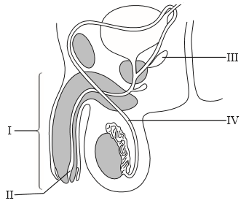
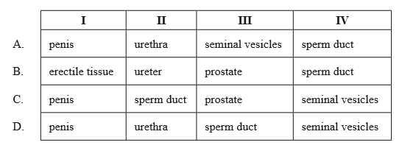

Markscheme
A
40. [1 mark]
LH causes the rupture of a follicle and release of an egg cell. What is this process called?
A. ConceptionB. FertilizationC. MenstruationD. Ovulation

Markscheme
D
41. [1 mark]
What is the state of the atrio-ventricular and semilunar valves when the left ventricle contracts?
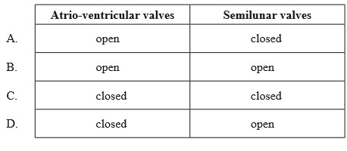

Markscheme
D
42. [1 mark]
What are the conditions of the blood travelling through the pulmonary vein?
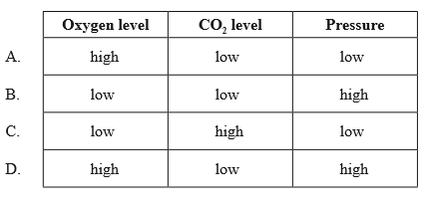

Markscheme
A
43. [1 mark]
Immediately after an action potential, which event causes the neuron membrane to repolarize?
A. Voltage-gated sodium channels open.B. Voltage-gated potassium channels open.C. Voltage-gated calcium channels close.D. Voltage-gated potassium channels close.

Markscheme
B
44. [1 mark]
What is a characteristic of type II diabetes?
A. Liver cells are less sensitive to insulin.B. Insulin is no longer produced.C. α cells in the pancreatic islets are destroyed.D. β cells in the pancreatic islets are destroyed.

Markscheme
A
45. [1 mark]
Enzymes produced by the pancreas could pass out of the body via the anus. Which route would these enzymes take to do this?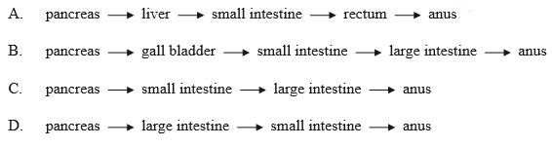

Markscheme
C
46. [1 mark]
What causes the rate of heart contraction to increase or decrease?
A. The heart muscle itselfB. Nerve impulses from the brainC. A hormone from the thyroid glandD. The rate of return of blood to the left atrium

Markscheme
B
47. [1 mark]
Why do nutrient molecules enter the blood?
A. Blood carries nutrients to cells.B. Blood converts nutrients into energy.C. Nutrients and oxygen are mixed by blood.D. Nutrients are stored in blood.

Markscheme
A
48. [1 mark]
Where are structures I, II and III found in the human body?
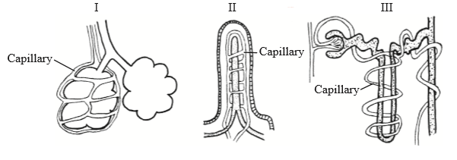
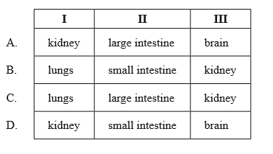

Markscheme
B
49. [1 mark]
What is the function of thrombin in the process of blood clotting?
A. It acts as a catalyst.B. It criss-crosses the wound to trap blood cells.C. It changes from a soluble protein to an insoluble fibrous protein.D. It releases clotting factors from platelets.

Markscheme
A
50. [1 mark]
Which element or ion is required for transmission of a nerve impulse?
A. Phosphorous B. Sodium C. Sulfur D. Iron

Markscheme
B
51. [1 mark]
A structure has a thin epithelium of one cell layer and contains a lacteal and blood capillaries. It has protein channels and mitochondria to aid absorption. What is this structure?
A. Alveolus B. Gastric gland C. Pancreas D. Villus

Markscheme
D
52. [1 mark]
Which statement describes the movements of the rib cage during inhalation of air?
A. External intercostal muscles contract moving the ribs up and outwards. B. Internal intercostal muscles contract moving the ribs down and inwards. C. External intercostal muscles relax moving ribs down and inwards. D. Internal intercostal muscles relax moving ribs up and outwards.

Markscheme
A
53. [1 mark]
What are antibodies?
A. Organisms or viruses that cause diseaseB. Drugs used to treat bacterial diseasesC. Substances the body recognizes as foreignD. Proteins that bind to foreign substances

Markscheme
D
54. [1 mark]
The diagram shows events at a synapse.
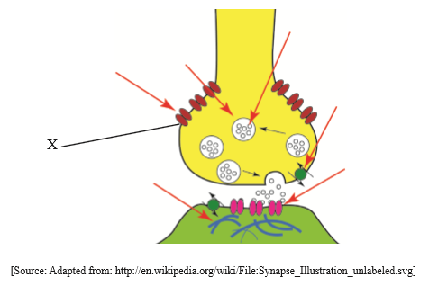
What is happening at the point labelled X?
A. Neurotransmitter binding B. Ca diffusing C. Neurotransmitter moving across synapse D. Na binding

Markscheme
B
55. [1 mark]
The concentration of which hormone peaks sharply triggering ovulation?
A. FSHB. LHC. EstrogenD. Progesterone

Markscheme
B
56. [1 mark]
The diagram shows a section through the male reproductive system. Which structure represents the prostate gland?
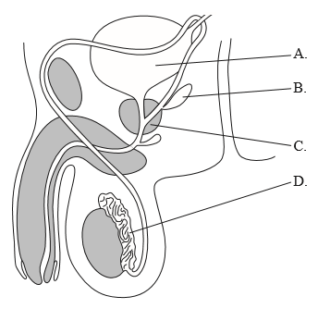

Markscheme
C
57. [1 mark]
The diagram below shows the human digestive system.
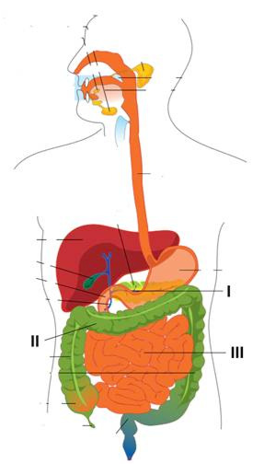
In which parts of the digestive system are most water and glucose absorbed?
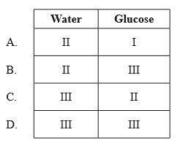

Markscheme
B
58. [1 mark]
What is a similarity between arteries and capillaries?
A. They both have elastic tissue. B. They both have smooth muscle cells. C. Neither has collagen fibres in their walls. D. Neither has valves.

Markscheme
D
59. [1 mark]
What is the condition of the valves of the heart when the right ventricle is contracting?
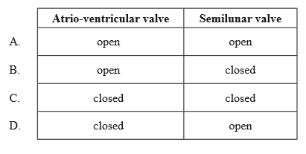

Markscheme
D
60. [1 mark]
What is a feature of alveoli?
A. They occur in all animals because they are needed for gas exchange. B. They have a higher oxygen concentration than air in the atmosphere to increase the rate of diffusion. C. They have walls that are one cell thick for faster diffusion. D. They are small so keep the gases inside them more concentrated.

Markscheme
C
61. [1 mark]
What is a characteristic of axons in motor neurons?
A. When there is a resting potential, the outside of the axon is negative relative to the inside. B. During an action potential, Na ions diffuse out of the axon. C. K ions diffusing out of the axon repolarizes it. D. Impulses in the axon travel towards the cell body.

Markscheme
C
62. [1 mark]
Which response takes place when blood glucose levels are low?
A. Glucagon is released from the α cells of the pancreatic islets. B. Glucagon is released from the β cells of the pancreatic islets. C. Insulin is released from the α cells of the pancreatic islets. D. Insulin is released from the β cells of the pancreatic islets.

Markscheme
A
63. [1 mark]
During the menstrual cycle, what occurs in response to a fall in the progesterone level?
A. Growth of the uterus lining B. Growth of the follicle surrounding the egg C. Ovulation D. Menstruation

Markscheme
D
64. [1 mark]
Which reaction during blood clotting is catalysed by the enzyme thrombin?
A. Soluble fibrin to fibrous fibrinogen B. Soluble fibrinogen to fibrous fibrin C. Fibrous fibrinogen to soluble fibrin D. Fibrous fibrin to soluble fibrinogen

Markscheme
B
65. [1 mark]
What is an important function of the lacteal in the villus?
A. Secretion of mucus B. Secretion of enzymes C. Transport of glucose D. Transport of fats

Markscheme
D
66. [1 mark]
Which blood vessel directly supplies oxygen to the heart muscle?
A. Aorta B. Coronary artery C. Pulmonary artery D. Pulmonary vein

Markscheme
B
67. [1 mark]
The diagram shows the ventilation system in humans.
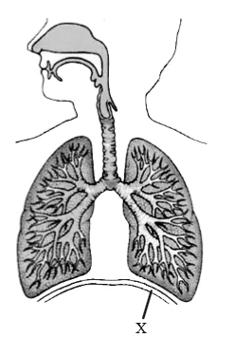
What is the function of the structure labelled X?
A. Protect the lungs B. Contract to cause inhalation C. Become flatter to move the ribcage up D. Relax in order to increase the thoracic capacity

Markscheme
B
68. [1 mark]
The diagram shows the adult female reproductive system. Which label shows the cervix and which shows the usual site of fertilization?
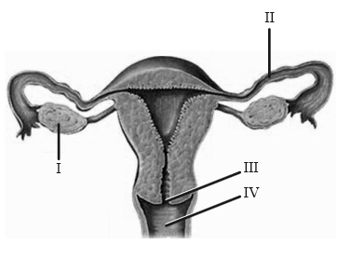
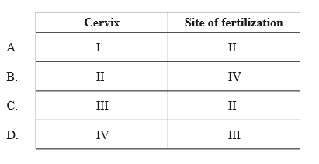

Markscheme
C
69. [1 mark]
Which of the following is a characteristic of type I but not type II diabetes?
A. β cells in the pancreas are destroyed. B. Insulin injections are required. C. α cells in the pancreas are destroyed. D. Sugar intake control is required.

Markscheme
A
70. [1 mark]
What is the structure labelled X?
A. Right ventricle B. Right atrium C. Left atrium D. Left ventricle

Markscheme
D
71. [1 mark]
What is a role of the coronary arteries?
A. To transport oxygen from the lungs directly to the heart muscle B. To remove deoxygenated blood from the heart muscle C. To supply the heart muscle with nutrients D. To remove cholesterol from the heart muscle

Markscheme
C
72. [1 mark]
Where does most assimilation take place?
A. In cells B. In the mouth C. In the small intestine D. In the large intestine

Markscheme
A
73. [1 mark]
Celiac disease causes the destruction of the villi cells. Which of the following is most likely to happen to people with celiac disease?
A. Incomplete digestion of fats B. Poor absorption of calcium C. Increased levels of glucose in blood D. Damage in the esophagus caused by increase in acid content of the stomach

Markscheme
B
74. [1 mark]
Which of the following statements about antibodies is correct?
A. Antibodies are polypeptides. B. Antibodies are produced by the bone marrow. C. Antibodies are pathogenic foreign substances. D. Antibodies kill bacteria but not viruses.

Markscheme
A
75. [1 mark]
What normally prevents the membranes of the alveoli from sticking together during expiration?
A. The thickness of the single-cell layer of alveoli membranes B. The secretion of fluids in the inner surface of the alveoli C. The pressure within the thoracic cavity D. The dense net of capillaries covering the alveoli

Markscheme
B
76. [1 mark]
Is the blood in the aorta, left ventricle and pulmonary artery oxygenated or deoxygenated?
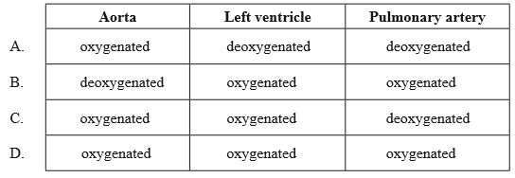

Markscheme
C
77. [1 mark]
Which of the following is correct for lipase?
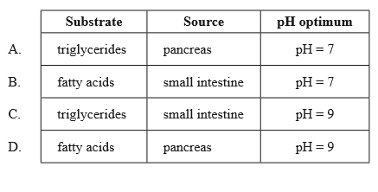

Markscheme
A
78. [1 mark]
What processes occur during assimilation and absorption of lipids?
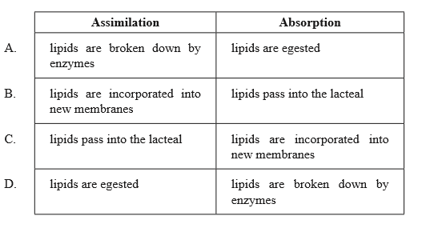

Markscheme
B
79. [1 mark]
What happens to the external and internal intercostal muscles and diaphragm when inhaling?
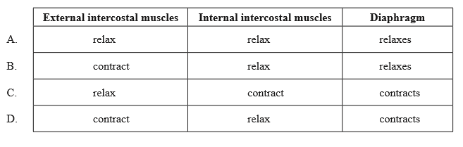

Markscheme
D
80. [1 mark]
Which of the following is/are a role of testosterone in males?
I. Pre-natal development of male genitalia II. Maintenance of sex drive III. Increase in mental development
A. II only B. I and II only C. II and III only D. I, II and III

Markscheme
B
81. [1 mark]
What prevents antibiotics from being effective against viruses?
A. Viruses have a high rate of mutation. B. Viruses have no RNA. C. Viruses have no metabolism. D. Viruses have a protein shell that protects them.

Markscheme
C
82. [1 mark]
The diagram below shows water in the human body.
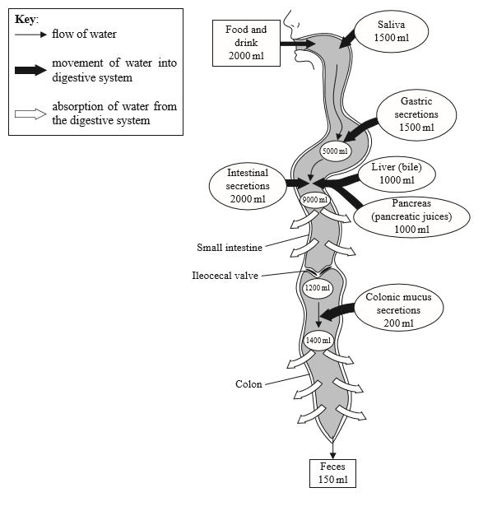
Where in the digestive system is the largest volume of water absorbed from?
A. Colon B. Pancreas C. Small intestine D. Liver

Markscheme
C
83. [1 mark]
What stimulates the production of antibodies?A. AIDSB. AntibioticsC. AnticodonsD. Antigens

Markscheme
D
84. [1 mark]
What is the sequence of operations during IVF treatment?A. egg collection → FSH injections → fertilizationB. egg collection → fertilization → FSH injectionsC. FSH injections → egg collection → fertilizationD. FSH injections → fertilization → egg collection

Markscheme
C
85. [1 mark]
What is the consequence of insufficient secretion of FSH in women?A. Embryo implantation fails because the uterus lining is too thin.B. Mature eggs (oocytes) are not produced.C. Menstruation starts before embryo implantation occurs.D. Progesterone secretion is inhibited.

Markscheme
B
86a. [4 marks]
Draw a labelled diagram to show the structure of a sarcomere.

Markscheme
Award [1] for each structure clearly drawn and correctly labelled.
Sarcomere – clearly indicated between Z lines;
Z lines;
actin filaments attached to Z line;
myosin filaments with heads;
(two) light bands;
dark band;
86b. [5 marks]
Outline how skeletal muscle contracts.

Markscheme
calcium ions are released from the sarcoplasmic reticulum;
they expose the myosin binding sites (on actin) / cause movement of blocking molecules/troponin;
cross-bridges form between actin and myosin molecules;
ATP provides energy;
for actin filaments to slide over the myosin filaments / for myosin to push actin;
ATP provides energy to release myosin from binding site;
action can be repeated further along the molecule;
86c. [9 marks]
Explain how nerve impulses are transmitted along and between neurons.

Markscheme
the resting potential of cell is negative inside compared with outside;
stimulation causes depolarization/reversal of charge on each side;
due to Na channels opening / Na flowing into the cell;
which causes an action potential;
K channels open / K flows out of the cell;
sodium potassium pump restores resting potential;
transmitted between neurons across a synapse;
neurotransmitter released into synaptic cleft;
diffuse across cleft to postsynaptic membrane;
where they bind to receptors;
influx of Na into cell;
which may initiate action potential;
87. [1 mark]
On the diagram of the motor neurone shown below, which label identifies a dendrite?
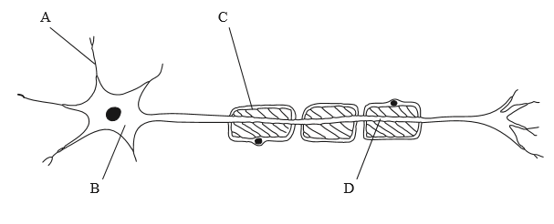

Markscheme
A
88. [1 mark]
Which term describes a molecule capable of triggering an immune response?
A. AntibodyB. AntigenC. PathogenD. Antibiotic

Markscheme
B
89. [1 mark]
Which of the following parts of the digestive system secrete proteases?
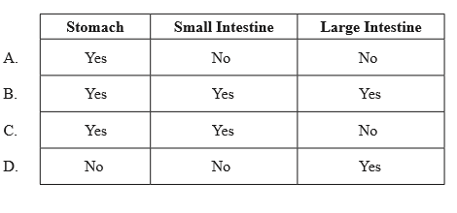

Markscheme
C
90. [1 mark]
What is the main function of the large intestine?
A. Absorption of waterB. Digestion of fats and proteinsC. Absorption of nutrientsD. Recycling of digestive enzymes

Markscheme
A

Printed for Highland High School
© International Baccalaureate Organization 2017
International Baccalaureate® - Baccalauréat International® - Bachillerato Internacional®

