A Little teeny tiny DNA Review Name ________________________________ B-1
20 Easy Points

1. What is the monomer (basic structural unit) for molecular DNA?

2. On the back of this paper please draw the molecular structure of DNA using at least 6 nitrogen bases.

3. Molecular DNA is condensed to form these string-like structures, referred to as?

4. The answer to #3 condenses to form what structures? _____________________.

5. The answer to #4 is divided into sections that are called ____________________.

6. The initials D.N.A. stand for _________________________________________.

7. Explain the function of the answer to #5. ______________________________________
________________________________________________________________________.

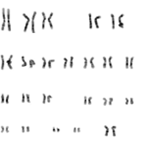
8. Where did you get your DNA?

9. What are the sex chromosomes?

10. Circle the sex chromosomes and tell if this organism is male or female.

11. Lets do some definitions;
A. Chromatid

B. Chromosome

C. Centromere

D. Kinetichore

E. Homologous Chromosome

F. Diploid

G. Haploid

H. Karyotype

12. Why does DNA need to be copied before cell division occurs?

13. Make up your own DNA type of question here, make it a good one!

