Option A
1a. [4 marks]
Draw a labelled diagram of a reflex arc for a pain withdrawal reflex.

Markscheme
Award [1] for any one of the following clearly drawn and correctly labelled.
a. spinal cord – showing white and grey matter;
b. spinal nerves – showing dorsal and ventral roots;
c. sensory neuron / receptor;
d. motor neuron / effector;
e. relay neuron;
f. arrows showing path from stimulus/receptor to response/effector;
1b. [3 marks]
Distinguish between innate behaviour and learned behaviour.

Markscheme
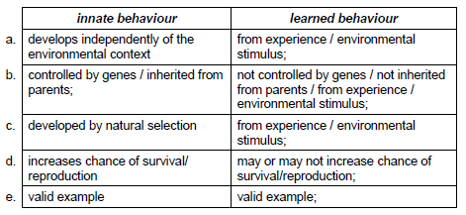
2a. [1 mark]
Identify the type of retinal cells that function best in dim light.

Markscheme
rods
2b. [1 mark]
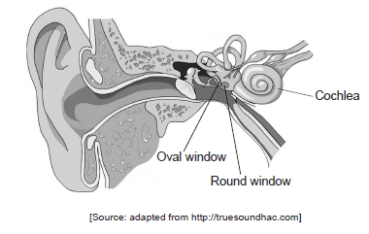
The image shows the human ear.
Outline the role of the round window in the perception of sound.

Markscheme
a. allows fluid in the cochlea to move;
b. as oval window moves in, round window moves out / vice versa;
3a. [1 mark]
State the type of stimulus provided by the sight and smell of the food.

Markscheme
unconditioned (stimulus)
3b. [1 mark]
State the function of the tube.

Markscheme
to collect the saliva (for measurement of volume)
3c. [1 mark]
State two effects presynaptic neurons could have on postsynaptic transmission.

Markscheme
excitation and inhibition
4a. [1 mark]
Identify the trial for each flower type that shows the greatest variation.
Paper: Plastic:

Markscheme
Paper: (trial) 1Plastic: (trial) 5 Both required for [1].
4b. [2 marks]
Compare the data for plastic and paper flowers.

Markscheme
a. discovery time in paper flowers always shorter than plastic flowers;b. larger variation in data for plastic flowers;c. decreasing discovery time (over the eight trials) for the paper flowers only;d. no trend in discovery time for plastic flowers;e. from trial four discovery time for paper flowers remains fairly constant/slight variation whereas for plastic flowers discovery time increases;
4c. [2 marks]
Outline the evidence from the data that the ability to find nectar using mechanoreceptors is a learned behaviour.

Markscheme
a. mechanoreceptors are touch receptors;b. discovery time decreases over the eight trials for paper flowers;c. showing evidence of learning;d. plastic flowers discovery times show no evidence of learning;e. paper flowers have a rough surface so mechanoreceptors are more effective / plastic flowers smooth so do not stimulate mechanoreceptors;
4d. [2 marks]
Discuss how learning to find nectar using mechanoreceptors could lead to improved chances of survival and reproduction for the tobacco hornworm moth.

Markscheme
a. improved chances of finding food;b. advantage in dark/conditions when coloured/scented flowers not available;c. not completely dependent on light/chemoreceptors to find food;d. more likely to reproduce and pass gene (for mechanoreceptors) to offspring; advantage over other members of the species through learning;
5a. [1 mark]
List two examples of excitatory psychoactive drugs.

Markscheme
nicotine;cocaine;amphetamines;ecstasy; Award [1] for any two. Consider the first two only, if there are more.
5b. [2 marks]
Outline the possible effects of excitatory drugs on mood and behaviour.

Markscheme
a. increases arousal/alertness;b. feelings of excitement/euphoria;c. aggressive behaviour;d. loss of judgement/self-control;e. social withdrawal/depression/dysfunction;f. loss of appetite;
5c. [3 marks]
Discuss the causes of addiction to cocaine.

Markscheme
a. peer pressure / cultural traditions;b. inherited / genetic predisposition;c. social problems / trauma;d. passed from mother to newborn/when breast feeding;e. many stimulate synapses with dopamine as a transmitter / blocks re-uptake of dopamine;f. pleasurable effects of dopamine/euphoria/regular use may lead to addiction;g. increasingly large/more regular doses needed for effect;
6a. [4 marks]
Compare the effects of cocaine and THC.

Markscheme
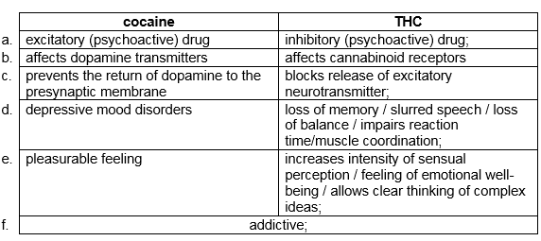
Answers do not need to be in a table format.
6b. [2 marks]
State one other example of an excitatory and an inhibitory psychoactive drug.
Excitatory drug: .....................................................
Inhibitory drug: .....................................................

Markscheme
a. excitatory drug: nicotine / amphetamines/ other drug;b. inhibitory drug: benzodiazepines / alcohol / other drug;
7a. [1 mark]
State the effect of morphine during pre-competition training for team C.

Markscheme
increases tolerance to pain (when given in weeks 2 and 3)
7b. [1 mark]
Identify which team showed the greatest tolerance to pain on competition day.

Markscheme
team C
7c. [2 marks]
Analyse the effect of the placebo as seen in the data.

Markscheme
a. placebo has no effect in team B where morphine was not administered previously;b. team B thought they were getting morphine but their performance was the same as team A;c. placebo has a greater effect if morphine has been administered previously as in team C;d. naloxone negates the (expected) effect of placebo (even if morphine administered previously) in team D;e. error bars overlap so results may not be statistically significant/no difference;
7d. [1 mark]
Suggest a reason for the reduced pain tolerance in team D during competition.

Markscheme
naloxone (an endorphin blocking drug) blocks the receptors for endorphins / stops endorphins from acting as pain killers
7e. [2 marks]
Analyse the data collected in the week following competition.

Markscheme
a. pain tolerance goes down in all groups / all have same level of pain tolerance;b. morphine-like effect/morphine effect is temporary;c. endorphins/naturally produced pain-killers levels/number of receptors for pain-killers decreases;d. decrease in pain tolerance is evidence for motivation/determination during competition and training / lack of motivation when no competition;
8a. [2 marks]
State one excitatory and one inhibitory psychoactive drug.
Excitatory: ............................................................
Inhibitory: ............................................................

Markscheme
a. excitatory: nicotine / cocaine / amphetamines / other drugs;b. inhibitory: benzodiazepines / alcohol / THC / other drugs;
8b. [2 marks]
Describe, using one specific example of an animal, how the process of learning can improve its chances of survival and reproduction.

Markscheme
a. named animal;b. description of learned action allowing a more flexible response that improves health/survival/reproduction;
eg:a. chimpanzees;b. poking sticks in the wood increases chances to get more food/termites/insects;
a. blue jays;b. avoidance of certain bad taste / poisonous insects prevents them from being sick/poisoned;
a. hedgehogs;b. running across roads instead of rolling up when vehicles approach more likely prevents them from being killed;Accept any other verifiable examples.
9a. [1 mark]
State the relationship between brain volume and hippocampal volume in the non-migratory sparrows.

Markscheme
as brain volume increases so does hippocampus volume / positive correlation
9b. [2 marks]
Compare the hippocampal volume in migratory and non-migratory young and adult sparrows.

Markscheme
hippocampus volumes are larger in adults than in young birds;
larger range for migratory;
young non-migratory show wider range of hippocampus volumes than young migratory;
some overlap for non-migratory / none for migratory;
9c. [1 mark]
Analyse the data in the scattergraph to find which of the four groups of birds has the highest relative hippocampal volume.

Markscheme
adult migratory (as for any brain volume this group has the largest hippocampal volume) } (allow mathematical explanation)
9d. [1 mark]
Suggest a reason why this group needs the largest relative hippocampal volume.

Markscheme
needed for migration / only adults migrate/remember flight paths
(Do not accept spatial navigation on its own without reference to migration)
9e. [2 marks]
It is possible that non-migratory species possess more advanced cognitive skills other than spatial memory. Use the data to evaluate this hypothesis.

Markscheme
Hypothesis supported:
non-migratory have larger brain volume;
larger brain implies more thinking skills;
hippocampus in non-migratory is approx same size as in migratory;
Hypothesis not supported:
only two species/small sample studied so over generalization;
similar hippocampus volume in both migratory and non-migratory birds;
10a. [3 marks]
Using the table below, distinguish between rod cells and cone cells.
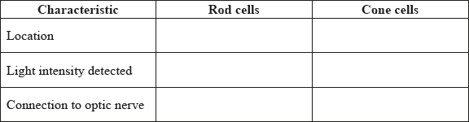

Markscheme
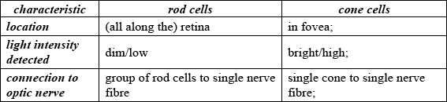
Award [1] for each correct row.
10b. [3 marks]
Outline how sound is perceived in the ear.

Markscheme
sound waves make eardrum/tympanic membrane vibrate;
vibration passes along the bones of middle ear/ossicles/malleus, incus and stapes making oval window vibrate;
vibration passed to fluid in cochlea;
vibration in cochlea stimulate hair cells/mechanoreceptors;
nerve impulse passed to auditory nerve;
11a. [1 mark]
Identify which stage of cocaine use shows the least percentage difference between identical twins and non-identical twins.

Markscheme
occasional
11b. [3 marks]
Compare the results for identical twins and non-identical twins.

Markscheme
both (identical and non-identical twins) show lower percentages going from occasional to abuse to dependence;
at every stage, the percentage is higher for identical twins;
non-identical twins percentage drops to zero for dependence (but identical twins does not);
difference is similar for both groups between abuse and dependence;
sharper decrease between occasional and abuse for non-identical twins than identical twins/OWTTE;
Do not accept answers stating numerical values only
11c. [3 marks]
Analyse the data to find whether it supports the hypothesis that genetic factors cause some people to have a much higher chance of cocaine dependence than others.

Markscheme
hypothesis supported as identical twins are more likely to behave the same for abuse and dependence than non-identical twins;
identical twins have the same genotype / OWTTE;
hypothesis not supported as environment is the major factor for trying cocaine;
not known if similar results may be due to similar environment;
not enough data for valid statistical analysis/OWTTE;
12a. [1 mark]
State the difference in neuron activity between nights 2 and 7.

Markscheme
0.8 (Accept answers from 0.75 to 0.85.)
12b. [2 marks]
Outline the effect of exposure to birdsong on neuron activity.

Markscheme
a. increases neuron activity;b. increase over three days/increase of about 75 %/of 50–100 %;c. then plateaus/levels off;d. large variation on days 14 and 15;
12c. [1 mark]
Suggest one reason for the large error bars on days 14 and 15.

Markscheme
a. small sample so one measure can skew the average / higher average value due to only one measurement;b. different birds respond differently/nothing being learned;c. change in behaviour due to biotic/abiotic changes;
12d. [2 marks]
Evaluate the hypothesis that listening to other zebra finches is important to develop singing ability amongst juveniles.

Markscheme
a. hypothesis seems to be verified since all points after exposure to birdsong are higher;b. learning phase (supported by changes on days 5–7);c. experiment shows only one brain area activity / other factors may also be involved;
13a. [2 marks]
Label the following diagram of the eye.
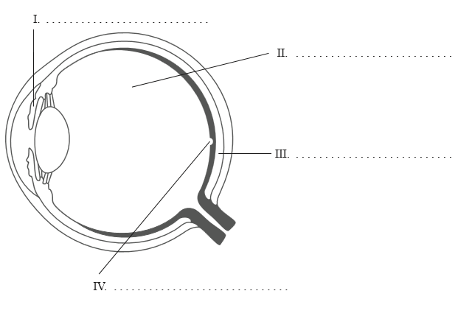

Markscheme
I irisII vitreous humourIII choroidIV fovea (do not accept yellow spot) Award [1] for every two correct answers.
13b. [2 marks]
Outline the diversity of stimuli that can be detected by human chemoreceptors.

Markscheme
a. (dissolved) chemicals detected by taste buds (in the tongue and mouth);b. (airborne) chemicals detected by (olfactory) receptors;c. chemicals/ions/pH in blood (for example CO/glucose) detected by chemoreceptors (in carotid artery/medulla oblongata);d. neuroreceptors detect neurotransmitters;
14. [3 marks]
The diagram below shows a synapse where the neurotransmitter is dopamine and some of the processes that take place during nerve transmission.
Explain the effect of cocaine on neurotransmission at a synapse.
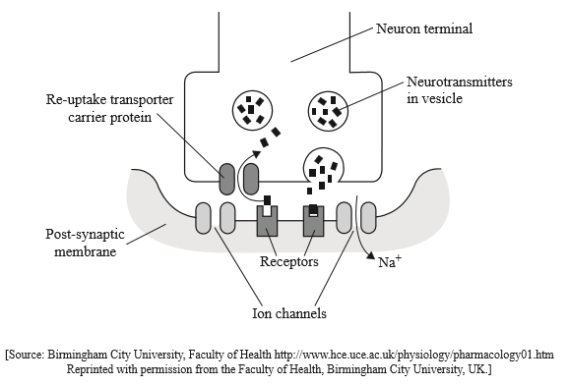

Markscheme
a. dopamine initiates depolarization of post-synaptic membrane;b. cocaine binds to (transporter) carrier proteins/proteins in pre-synaptic membrane;c. cocaine blocks reabsorption (of dopamine);d. cocaine causes dopamine build up in synaptic cleft/space;e. so stimulus continues/cocaine is excitatory;
15a. [1 mark]
Label structures I and II
I. .............................................................
II. .............................................................

Markscheme
I: pinna;II: ear drum / tympanic membrane; (both needed)
15b. [1 mark]
Outline how sounds are perceived in the cochlea, including the name of the cell type involved.

Markscheme
cilia/hair/hair bundles of hair cells vibrate with (cochlear) liquid/fluid movement
15c. [2 marks]
Identify a function of the parts of the brain by using numerals II to V to complete the chart. Hypothalamus has been completed for you.
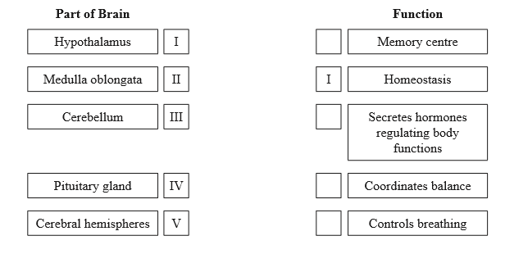

Markscheme
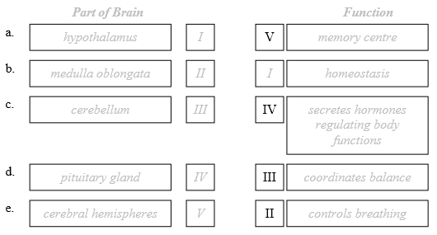
Award [1] for any two correct responses.
15d. [2 marks]
Discuss how the pupil reflex can be used as a test for brain death.

Markscheme
a. pupil reflex is controlled by autonomic nervous system/brain/midbrain; (do not accept medulla)b. light shone into the eye would normally cause pupil contraction;c. no pupil reflex indicates that synapses are not functioning;d. can indicate brain death but not necessarily / OWTTE;
16a. [3 marks]
Explain how sound is perceived by the ear.

Markscheme
sound (waves) vibrate eardrum/tympanic membrane;movement is magnified by ossicles/middle ear bones;oval window vibrates / fluid in cochlea moves and moves hairs in cochlea;different frequencies detected by different parts of cochlea membrane and hair cells;these are connected to the auditory nerve;
16b. [1 mark]
Hearing is a result of the stimulation of mechanoreceptors. List three other main types of receptors.
1. ..................................................................
2. ..................................................................
3. ..................................................................

Markscheme
chemoreceptors / photoreceptors / thermoreceptors / baroreceptors Award [1] for three correct receptors.
17a. [1 mark]
Distinguish between innate behaviour and learned behaviour.

Markscheme
innate behaviour develops independently of the environmental context, whereaslearned behaviour develops as a result of experienceTo award [1], answers need to address both innate and learned behaviour.Do not accept “instinct” as a description of innate behaviour.
17b. [2 marks]
Outline Pavlov’s experiments into conditioning of dogs.

Markscheme
conditioned stimulus of sound/ringing bell / other stimulus used by Pavlov;replaces unconditioned stimulus of sight/smell of food;both result in conditioned response/production of saliva;
18a. [1 mark]
Define the term reflex.

Markscheme
rapid and unconscious/automatic response (to a stimulus)
18b. [3 marks]
Draw a labelled diagram of a reflex arc for a pain withdrawal reflex.

Markscheme
Example of diagram.
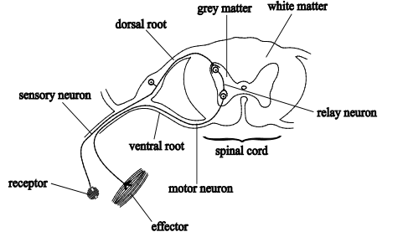
sensory neuron shown connecting site of stimulus/receptor to relay neuron; relay neuron shown in grey matter, connecting sensory neuron to motor neuron; motor neuron shown connecting relay neuron to effector/muscle / cell body of motor neuron shown in grey matter; cell body of sensory neuron shown outside spinal cord/in dorsal root; spinal cord shown with grey and white matter;
18c. [2 marks]
Outline Pavlov’s experiments into conditioning in dogs.

Markscheme
unconditioned stimulus is smell/sight of food and unconditioned response is salivation;conditioned stimulus is sound of a bell and conditioned response is salivation at sound of bell;bell/other stimulus is repeatedly applied just before food;after several repeats the response can be seen without the food/when only the bell is rung/other stimulus;
19. [3 marks]
Explain the effects of psychoactive drugs on synaptic transmission.

Markscheme
psychoactive drugs may increase or decrease transmission (to the post-synaptic membrane);may increase the release/delay the breakdown/interfere with storage/uptake/reabsorption of neurotransmitters;may mimic the action of neurotransmitters;inhibitory drugs may reduce the effect of excitatory neurotransmitters / increase the effect/release of inhibitory neurotransmitters;inhibitory drugs can hyperpolarize the post-synaptic neuron;
20a. [1 mark]
Define the term stimulus.

Markscheme
stimulus is a change in the (internal/external) environment that can be detected
20b. [1 mark]
Outline the functions of the following parts of the brain.
Medulla oblongata:

Markscheme
medulla oblongata: controls autonomic functions of the body such as heart rate/blood pressure/ventilation/swallowing/vomiting/digestion/cranial reflexes
20c. [1 mark]
Outline the functions of the following parts of the brain.
Hypothalamus:

Markscheme
hypothalamus: links nervous and endocrine systems/produces hormones secreted by posterior pituitary/controls hormonal secretion by pituitary/maintains homeostasis such as control of body temperature/hunger/thirst/fatigue/circadian cycles
20d. [3 marks]
Explain the effects of psychoactive drugs on synaptic transmission.

Markscheme
psychoactive drugs may increase or decrease transmission (to the post-synaptic membrane);may increase the release/delay the breakdown/interfere with storage/uptake/reabsorption of neurotransmitters;may mimic the action of neurotransmitters;inhibitory drugs may reduce the effect of excitatory neurotransmitters/increase the effect/release of inhibitory neurotransmitters;inhibitory drugs can hyperpolarize the post-synaptic neuron;
20e. [2 marks]
Outline how endorphins act as painkillers.

Markscheme
endorphins released by pituitary gland (during stress, injury or exercise);endorphins block transmission of impulses at synapses involved in pain perception;bind to receptors in the membrane neurons (involved in) sending pain signal;block release of neurotransmitters;
21a. [2 marks]
Identify the parts of the brain indicated on the diagram below.
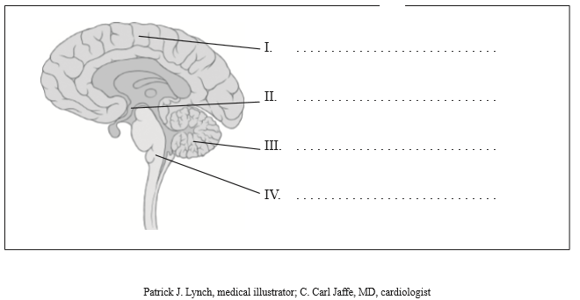

Markscheme
I. cerebral hemisphere / cerebrum;II. hypothalamus;III. cerebellum;IV. medulla oblongata; Award [1] for any two of the above.
21b. [3 marks]
Outline the unconscious control of the heart rate.

Markscheme
heart can contract without nervous stimulation/myogenic contractions;SA node is pacemaker/generates heart beat/initiates each cardiac cycle;epinephrine/adrenalin speeds up the heart rate;autonomic/sympathetic and parasympathetic nervous system control;sympathetic speeds up heart rate;parasympathetic/vagus nerve slows heart rate (back to normal/resting rate);
21c. [3 marks]
Describe different aspects of the processing of visual stimuli.

Markscheme
edge enhancement is greater perception at edges of light/dark areas;caused by processing in two types of ganglion cell in retina;
contralateral is processing left field of view in right side of brain / vice versa;cross over between left and right sides in the optic chiasma;
convergence is combining impulses from groups of (rod/cone) cells;done by bipolar cells in retina;
22. [6 marks]
Discuss the causes of addiction, including genetic predisposition, social factors and dopamine secretion.

Markscheme
social and genetic: [3 max]
genetic:
a. genetic link found for (cocaine) addiction;
b. difficult to prove / multifactorial;
social:
c. alcohol/other drug problems among family members;
d. poor school performance;
e. poverty / family conflicts / chaos / stress;
f. having friends who drink/use other drugs;
g. not fitting in socially / being excluded because of race/ability/ethnicity/gender/age/sexual orientation / other factors;
dopamine and addiction: [3 max]
h. substances with addictive potential stimulate the release of dopamine;
i. dopamine is a chemical in the brain that is associated with reward and pleasure;
j. substance use brings a flood of dopamine, which alters the chemistry of the brain;
23a. [1 mark]
List two dietary sources of vitamin D.

Markscheme
e.g. cod liver oil / fish liver oil / oily fish (accept correctly named example) / egg yolk / fortified cereal / ONE named dairy product (i.e. milk/cheese/ yoghurt)Allow any two sources for the mark. Reject fish alone.
23b. [1 mark]
State an example of these receptors in humans.

Markscheme
hair cells of cochlea
23c. [3 marks]
Discuss exposure to sunlight as a source of vitamin D.

Markscheme
UV light/sunlight on skin causes chemical production of vitamin D;UV too low in winter in high latitudes;vitamin D stored in liver so can make enough to last several months/through winter;UV light can damage skin and cause skin cancer so exposure needs to be limited;use of sun-block will inhibit vitamin D production;covering skin with clothing prevents UV reaching skin; Accept reference to cultural/religious customs
24a. [3 marks]
Distinguish, using examples, between innate behaviour and learned behaviour.

Markscheme
learned behaviour occurs as a result of experience (while innate is independent of environment);innate behaviour is controlled by genes/inherited (while learned is not inherited);correct example of both;
24b. [2 marks]
Using two examples, discuss how the process of learning can improve survival.

Markscheme
name of animal, how they learn and advantages for survival;name of another animal, how they learn and advantages for survival; e.g. grizzly bears by operant conditioning/practise how to catch salmon providing needed food supply;goslings learn who their mother is/imprinting, avoid predators by staying near mother;
25a. [2 marks]
The diagram below represents the human eye. State the names of structures I, II, III and IV.
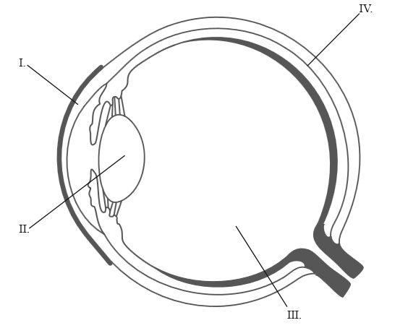
I. ..................................................................
II. ..................................................................
III. ..................................................................
IV. ..................................................................

Markscheme
I. cornea;II. lens;III. vitreous humour;IV. choroid; (Accept sclera as line is on the border between these two)Two correct for [1] and four correct for [2].
25b. [2 marks]
Outline the evidence provided by DNA for the common ancestry of living organisms.

Markscheme
all living organisms use DNA as genetic/hereditary material;genetic code is (almost) universal;idea that mutations accumulate gradually in DNA;
25c. [2 marks]
The cladogram below shows the classification of species A to D. Deduce how similar species A is to species B, C and D.
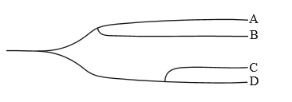

Markscheme
A is most similar to B;A is equally similar to C and D;A is least similar to both C and D;
25d. [2 marks]
Suggest two reasons for using cladograms for the classification of organisms.

Markscheme
methods used to prepare cladograms use a different approach from traditional classification/taxonomy;show ancestral relationships;reflect how recently two groups shared a common ancestry;cladograms are (objective/accurate because they are usually) based on molecular differences;they should be considered as a good complement to traditional classification;
26. [6 marks]
Discuss the concept of brain death and the use of the pupil reflex in testing for brain death.

Markscheme
whole brain death is brain stem and cerebrum;
failure of pupil to respond to light indicates brain stem death;
without brain stem function, life cannot continue;
cerebrum involves higher order brain function;
non-functioning cerebrum with functioning brain stem is vegetative state;
some would argue this is the death of the person;
though brain stem function alone may be able to maintain homeostasis;
27a. [4 marks]
Outline the use of two named ex situ conservation measures.

Markscheme
name;use;
example 1:name: zoos;captive breeding of animals / permits assisted reproductive methods / use of modern technology;example 2:name: botanic gardens;allows for protected growth of plants / protected from extreme climatic conditions / provision of all necessary conditions;Award [1] for name and [1] for its use.Accept other suitable examples.
27b. [4 marks]
Outline two factors that affect the incidence of coronary heart disease.

Markscheme
Award [1] for a factor and [1] for its effect.
Accept any two of the following factors with its associated effect:e.g.: genetic predisposition / age / being male / obesity / eating too much saturated fat and cholesterol / lack of exercise / smoking / diabetes (melitus) / hypertension / stress.Accept converse statements of factors decreasing risk.
e.g. factor: genetic predisposition; effect: some synthesise more cholesterol/LDL than others;e.g. factor: being male; effect: women before menopause appear to be protected by higher blood estrogen levels which men do not have;e.g. factor: obesity; effect: excess weight raises blood pressure/blood cholesterol/triglyceride levels / lowers HDL/good cholesterol levels;
27c. [5 marks]
Discuss how brain lesions and fMRI (functional magnetic resonance imaging) scanning can be used in the identification of the brain part involved in specific functions of animals.

Markscheme
lesions (from accidents/birth) indicate effect of loss of area;e.g. split brain patients/severed corpus callosum led to understanding different functional roles of left and right hemispheres / other valid examples;many actions of the body involve different areas of the brain;damage may be to several/many parts so results unclear;difficult to interpret due to complexity of reactions;fMRI gives a more specific knowledge of stimulated area/activation;e.g. used to study/diagnose ADHD/dyslexia/recovery from strokes/music comprehension / other valid examples;non-invasive / no damage to brain;can study healthy subjects;involves blood flow/supply/oxygenation;not neuronal connections (so requires interpretation);good spatial but poor temporal resolution;problem of statistical interpretations of model; Award [4 max] if either brain lesions or fMRI alone are discussed.
27d. [5 marks]
Explain the liver damage caused by excessive alcohol consumption.

Markscheme
can cause inflammation/fatty liver/cirrhosis of the liver from alcohol abuse;usually from prolonged/excessive drinking / OWTTE;products of alcohol metabolism toxic to cells / alcohol consumption reduces antioxidant activity;replacement of healthy liver cells with fibrous/scar tissue;blocks blood flow through liver / loss of functional liver cells / blocks normal metabolic carbohydrates/fats/proteins;decreased ability to remove toxins (through bile)/bacteria / production of bile and blood proteins;nutritional deprivation / susceptible to infection/hepatic viruses;
28. [6 marks]
Explain how the structures of the human ear allow for sound perception.

Markscheme
eardrum/tympanic membrane vibrates with sound (waves);movements of eardrum/tympanic membrane amplified by bones of middle ear/stapes;bones are malleus/hammer, incus/anvil, stapes/stirrup;movement transmitted to oval window;creates pressure waves in the liquid within cochlea;waves travel up to/dissipate at round window;hairs in cochlea vibrate according to movement (of liquid/waves);different frequencies detected by different hair cells (on different parts of membrane);movement of hairs cause action potential/depolarization/hyperpolarization of hair cells;cause nerve impulses to be transmitted through auditory nerve;
29. [6 marks]
Discuss the evolution of altruistic behaviour using one non-human example.

Markscheme
organism expends time/energy in caring for other (unrelated) members of the same species;put themselves at risk or disadvantage for the good of other members of the species / actions that increase another individual’s number of offspring at cost to one’s own reproduction;
valid example; (e.g. primates / vampire bats / male turkeys or other birds such as Florida jays / mole rats)Do not accept parental care.
description of altruistic behaviour of the example given;might expect natural selection to be against behaviour that reduces chances of survival and reproduction;close kin share alleles;(adaptive significance is to) increase frequency of alleles shared in common;(provides genetic advantages in kin by) promoting survival and reproduction within species;altruistic behaviour towards non-relatives may allow selection of alleles responsible for the behaviour to be perpetuated;some argue no true altruism as organism benefits either directly or indirectly in the future; Award [5 max] if no valid non-human example given.
30. [2 marks]
Explain the effects of cocaine in terms of action at synapses in the brain.

Markscheme
cocaine affects synapses using dopamine as neurotransmitter;cocaine attaches to dopamine receptors on presynaptic membrane;blocks dopamine transporters/prevents re-uptake / causes dopamine to persist in the synaptic cleft;amplifies synaptic transmission / is an excitatory psychoactive drug / causes constant stimulation of postsynaptic neuron;dopamine builds up in the synapse contributing to euphoria/pleasurable effects;
31. [6 marks]
Discuss the concept of brain death and how it can be diagnosed.

Markscheme
it is a legal/medical definition of death;some cases of coma are irreversible / some cases of coma may recover;damage in the medulla (oblongata) is generally permanent;doctors have to diagnose damage to decide treatment;use tests of brain stem function to decide whether to preserve patient’s life / without brain stem function life cannot continue;test pupil reflex / shine light into eye;if pupils do not constrict with light this suggests brain death;more than one test used to diagnose brain death;no response to pain or cranial reflexes;legal/ethical definition needed for organ donation / long term use of life-support machines may be inappropriate / bioethical considerations;

Printed for Highland High School
© International Baccalaureate Organization 2017
International Baccalaureate® - Baccalauréat International® - Bachillerato Internacional®

