Option D
1a. [1 mark]
State which country has the lowest total percentage of overweight and obese adults.

Markscheme
Indonesia
1b. [2 marks]
Distinguish between the levels of male obesity and female obesity.

Markscheme
a. higher percentage of obese females (compared to males);
b. greatest difference is in Morocco/Brazil;
c. least difference (between obese males and females) is in China/UK;
Accept numerical distinctions.
1c. [2 marks]
Compare the overweight and obesity patterns in Australia and Morocco.

Markscheme
a. higher total percentage of overweight/obese in Australia (compared to Morocco);
b. Australia has more overweight/obese males than females and Morocco has more overweight/obese females than males / vice versa;
c. less difference between male and female obesity in Australia than Morocco / vice versa;
d. more overweight than obese in both Australia and Morocco;
1d. [2 marks]
Suggest two possible reasons for the differences in BMI from the reported countries.

Markscheme
a. different availability/poverty/costs of inexpensive high-energy/high fat/high sugar foods;
b. portion sizes / availability of away-from-home food/fast food;
c. different levels of activity / sedentary lifestyle;
d. cultural differences;
e. nutritional education;
f. genetic/inherited differences;
2. [1 mark]
List two natural food sources of vitamin D in human diets.

Markscheme
Award [1] for any two natural food sources.
fatty fish / salmon/tuna/mackerel/sardines/fish oils;
egg / egg yolks;
liver;
mushrooms;
cheese/milk/butter/yogurt/other dairy product;
Do not accept supplemented foods or "fish" alone.
3a. [1 mark]
State the risk of a man developing CHD between the ages of 55–59 if his brother had CHD.

Markscheme
35 %
3b. [1 mark]
Calculate the increase in risk over the control group for a woman of 60–64 of developing CHD if her sister had the disease.

Markscheme
15 %
3c. [3 marks]
Compare the results for the men and the women.

Markscheme
a. both show an increase in the risk of CHD as age increases;
b. men/women with (either) siblings with CHD show an increased risk (relative to their control);
c. men have greater risk than women of developing CHD (at all ages);
d. both men and women/women only are more likely to develop CHD if their sister has the disease;
e. men with a brother with CHD have a greater risk than women with a brother with CHD;
Accept any other valid comparison using the graph.
3d. [2 marks]
Suggest two reasons why a man is more likely to develop CHD if his brother had the disease.

Markscheme
a. hereditary/genetic predisposition;
b. similar (unhealthy) lifestyles/diets;
4a. [1 mark]
Water and minerals are essential in the human diet. List two other types of nutrient in a human diet.
1: . . . . . . . . . . . . . . . . . . . . . . . . . . . . . . . . . . . . . . . . . . . . . . . . . . . . . . . . . . . . . . . . . . .2: . . . . . . . . . . . . . . . . . . . . . . . . . . . . . . . . . . . . . . . . . . . . . . . . . . . . . . . . . . . . . . . . . . .

Markscheme
(essential) amino acids;(essential) fatty acids / oils / lipids / fats;vitamins;carbohydrates;
4b. [2 marks]
Outline the benefits of using iodine as a dietary supplement.

Markscheme
a. iodine is a mineral that is often scarce in local diets/water supplies;b.required for normal thyroid function/synthesise thyroxine;c.prevents goitre/avoid iodine deficiency/avoid absorbing iodine–131/radioactiveiodine;d.prevents brain damage;[
5a. [1 mark]
Identify the substance that varies the most in the plasma of the mothers.

Markscheme
urea
5b. [1 mark]
Calculate the difference between birth mass of offspring whose mothers were fed the AP diet and the HP diet.
. . . . . . . . . . . . . . . . . . . . . kg

Markscheme
0.20 (kg) (less weight in HP)
5c. [1 mark]
Distinguish between LDL cholesterol and HDL cholesterol in relation to the diet.

Markscheme
LDL cholesterol increases and HDL cholesterol decreases as (proportion of) protein increases/carbohydrate decreases / OWTTE.
5d. [2 marks]
Explain the low birth mass of offspring born to mothers who were fed the LP diet.

Markscheme
a. lack of essential amino acids to form protein;b. not enough protein for growth;c. not enough amino acids/protein to form muscle/tissues;d. low protein may affect production of enzymes;
5e. [3 marks]
In many societies doctors may recommend an HP diet for pregnant humans. Using the data, evaluate this recommendation.

Markscheme
(the data does not support the recommendation):a. as HP has the highest level of plasma urea which could be toxic;b. HP has a high level of LDL/bad cholesterol and a low level of HDL/good cholesterol which could lead to coronary heart disease;(accept high ratio of LDL: HDL)c. HP produces a high level of glucose (compared to AP) which could lead to diabetes;d. HP produces a low birth weight (compared to AP) which may affect development / OWTTE;
(the data does support the recommendation):e. the mother has a similar weight gain to AP thus avoiding health problems;
6a. [2 marks]
State two symptoms of type II diabetes.

Markscheme
a. glucose in urine;b. high blood glucose;c. frequent urination / dehydration/excess thirst;d. constant hunger;e. weight loss;f. tiredness;
6b. [4 marks]
Explain the causes and consequences of phenylketonuria (PKU).

Markscheme
a. (point) mutation of gene;b. defective enzyme/phenylalanine hydroxylase (PAH);c. phenylalanine/Phe not broken down to tyrosine/Tyr;d. phenylalanine/Phe accumulates;e. (if not treated) symptoms mental retardation/seizures;f. diet free of phenylalanine/Phe to avoid symptoms;
7. [2 marks]
The electron micrograph shows the epithelial cells of the villus.
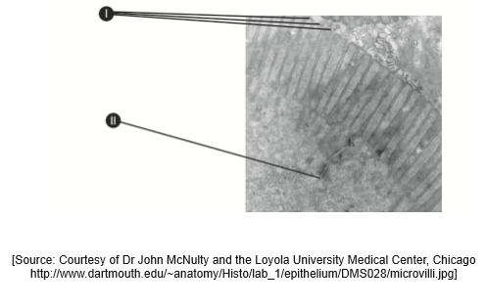
Identify the parts labelled I and II.
I: . . . . . . . . . . . . . . . . . . . . . . . . . . . . . . . . . . . . . . . . . . . . . . . . . . . . . . . . . . . . . . . . II: . . . . . . . . . . . . . . . . . . . . . . . . . . . . . . . . . . . . . . . . . . . . . . . . . . . . . . . . . . . . . . . .

Markscheme
a. I: microvilli;b. II: tight junction / plasma membrane;
8a. [1 mark]
List two consequences of anorexia nervosa.
1.
2.

Markscheme
Award [1] for any two consequences.
weight loss;
anemia;
depression/anxiety disorders;
abdominal distension;
hair loss/thinning;
flaky skin;
cessation of menstrual cycle / other hormonal imbalance;
death;
8b. [3 marks]
Explain the causes, consequences and treatment of phenylketonuria (PKU).

Markscheme
causes: genetic/inherited (homozygous recessive) disorder / mutation in (gene for) enzyme that converts phenylalanine into tyrosine / lack of phenylalanine hydrolase/PAH;
consequences: phenylalanine converted to phenylketone / mental retardation / brain damage / seizures;
treatment: low-phenylalanine diet / example of substances that cannot be eaten;
(eg any food containing protein / aspartame)
9a. [3 marks]
Outline the molecular structure of different types of fatty acids.

Markscheme
fatty acids share a common structure but differ in the total number of carbon atoms in the chain;
saturated fatty acids have no double bonds between carbon atoms;
unsaturated have double bond(s);
monounsaturated have one double bond / polyunsaturated have more than one double bond;
cis fatty acids have adjacent hydrogen atoms on same side of double bond and trans have them on opposite side;
(accept annotated diagrams)
9b. [3 marks]
Evaluate the benefit of reducing cholesterol in the diet.

Markscheme
cholesterol is a steroid found mainly in animal products;
it builds up in the walls of arteries / causes clogging/narrowing/blockage of artery / atherosclerosis;
lowering its ingestion may lower the probability/ risk of coronary heart disease/CHD;
cholesterol can be synthesized by the liver;
factors other than diet can affect levels of cholesterol / genetic factor more important than diet;
10a. [2 marks]
State the concentration of cholesterol in liver tissue and the mass of bile salts in feces for the normal diet, giving the units.
Concentration of cholesterol:
Mass of bile salts:

Markscheme
concentration of cholesterol: 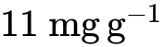;
(accept answer in the range of 10.5 mgg to 11.5 mgg)
mass of bile salts: 12 mgday;
(accept answers in the range of 11.5 mgday to 12.5 mgday)
Units are required.
10b. [1 mark]
Calculate the percentage increase in the concentration of cholesterol in liver tissue, caused by feeding the rats a high cholesterol diet without supplementing with bacteria. Show your workings.

Markscheme
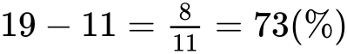 (accept answers in the range of 72.7(%) to 81.0(%))
10c. [2 marks]
Deduce the effects of supplementing the diet with Lactobacillus on the concentration of cholesterol in liver tissue and on the mass of bile salts in feces.

Markscheme
supplementation decreases liver cholesterol in high cholesterol diet;
not enough to bring it to the level of a normal diet;
no difference between L. plantarum and L. fermentum in the decrease of liver cholesterol;
supplementation increases bile salts levels;
greater increase in bile salts levels with L. plantarum / lesser/(perhaps) non-significant increase with L. fermentum;
10d. [3 marks]
Scientists hypothesized that Lactobacillus could be used in diets to reduce the incidence of coronary heart disease (CHD). Evaluate the evidence for and against this hypothesis provided by the data.

Markscheme
Evidence for hypothesis:
Lactobacillus/supplements lower liver cholesterol (in high cholesterol diet) which is a risk factor for CHD;
Lactobacillus/supplements increase bile salts in feces which implies some cholesterol may be eliminated;
Evidence against hypothesis:
not known if cholesterol ends up in blood instead thus increasing risk for CHD;
no data about benefit for normal diet/actual decrease of incidence of CHD;
data/results based on rat experiments / may not apply to humans;
WTTE of taking into account difference in bile salt level between L. fermentum and L. plantarum;
11a. [1 mark]
This study also showed a significant reduction in insulin sensitivity when participants were given fructose-sweetened drinks, but not when they were given glucose-sweetened drinks.State the disease that could be caused by excessive consumption of fructose.

Markscheme
diabetes type II / late/adult-onset diabetesDo not award mark for type I diabetes.
11b. [2 marks]
Suggest how sugar uptake might be related to pancreatic cancer.

Markscheme
a. cancer is uncontrolled mitosis/cell division;b. sugar is an energy source/nutrient needed for mitosis/cell division;c. ribose is used to produce nucleic acids/DNA/RNA;d. production of nucleic acid is necessary for mitosis;
12a. [1 mark]
Outline the effect of vitamin C intake on changes in bone density in the spine.

Markscheme
a. high (vitamin C) causes a positive change (in BMD) whereas medium/low causes negative change;b. inversely proportional (for relative change);c. if vitamin C intake increases, BMD increases;
12b. [2 marks]
Compare the changes in bone density of the femoral neck with those of the spine.

Markscheme
a. positive change/reduced loss for femoral neck at all levels whereas only at high intake for spine;b. higher values for femoral neck for each intake category;c. inversely proportional for both;d. no overlap between range/standard deviation / clear distinction of protective effect between femoral neck and spine (for high/all intake categories);
12c. [2 marks]
Evaluate the evidence provided by the data that the intake of vitamin C supplements may reduce bone density loss in elderly people.

Markscheme
Implications:a. high intake results in positive value (for all locations);b. protective effect proportional to intake;
Limitations:c. proportion of vitamin C intake from supplements / influence of other factors not stated;d. only a few bone locations measured / sample size unknown / high medium and low not defined; At least one implication and one limitation required.
13a. [2 marks]
Outline the control mechanism for appetite in humans.

Markscheme
a. appetite control centre (in brain) makes person feel full/satiated/hungry;b. function is both nervous and hormonal;c. after eating (centre) responds to hormones/insulin from pancreas/hormones/PYY from small intestine/hormones from adipose tissue/leptin in response to fat storage;d. centre responds to hormone/ghrelin released from empty stomach;e. part of centre responds to levels of lipid/sugar in the blood;
13b. [3 marks]
Explain the possible health consequences of a diet rich in protein.

Markscheme
a. high amount of one nutrient may cause deficiency in another one;b. excess protein not stored as protein by the body / converted to fat;c. results in weight/mass loss in many people (due to fat/carbohydrate deficiency);d. health problems such as kidney stones/other health problems;e. high protein as part of a weight/mass loss diet;
14. [2 marks]
Evaluate the health consequences of a diet rich in polyunsaturated fatty acids.

Markscheme
a. polyunsaturated fatty acids are preferable to saturated fatty acids;b. decreases risk of cardiovascular disease;c. provide (concentrated) energy / can lead to obesity;
15a. [1 mark]
Outline how bile helps in lipid digestion.

Markscheme
bile emulsifies/OWTTE lipids so enzymes can act on them
15b. [3 marks]
Describe how bile pigment is formed.

Markscheme
a. hemoglobin from the red blood cells is absorbed/phagocytosed in the liver/by Kuppfer cells;b. hemoglobin is broken down into heme and globin groups;c. iron is removed from the heme groups;d. (residue from) heme becomes bilirubin/bile pigment (in hepatocytes);
16. [3 marks]
Explain two pieces of dietary advice that might be given to someone suffering from type II diabetes.

Markscheme
(dietary recommendations needed) to reduce blood glucose levels as target/ body/muscle cells less sensitive to insulin / not enough insulin produced;reduce intake of (saturated) fats, to reduce weight;reduce the intake of sugar/simple carbohydrates, causes rapid increase in blood glucose concentration;eat more high fibre foods, satisfy appetite, but cannot be broken down;regular/many small meals, to avoid (rapid) rise in glucose after a big meal;eat complex carbohydrates/carbohydrates with a low glycemic index, digested and absorbed more slowly; To award the mark, answers require recommendation with a reason.
17a. [3 marks]
The table shows the death rate due to coronary heart disease (CHD) in two different countries.
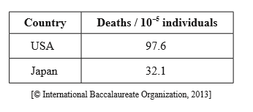
Using the table below, outline three named factors that could be responsible for the differences between the two populations.
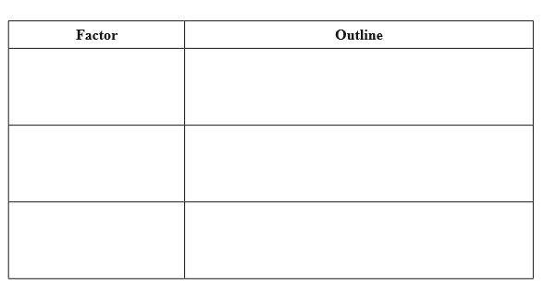

Markscheme
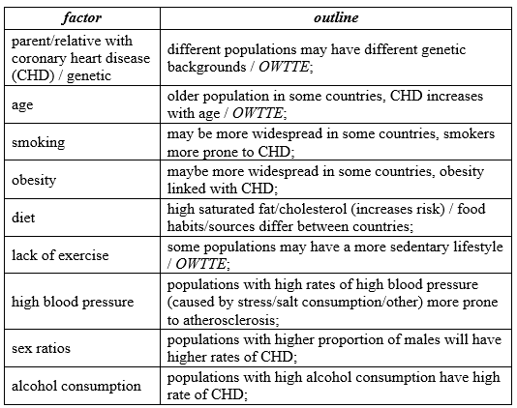
Award [1] for a factor and a corresponding outline.
17b. [2 marks]
State four glands secreting digestive juices into the alimentary canal.
1. ............................................................. 2. ............................................................. 3. ............................................................. 4. .............................................................

Markscheme
Award [1] for two correct glands.salivary glands;gastric glands;pancreas;wall of the small intestine;
18a. [3 marks]
Outline the importance of fibre as a component of a balanced diet.

Markscheme
fibre/cellulose cannot be digested;aids peristalsis/helps to prevent constipation/adds bulk;prevents obesity by increasing bulk in the stomach;reduces the risk of appendicitis/cancer/hemorrhoids;slows the rate of sugar absorption/helps prevent diabetes;
18b. [1 mark]
Distinguish between minerals and vitamins.

Markscheme
minerals are inorganic elements (simple compounds from elements in ionic form) and vitamins are organic compounds (which cannot be synthesised by the body);minerals are all water soluble but only some vitamins are water soluble (others are lipid soluble);some vitamins are destroyed by exposure to oxygen, minerals are not;
19a. [2 marks]
In healthy adults, there are heart sounds during the cardiac cycle. Outline the causes of two of these sounds.

Markscheme
changing pressure of blood in heart automatically opens and closes the valves / the closing of valves generates the heart sounds;first heart sound (S) is produced by the closing of the AV valves/mitral and tricuspid valves;second heart sound (S) produced by the closing of semilunar valves/aortic and pulmonary valves;
19b. [2 marks]
State two products resulting from the breakdown of erythrocytes (red blood cells) in the liver.
1. ..................................................................
2. ..................................................................

Markscheme
iron;bile pigments/bilirubin;globin/amino acids;
19c. [3 marks]
Compare gastric juice and pancreatic juice.
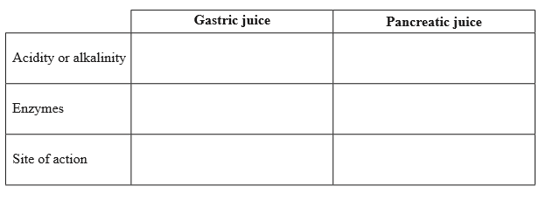

Markscheme
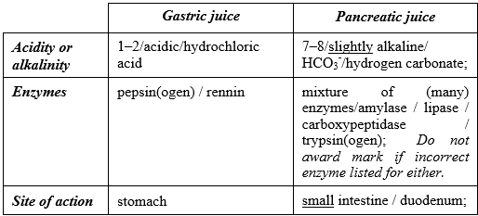
Award [1] for each correct row.
19d. [1 mark]
List one material that is egested after human digestion.

Markscheme
cellulose / lignin / bile pigments / intestinal cells / bacteria
20a. [1 mark]
Measure the difference between the percentage of overweight men and the percentage of overweight women at age 20.

Markscheme
10 (%) (allow responses in the range of 9 to 11 %)
20b. [1 mark]
State the range of the body mass index (BMI) that corresponds to overweight status.

Markscheme
25.0 −29.9 / above 25 and below 30 Do not accept 30 as this is classed as obese.
20c. [2 marks]
Compare the percentage of men and women who exercised daily.

Markscheme
more women exercise than men;both show an increase (between ages 16 to 25);similar trend lines over time / slightly greater increase in women;women have greater increases and decreases/greater variability while men gradually increase/stays level; Award any one of the above marking points if shown as a valid numerical comparison.
20d. [3 marks]
Evaluate the hypothesis that being overweight is due to lack of exercise.

Markscheme
(hypothesis is supported) as the greater percentage of men are overweight and they exercise less than women / vice versa;(hypothesis is supported) lowest percentages of overweight ages (18 and 20) correspond with peaks of exercise;(hypothesis is not supported) as even though both men and women exercise more over time the percentage overweight also increases;(hypothesis is not supported) other named factor which influences being overweight; (e.g. availability of cheap high energy foods / large portion sizes / increasing use of vehicles for transport / changes from active to sedentary occupations / genetics)
BMI does not consider muscle mass/bone structure/bone density;only narrow range of ages considered;
21a. [1 mark]
State which listed nutrient does not supply energy.

Markscheme
fibre
21b. [2 marks]
Deduce, with a reason, which listed nutrient provides the most energy per 25 g serving.

Markscheme
monounsaturated fat;fats contain more energy than carbohydrates or proteins;fats contain 4000 kJ per 100 g/9 kcal per 100 g;more monounsaturated fat present than other fats;
21c. [3 marks]
Outline the differences in molecular structure between the types of fat found in the peanuts.

Markscheme
saturated and unsaturated fats differ in number of single and double carboncarbon bonds/ratio of hydrogen to carbon atoms in fatty acid chains;saturated fat – carbon atoms all joined by single bonds / have no double bonds / have no increase in number of hydrogen atoms possible;monounsaturated fat – one double bond in carbon chain / could add two hydrogens in the carbon chain;polyunsaturated fat – two/more double bonds in the carbon chain;saturated fatty acid chains tend to be straight while mono/polyunsaturated have kinks/bends;
22. [3 marks]
Explain the benefits of supplementing common foods with vitamins and minerals.

Markscheme
supplies essential nutrients lacking in diet / nutrients added by manufacturers;benefits lower socio-economic groups as common foods are consumed by most people / reduces the need to purchase supplements;prevents nutritional deficiencies/deficiency diseases;named example of mineral/vitamin supplementation; (e.g. iodine in salt)
23a. [3 marks]
Outline factors that can lead to an individual becoming obese.

Markscheme
diet rich in carbohydrate/fat;too much food intake / unbalanced diet / food cheap and readily available;sedentary lifestyle / lack of training/exercise;genetic disposition/disorder;malfunction of hunger centre;
23b. [3 marks]
Amino acid polarity is an important factor in determining the functions of proteins. Explain the importance of polar and non-polar amino acids in membrane proteins.

Markscheme
polar amino acids are soluble/have stable interactions in water/extracellular fluid/cytoplasm;non-polar amino acids are soluble/have stable interactions in the lipid bilayer;polar amino acids strongly hydrophilic and non-polar amino acids are repelled by water/are hydrophobic;(help to) retain protein in position in the membrane;polar amino acids form hydrophilic channels/protein pores in membranes;transmembrane proteins have polar amino acids on either side of the membrane;
24. [2 marks]
Outline consequences of protein deficiency malnutrition.

Markscheme
lack of blood plasma proteins and tissue fluid retention/abdominal bloating/ swollen abdomen;kwashiorkor/marasmus develops;poor growth and development (among children);(often) mental retardation;lethargic/little interest in surroundings;wasting of muscle / thin muscles;
25a. [2 marks]
Outline how coronary thrombosis can be caused.

Markscheme
atheroma/fatty deposits in arteries;hardening of arteries/atherosclerosis/arteriosclerosis;rough surface causes rupture of platelets;clots form in coronary artery;
25b. [1 mark]
State the possible cause of the curve shifting from A to B.

Markscheme
increase in CO concentration;decrease in pH;
25c. [2 marks]
On the graph, draw the curve for myoglobin.

Markscheme
graph drawn to left of A; curve not sigmoid; As shown below.
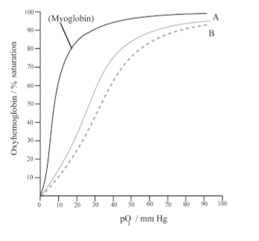
25d. [2 marks]
Describe the breakdown of hemoglobin in the liver.

Markscheme
hemoglobin absorbed by phagocytes/Kupffer cells;split into heme and globins;globin hydrolysed/broken down to amino acids;iron removed from heme group / heme broken down to form bilirubin/bile pigment;
26a. [1 mark]
State the change in blood calcium levels in normal mice 10 minutes after the administration of calcium, with and without the addition of vitamin D.
With vitamin D:
Without vitamin D:

Markscheme
with vitamin D: (from 0.0 to) 1.7 μmol (units required – allow answers in the range of 1.65 to 1.75 μmol)
without vitamin D: (from 0.0 to) 1.1 μmol (units required – allow answers in the range of 1.05 to 1.15 μmol)
Both needed to award the mark.
26b. [2 marks]
Compare the changes in blood calcium levels in normal mice and in mutant mice after the administration of calcium.

Markscheme
a. both increase with time;
b. normal mice have a greater increase in blood calcium levels than mutant mice (after ten minutes);
c. normal mice have a maximum change of 1.1 μmol while mutant mice have a maximum change of 0.6 μmol;
d. mutant mice show gradual increase while normal mice show rapid increase followed by a plateau;
26c. [2 marks]
Explain, using graph B, the changes in blood calcium levels for the mice with different diets.

Markscheme
a. mice with low calcium diets have a greater increase in blood calcium levels (after calcium administration) because their body absorbs more calcium;
b. if they have had a high calcium diet they do not need to absorb so much calcium / vice versa;
c. probably receptors are all occupied/inhibited / less receptors;
26d. [2 marks]
Discuss whether the scientists were able to support their hypothesis that rickets caused by the defective vitamin D receptor can be prevented by the intake of large amounts of calcium.

Markscheme
a. hypothesis supported as blood calcium levels increased in mutant mice after intake of calcium (graph A);
b. but less than in normal mice / perhaps not enough to cure disease/rickets;
c. administering vitamin D also shows an increase in blood calcium levels (graph A);
d. but no good administering vitamin D as the receptor is defective;
e. in a high calcium diet, less absorption occurs (graph B), so might not be the solution;
f. should have tested mutant mice with different diets;
27a. [3 marks]
Label the section of healthy liver tissue below.
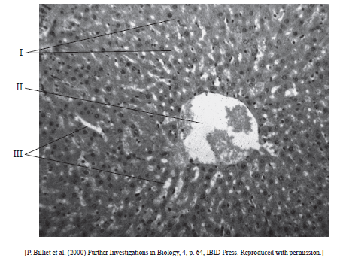
I.
II.
III.

Markscheme
I. hepatic cells / hepatocytes / liver cells / liver tissue;
II. hepatic vein / blood cells;
III. sinusoids;
27b. [2 marks]
Outline two roles of the liver.

Markscheme
a. storage of nutrients;
b. detoxification of poisons;
c. breakdown of hemoglobin;
d. production of bile pigments;
e. synthesis of plasma proteins;
f. synthesis of cholesterol;
27c. [1 mark]
List two materials that are not absorbed but are egested by the body.

Markscheme
Award [1] for two of the following.
cellulose / lignin / bile pigments / bacteria / intestinal cells
Do not accept fibre.
27d. [1 mark]
State an example of a protein hormone.

Markscheme
insulin / glucagon / prolactin / somatotrophin
Award other suitable examples.
28a. [2 marks]
Describe the effect of increased BMI on the risk of developing type II diabetes.

Markscheme
higher BMI increases risk of type II diabetes / risk increases as the BMI increases;greater risk for women than for men / men have a lower risk than women;values above 25 kg m increase the risk of diabetes exponentially / BMI below 25 kg m shows minimal risk;
28b. [1 mark]
Identify the risk of developing type II diabetes in men with a BMI of 33 kg m.

Markscheme
21 % (allow answers in the range of 20 % to 22 %)
28c. [1 mark]
Determine, by indicating on the graph, the range of age-adjusted relative risk for women who are overweight but not obese.

Markscheme
indicated by marks on the graph on the vertical axis or on the line of the woman 8 % to 33 % (allow 1 % error at either end) Information must be indicated on the graph.
28d. [4 marks]
Explain the dietary advice that should be given to a patient who has developed type II diabetes.

Markscheme
moderate portions of food to avoid fluctuations in blood sugar levels;regular mealtimes to avoid fluctuations in blood sugar levels;include unrefined carbohydrates because they are more slowly absorbed; (accept reverse for refined)include carbohydrates with a low glycemic index; (accept reverse for high)include fibre-rich foods to slow absorption of sugar;limit saturated/trans fats/cholesterol because diabetes increases risk of coronary heart disease;
29a. [1 mark]
Define hormones.

Markscheme
chemical messengers secreted by endocrine glands/specialized cells directly into the blood/body fluid (and transported to specific target cells);
29b. [1 mark]
State one type of hormone, giving an example.

Markscheme
steroid hormone e.g. testosterone / peptide hormone e.g. insulin / tyrosine derivatives e.g. thyroxine;
29c. [3 marks]
Compare gastric juice and pancreatic juice.
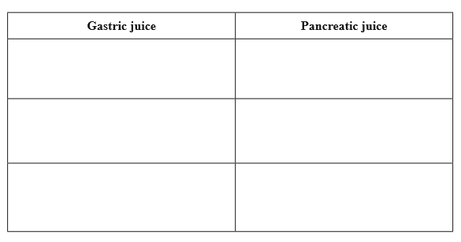

Markscheme
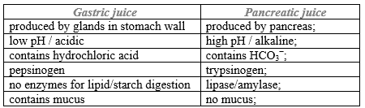
Award [1] for each pair.
29d. [2 marks]
Outline the reason for one named substance found in food not being digested and absorbed by humans.

Markscheme
cellulose / lignin;cellulase not present / no enzymes for digesting lignin; Accept any other reasonable substance.
30a. [1 mark]
State one consequence of protein deficiency malnutrition.

Markscheme
lack of blood plasma proteins;
subsequent tissue fluid retention;
swelling of abdomen;
retarded physical and mental development of children;
muscle wastage;
30b. [3 marks]
Outline the reasons for increasing rates of clinical obesity in some countries.

Markscheme
sedentary lifestyle/occupations / lack of exercise;
diets high in processed contents / low in complex carbohydrates;
diets high in fat; availability of inexpensive food / large portion sizes;
31a. [1 mark]
State which diets increase the levels of cholesterol more than a diet rich in saturated fatty acids.

Markscheme
monounsaturated fatty acids and carbohydrates (both required)
31b. [1 mark]
State the arterial lactate concentration measured at 0 m (sea level) with normoxia when exercise intensity is high.

Markscheme
3 mmol l (allow answers in the range of 2.8 mmol l to 3.2 mmol l )
31c. [1 mark]
Calculate the percentage increase in VLDL when changing from a diet rich in saturated fatty acids to a diet rich in carbohydrates.

Markscheme
80 (%) (units not required)Allow answers in the range of 80.00 to 80.20 %.
31d. [2 marks]
Compare a diet rich in saturated fatty acids and a diet rich in monounsaturated fatty acids.

Markscheme
monounsaturated fatty acids has more VLDL/cholesterol/ LDL/triglycerides; Allow numerical expressions.monounsaturated fatty acids has (slightly) less HDL; Allow numerical expressions.cholesterol increases the most in monounsaturated fatty acids (in mg dl);VLDL has highest percentage increase in monounsaturated fatty acids;
31e. [3 marks]
Evaluate the hypothesis that changing from a diet rich in saturated fatty acids to a diet rich in polyunsaturated fatty acids is healthy.

Markscheme
less cholesterol/VLDL/LDL means lower chance of coronary heart disease/CHD;accumulation of fats in arteries leads to atherosclerosis/clots/coronary heart disease/CHD;hypothesis seems to be supported as triglycerides/cholesterol/VLDL/LDL decrease;hypothesis seems to be supported as the ratio of the LDL:HDL is lower;hypothesis seems not to be supported as HDL remains about the same;
32a. [2 marks]
Distinguish between the mode of action of steroid hormones and protein hormones.

Markscheme
steroid hormones enter cell while protein hormones bind to specific membrane receptors / steroid hormones can pass through cell membranes while protein hormones cannot;steroid hormones interact directly with genes/receptor proteins in the cytoplasm while protein hormones achieve their effects by causing the release of secondary messenger into the cell;
32b. [2 marks]
Label the four parts of the ear indicated on the drawing below.
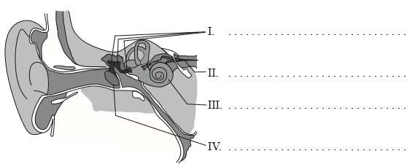

Markscheme
Award [1] for any two of the following correct names.I. bones of middle ear / ossicles / malleus, incus and stapes;II. auditory nerve/ cochlear nerve;III. cochlea;IV. eardrum / tympanic membrane / tympanum;
32c. [1 mark]
State the major role of Helicobacter pylori in the development of stomach ulcers.

Markscheme
causes increased acid secretion / produces toxins / forms pores in epithelial cell membrane / produces urease which produces ammonia (which is toxic) / resides in gastric mucous protected from immune system reactions but cause inflammation and increase acid production / destroys mucus lining exposure to acid/causing inflammation
32d. [3 marks]
Explain, using a named example, the cause and consequence of biomagnification.

Markscheme
named example;definition of biomagnification;cause;consequence;
e.g.name: DDT / pesticide to control mosquitoes of malaria;definition of biomagnification: chemicals accumulate along the food chain;cause: as fat soluble, it accumulates in fatty tissue;consequence: becoming more concentrated at each trophic level / increasingly more toxic / ultimately leading to death of organism up in food chain;
32e. [2 marks]
Discuss how the process of learning can increase chances of survival.

Markscheme
animals learn to avoid dangerous situations/predators;animals learn how to hunt/obtain food;animals learn to adapt to changing environments;e.g. birds learn to avoid the bad-tasting black and orange caterpillars of the cinnabar moth (by classical conditioning) and thus avoid possible poisoning; Accept any other valid examples.
33a. [4 marks]
Outline the use of two named ex situ conservation measures.

Markscheme
name;use;
example 1:name: zoos;captive breeding of animals / permits assisted reproductive methods / use of modern technology;example 2:name: botanic gardens;allows for protected growth of plants / protected from extreme climatic conditions / provision of all necessary conditions;Award [1] for name and [1] for its use.Accept other suitable examples.
33b. [4 marks]
Outline two factors that affect the incidence of coronary heart disease.

Markscheme
Award [1] for a factor and [1] for its effect.
Accept any two of the following factors with its associated effect:e.g.: genetic predisposition / age / being male / obesity / eating too much saturated fat and cholesterol / lack of exercise / smoking / diabetes (melitus) / hypertension / stress.Accept converse statements of factors decreasing risk.
e.g. factor: genetic predisposition; effect: some synthesise more cholesterol/LDL than others;e.g. factor: being male; effect: women before menopause appear to be protected by higher blood estrogen levels which men do not have;e.g. factor: obesity; effect: excess weight raises blood pressure/blood cholesterol/triglyceride levels / lowers HDL/good cholesterol levels;
33c. [5 marks]
Discuss how brain lesions and fMRI (functional magnetic resonance imaging) scanning can be used in the identification of the brain part involved in specific functions of animals.

Markscheme
lesions (from accidents/birth) indicate effect of loss of area;e.g. split brain patients/severed corpus callosum led to understanding different functional roles of left and right hemispheres / other valid examples;many actions of the body involve different areas of the brain;damage may be to several/many parts so results unclear;difficult to interpret due to complexity of reactions;fMRI gives a more specific knowledge of stimulated area/activation;e.g. used to study/diagnose ADHD/dyslexia/recovery from strokes/music comprehension / other valid examples;non-invasive / no damage to brain;can study healthy subjects;involves blood flow/supply/oxygenation;not neuronal connections (so requires interpretation);good spatial but poor temporal resolution;problem of statistical interpretations of model; Award [4 max] if either brain lesions or fMRI alone are discussed.
33d. [5 marks]
Explain the liver damage caused by excessive alcohol consumption.

Markscheme
can cause inflammation/fatty liver/cirrhosis of the liver from alcohol abuse;usually from prolonged/excessive drinking / OWTTE;products of alcohol metabolism toxic to cells / alcohol consumption reduces antioxidant activity;replacement of healthy liver cells with fibrous/scar tissue;blocks blood flow through liver / loss of functional liver cells / blocks normal metabolic carbohydrates/fats/proteins;decreased ability to remove toxins (through bile)/bacteria / production of bile and blood proteins;nutritional deprivation / susceptible to infection/hepatic viruses;
34. [6 marks]
Explain the role of the liver in regulating and storing nutrients.

Markscheme
a. all nutrients arrive at the liver (from small intestine) via hepatic portal vein;
b. liver stores (excess) glucose as glycogen and releases it as needed / OWTTE;
c. process is (respectively) under the control of insulin/glucagon;
d. (glucose levels) controlled by negative feedback;
e. amino acids are deaminated in the liver;
f. liver produces plasma proteins/albumin/fibrinogen;
g. synthesizes/stores cholesterol;
h. liver stores iron from the breakdown of hemoglobin in red blood cells;
i. liver stores vitamin A/vitamin D;
35. [6 marks]
Explain the events of the cardiac cycle, including the heart sounds.

Markscheme
a. during diastole the heart muscles/atria/ventricles are relaxed;b. blood enters the atria;c. during atrial systole the atria contract and blood moves into the ventricles;d. pressure (in ventricles) causes bicuspid/tricuspid/AV valves to close;e. (this) closing of valves causes first heart sound;f. during ventricular systole the ventricles contract causing blood to flow to aorta/pulmonary artery/arteries/out of heart;g. semilunar valves close so blood does not return to the ventricles;h. this causes the second heart sound;i. blood leaving atria/ventricles during contraction is caused by increased pressure which reduces volume;
36. [6 marks]
Explain the mechanisms used by the ileum to absorb and transport food.

Markscheme
absorption occurs through epithelial cells on villi/tiny projections;microvilli/brush border on cell membrane increase surface area;tight junctions prevent leakage of nutrients;lipids/fat soluble/non-polar substances diffuse across membranes;converted into tryglicerides / coated with proteins to form chylomicrons/lipoproteins;which enter into lacteals/lymphatic system by exocytosis;fructose/hydrophilic food enters by facilitated diffusion/through channel proteins;active transport requires ATP (from many mitochondria in cells) / against concentration gradient through pump proteins;e.g. glucose/amino acids/minerals enter through co-transported sodium carriers;endocytosis of large molecules (e.g. vitamin B12) / pinocytosis of liquids;capillaries (close to epithelial cells) transport substances (to body via bloodstream);
37. [6 marks]
Explain the role of the SA (sinoatrial) node in the cardiac cycle.

Markscheme
SA node is located in the wall of right atrium of heart muscle;has characteristics of both nerve and muscle tissue;SA node initiates each impulse;acts as pacemaker of the heart;no nerve impulses needed for contraction / myogenic;connected to nerves which slow/accelerate heart rate;impulses spread out in all directions through walls of atria;stimulates atrial systole/contraction;fibres in walls of atria prevent impulses from reaching ventricles;impulses reach AV node (after atrial contraction);
38a. [6 marks]
Discuss international measures that would promote the conservation of fish.

Markscheme
a- require international agreement/cooperation;b- difficulties of enforcing agreements / to determine maximum sustainable yield / to obtain and interpret data / monitor populations/stocks;c- economic consequences for livelihood of fishermen/associated trades;d- total ban on fishing in threatened areas/endangered species/exclusion zones;e- limiting size of fish caught / limits on size of net mesh / ban on drift nets / indiscriminate in species of fish caught;f- limiting size to total allowable catch/quotas;g- limiting fishing to non-productive periods of fish / closed seasons banning fishing during breeding season;h- reducing fishing days at sea / fixing number and type of vessels authorized to fish;i- regulation on pollution of bodies of water;j- use of fish farms;
38b. [6 marks]
Explain with the use of a diagram, the role of the Bohr shift in the supply of oxygen to respiring heart muscle.

Markscheme
diagram with correct labels:a- partial pressure O/percentage O saturation on x-axis and percentage saturation hemoglobin with Oon y-axis;b- exponential shape curve at lower partial pressure/concentration of CO;c- curve shifted to right (and lower) for higher partial pressure/concentration of CO;
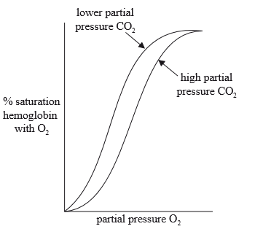
d- hemoglobin carries (up to) four oxygen molecules; e- Bohr shift promotes the release of oxygen in respiring heart muscle; f- active respiration releases CO; g- partial pressure of CO increases; h- increases acidity/lower pH/increase lactic acid; i- hydrogen ions bind to hemoglobin / which decreases hemoglobin’s affinity for O; j- so O is released (from the oxyhemoglobin); k- allosteric effect / conformational change in hemoglobin which releases O more readily;
Award [4 max] if no diagram provided.

Printed for Highland High School
© International Baccalaureate Organization 2017
International Baccalaureate® - Baccalauréat International® - Bachillerato Internacional®

