Option C - Ecology
1. [6 marks]
Discuss, using three examples, how alien species have impacted ecosystems.

Markscheme
a. the alien species can compete with existing species for resources / interspecific competition with native species;
b. appropriate example for competition with existing species;
c. alien species can be a predator of native species;
d. different appropriate example for predator of native species;
e. alien species can cause extinction of local species;
f. different appropriate example for causing extinction;
g. alien species can be deliberately added for biological control;
h. different appropriate example for biological control;
i. deliberate introduction of alien species for economic/other reasons;
j. different appropriate example for economic/other reasons;
Each impact must have a different example.
2. [6 marks]
Describe a named method for determining the size of fish populations and the challenges in conserving world fish stocks.

Markscheme
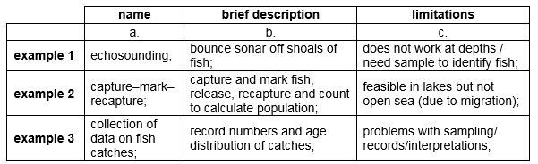
challenges:d. maintain fish as an important food source for humans/other animals;e. a sustainable yield means not overfishing an area/not causing a decline in the population/ not catching faster than the fish can replace themselves / OWTTE;f. pollution threatens world fish stocks/habitat;g. disagreements as to what is a sustainable population;h. disagreements in the collection of data of population sizes;i. requires international cooperation to define conservation measures/regulations/quotas;j. difficult to reinforce/control regulations / monitor practices / OWTTE; Award [4 max] if only challenges addressed.
Named method could be any of the three examples given above but the description and limitation must be based on one named method only.
3a. [6 marks]
Discuss how international efforts can contribute to the conservation of fish stocks.

Markscheme
a. oceans are huge ecosystems with no borders / many important fishing grounds are in international waters;b. fishing vessels often have a large geographical range / operate outside of national jurisdiction;c. marine organisms migrate so need protection across their full range / breeding sites may be distant from feeding grounds so both need to be protected;d. agree on maximum sustainable yields/quotas;e. apply the precautionary principle in determining the level of exploitation;f. agree on allowed fishing sites and exclusion zones;g. agree on fishing seasons and moratoriums;h. identify and agree on species that may be fished and those that may not;i. determine and agree on which fishing methods are allowed and which are not/net and mesh size limitations;
3b. [3 marks]
Outline the biogeographical features of nature reserves that promote the conservation of diversity.

Markscheme
a. nature reserve is a well defined/limited region with a protective framework/legislative protection;b. large reserves promote biodiversity more effectively than small reserves;c. size must be enough to have a well defined community of organisms;d. edge effect is seen at or near the boundary between ecosystems;e. leads to differences in population densities/biodiversity/levels of predation in central areas compared to edges;f. habitat corridors allow organisms to move between parts of a fragmented ecosystem;g. example of habitat corridors such as hedges/canals/drainage channels/tunnels/underpasses/overpasses;
4. [6 marks]
Explain the causes and consequences of biomagnification with reference to a named example.

Markscheme
a. named example of chemical;b. chemical absorbed by organism low in the food chain;c. chemical not excreted/accumulates in body fat;d. organism eaten by other organisms in higher trophic levels;e. causing it to be much more concentrated at each trophic level;f. substance accumulates in species at the highest trophic level;g. may reach toxic levels;h. named example of species at top of food chain;i. harmful effect caused by the chemical; Award [5 max] if specific name of chemical is not given or chemical does not bioaccumulate.
eg:a. mercury;b. absorbed by small fish;c. (mercury) not excreted (by small fish) / accumulates in (small fish) tissues;d. eaten by tuna;e. (mercury) becomes more concentrated at each trophic level;f. (mercury) accumulates in species at the highest trophic level;g. may reach toxic levels;h. humans may eat the tuna;i. leads to brain damage / birth defects / mercury poisoning;
5. [6 marks]
Discuss the advantages of in situ conservation of endangered species, using examples.

Markscheme
in situ conservation is carried out in nature reserves/natural habitats;named example of a species that is being conserved in situ;in situ conservation reduces possibility that habitat disappears and the whole community is lost / may prevent the total number of species that become endangered from increasing;allows species to live in an environment for which they are adapted / they are able to fit into their normal food chains;threatened species in a reserve may be monitored for further deterioration in numbers / remedial steps can be taken;offspring acquire skills from parents/peers around them / offspring acquire natural behaviour;reserves and protected areas in various parts of the world can share experience on how to manage them successfully;nature reserves are popular sites for the public to visit maintaining awareness/education/scientific study;reserves are places to return endangered individuals from breeding programmes as they provide realistic conditions for re-adaptation / OWTTE;
6. [6 marks]
Explain, with examples, the use of specific indicator species and biotic indices to detect changes in the environment.

Markscheme
indicator species:indicator species are sensitive to/need specific environmental conditions/have specific/limited range of tolerance;their population growth/disappearance/reduction indicates specific changes in the environment;example of indicator species and what it indicates; (e.g. decrease in the population of stonefly larvae indicates increasing pollution levels/dissolved oxygen loss)Allow any other example.
biotic index:compares the relative frequency of indicator species;can be calculated for overall environmental assessment of an ecosystem;multiply number of individuals of each indicator species by its pollution tolerance rating;an abundance of intolerant species gives a high score / vice versa;indicating an unpolluted environment / vice versa;a change in the biotic index over time indicates a change in environmental conditions; Award [4 max] if only indicator species or biotic indices are addressed.
7. [6 marks]
Discuss international measures that would promote the conservation of fish stocks.

Markscheme
large areas of ocean under no government control therefore need for international agreement/legislation;fish stocks are a renewable resource if managed properly/should not be overexploited;total allowable catches/quotas to limit maximum catch;regulation of mesh sizes/selective fishing gear/limit size of fish caught/ban drift nets;limit fishing effort by reducing the number of fishing days at sea of fishing vessels;fix the number and type of fishing vessels authorized to fish;cooperation may be difficult as most laws made at national level;closed areas/total ban on fishing in threatened areas;closed seasons banning fishing during breeding season;use of fish farms;
8. [6 marks]
Evaluate the use of indicator species in monitoring environmental changes.

Markscheme
indicator species sensitive to/need specific environmental conditions to survive;monitor population size of indicator species over time;biotic index can be calculated;low overall score when abundance of tolerant species / lack of indicator species / vice versa;represent summation of factors/overall assessment of environmental conditions;time consuming / species not easy to identify (need keys) / species may not be present for other reasons such as season / another disadvantage;methodology is simple / minimum equipment needed;needs a reference study/guide to compare;example of variable e.g. oxygen level / temperature / heavy metals / sulphur dioxide in air / other;example of appropriate indicator species e.g. Tubifex to heavy metals / Chironomis to low oxygen levels / lichens to sulphur dioxide / other;
9a. [6 marks]
Discuss international measures that would promote the conservation of fish.

Markscheme
a- require international agreement/cooperation;b- difficulties of enforcing agreements / to determine maximum sustainable yield / to obtain and interpret data / monitor populations/stocks;c- economic consequences for livelihood of fishermen/associated trades;d- total ban on fishing in threatened areas/endangered species/exclusion zones;e- limiting size of fish caught / limits on size of net mesh / ban on drift nets / indiscriminate in species of fish caught;f- limiting size to total allowable catch/quotas;g- limiting fishing to non-productive periods of fish / closed seasons banning fishing during breeding season;h- reducing fishing days at sea / fixing number and type of vessels authorized to fish;i- regulation on pollution of bodies of water;j- use of fish farms;
9b. [6 marks]
Explain with the use of a diagram, the role of the Bohr shift in the supply of oxygen to respiring heart muscle.

Markscheme
diagram with correct labels:a- partial pressure O/percentage O saturation on x-axis and percentage saturation hemoglobin with Oon y-axis;b- exponential shape curve at lower partial pressure/concentration of CO;c- curve shifted to right (and lower) for higher partial pressure/concentration of CO;
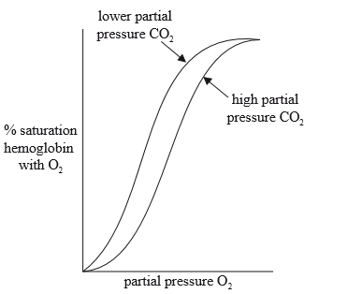
d- hemoglobin carries (up to) four oxygen molecules; e- Bohr shift promotes the release of oxygen in respiring heart muscle; f- active respiration releases CO; g- partial pressure of CO increases; h- increases acidity/lower pH/increase lactic acid; i- hydrogen ions bind to hemoglobin / which decreases hemoglobin’s affinity for O; j- so O is released (from the oxyhemoglobin); k- allosteric effect / conformational change in hemoglobin which releases O more readily;
Award [4 max] if no diagram provided.
10a. [1 mark]
Identify the phases labelled X and Y.
X:
Y:

Markscheme
X: plateau phase
Y: exponential growth / log phase
(both needed)
10b. [2 marks]
Outline how fossil records can provide evidence for evolution.

Markscheme
a. the sequence in which fossils appear matches the expected sequence of evolution;
b. comparisons with fossils and living organisms (morphology) shows change in characteristics from an ancestral form / OWTTE;
Vestigial organs and homologous structures are acceptable answers.
c. fossils of extinct species show that (evolutionary) change has occurred;
d. fossils can be dated with radioisotopes / geological depth/strata indicates (relative) age/date of organism;
e. can yield DNA for molecular clock analysis;
f. example of any of the above can earn one mark (eg: reptiles follow amphibians);
10c. [1 mark]
Distinguish between the terms genotype and phenotype.

Markscheme
genotype is the genetic make-up/set of alleles (of an organism) while phenotype is the characteristics (expressed/shown in an organism)
10d. [1 mark]
Outline a structural difference between the chromosomes of Helicobacter pylori and Homo sapiens.

Markscheme
chromosome from bacteria has no protein associated/naked DNA / bacteria is circular, H. sapiens is linear / (chromosomes of) H. sapiens are much bigger/have many more base pairs than bacteria
N.B.: Answer must refer to "chromosomes" not genomes of the two organisms.
10e. [1 mark]
Deduce the percentage of adenine in Oryza sativa if the proportion of guanine in that organism is 30 %.

Markscheme
20 %
10f. [1 mark]
Deduce the possible phenotypes of individual X.

Markscheme
A, B, AB and O
All four phenotypes must be shown to award the mark.
10g. [1 mark]
Describe ABO blood groups as an example of codominance.

Markscheme
allele Iand the allele Iare (co)dominant as they are both expressed in the heterozygote/AB type blood / OWTTE
11. [2 marks]
Outline the process of nitrogen fixation by a named free-living bacterium.

Markscheme
a. atmospheric nitrogen is converted to ammonia;
b. by Azotobacter;
Do not accept Rhizobium.
12a. [1 mark]
State which taxonomic group shows the greatest median shift.

Markscheme
spider
12b. [1 mark]
Calculate the percentage of ground beetles that are below the zero shift.

Markscheme
16.75(%)
Accept answer in the range of 16.5 (%) to 17(%).
12c. [2 marks]
Compare the changes in the range of ground beetles with the changes in the range of spiders.

Markscheme
a. both taxonomic groups showed movement to the north;
b. slightly more spiders moved north;
c. spiders shows the furthest northern shift;
d. range of ground beetles extends further south (than spiders);
e. the spiders' biggest movement is 75 to 100 km to the north and the ground beetles' biggest movement is 50 to 75 km to the north;
f. overall spiders have a broader range;
12d. [2 marks]
Spiders and ground beetles are both predators. Discuss possible effects on other species resulting from the latitudinal shift of the predators.

Markscheme
a. competition for resources/food/space/other resource;
b. change in predation/number of other species;
c. change/decrease/increase in biodiversity;
d. food webs may change;
13a. [1 mark]
State the process where pesticides such as DDT become more concentrated at each trophic level.

Markscheme
biomagnification/bioaccumulation
13b. [3 marks]
Explain what is meant by the niche concept.

Markscheme
a. every organism in an ecosystem has their own role;
b. (includes) spatial habitat/space inhabited by organism;
c. (includes) feeding activities of organism;
d. (includes) interactions with other species;
e. valid description of an organism’s niche including habitat, feeding activities and interaction with other species;
14a. [1 mark]
State one example of a bacterium that forms aggregates.

Markscheme
Pseudomonas aeruginosa / Vibrio fischeri
Accept other correct answers.
14b. [2 marks]
Outline the process of nitrogen fixation by a named free-living bacterium.

Markscheme
a. (atmospheric) nitrogen is converted to ammonia;
b. by Azotobacter;
Do not accept Rhizobium.
14c. [3 marks]
The image shows part of a sewage treatment plant.
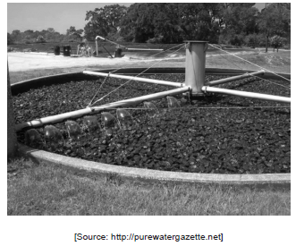
Outline the role of bacteria in trickling filter bed treatment of sewage.

Markscheme
a. (saprotrophic) bacteria/biofilm fix on the surface of the rocks/material in the trickling filter;
b. bacteria decompose the sewage/organic matter as it runs over the filter bed;
c. bacteria break down organic matter aerobically;
d. the rocks increase the surface area for the decomposition of organic matter;
e. filter bed can treat high amounts of sewage quickly;
15a. [1 mark]
State the relative use of the habitat by the Great Tit in the upper crown of the tree close to the trunk.

Markscheme
medium to low
15b. [1 mark]
Identify the section of habitat used least by the birds.

Markscheme
lower crown, far from trunk
15c. [2 marks]
Compare how the Varied Tit and the Marsh Tit use the habitat in the upper crown of the tree.

Markscheme
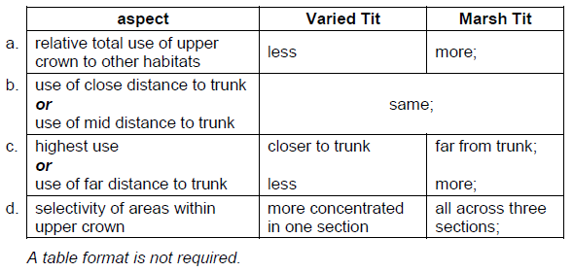
15d. [1 mark]
State how the distribution of birds changes with their size in the middle crown of the tree.

Markscheme
smaller birds make more use of the habitat further from the trunk / larger birds make more use of the habitat closer to the trunk
15e. [1 mark]
Suggest one reason why few Varied Tits were found far from trunk.

Markscheme
their food is close to the trunk / fewer predators close to trunk / too big for small outside branches
Accept any valid suggestion.
15f. [2 marks]
Discuss whether the results for the Varied Tit and Coal Tit indicate competitive exclusion.

Markscheme
a. the competitive exclusion principle states that no two species can coexist if they occupy the same niche/compete for the same resources;
b. competitive exclusion is supported as there is little overlap between the two species in the habitat;
c. competitive exclusion is not supported as there is some overlap between the species;
d. we do not have enough information about the resources required by each species to say if competitive exclusion is occurring;
16a. [1 mark]
Outline how habitat corridors can aid conservation of biodiversity in a nature reserve.

Markscheme
a. they allow species to travel between habitats / OWTTE;
b. outline of an example of a habitat corridor;
16b. [3 marks]
Explain how living organisms can change the abiotic environment during primary succession.

Markscheme
a. lichens secrete chemicals/acid which break down inorganic material/rock;
b. lichens/plants/litter change pH of the soil (which prevents/assists some species to establish);
c. organisms increase the mineral/organic/humus content of the soil when they decompose;
d. (organic matter and humus) can increase water retention;
e. plant roots can bind soil preventing erosion / break down soil particles;
17a. [1 mark]
Identify the most abundant animal type at
the S. muticum site: the control site:

Markscheme
S.muticum site: Corophiidae sp.
control site: S. squamataBoth needed for [1].
17b. [3 marks]
Describe the impact of invasive S. muticum on the shoreline animal community.

Markscheme
a. fewer different types of organism / smaller diversity at S. muticum site;b. mean abundance at S. muticum site is higher for those organisms present;c. Rissoidea sp. and P. maculata found at control site but not at S. muticum site;d. C. pagurus only found at S. muticum site;Comparisons are required but the control site does not need to be mentioned in each response.
17c. [3 marks]
Discuss possible reasons for the differences in the animal communities seen at the two sites.

Markscheme
a. S. muticum provide habitat/shelter/protection from predators for some species;b. S. muticum change the environment to suit some species/example of a change;c. some organisms more successful because less (inter-specific) competition;d. more food may be available (for herbivores);e. some herbivores may rely on native algae that have been displaced;f. (other) conditions at the control site may not be identical to the test site;
18a. [3 marks]
Explain the causes and consequences of biomagnification of a named chemical.

Markscheme
a. named example of chemical (for example: mercury, DDT, PCBs, TBT, PAHs,heavy metals, selenium);b. long lived / do not biodegrade / stored in body tissues / fat soluble;c. present in small concentration in the environment;d. chemical becomes more concentrated in the bodies of organisms at each successive trophic level;e. reach toxic levels in top consumer/organisms near the end of the food chain / example of top consumer affected;Award [2 max] if no named example of chemical.
18b. [2 marks]
Explain the concept of niche.

Markscheme
a. includes all aspects of way of life of a species/role of the species in the ecosystem;b. includes relationships within the community;c. feeding relationships;d. interaction with environment/spatial habitat;
19a. [3 marks]
State the role of Rhizobium, Nitrobacter and Azotobacter in the nitrogen cycle.
Rhizobium: ..................................................................... Nitrobacter: ..................................................................... Azotobacter: .....................................................................

Markscheme
a. Rhizobium: nitrogen fixation;b. Nitrobacter: oxidizes/changes nitrites to nitrates;c. Azotobacter: nitrification / bind atmospheric nitrogen / nitrogen fixation;
19b. [4 marks]
Explain the production of methane from biomass.

Markscheme
a. anaerobic digestion of biodegradable material;b. fermentation (of carbohydrates) by bacteria;c. methanogens produce methane;d. methane/biogas used as energy;e. waste products used as fertilizer;f. CO produced (as a by-product);
20a. [1 mark]
State the force required to detach a limpet with an area of foot of 2 cm .

Markscheme
42 (N) (allow answers in the range of 41 (N) to 43 (N))
20b. [1 mark]
State the smallest area of foot necessary to resist a force of 50 N.
...................cm

Markscheme
2.6 (cm) (allow answers in the range of 2.5 (cm) to 2.7 (cm))
20c. [1 mark]
Outline the relationship between area of foot and the force required to detach the limpet.

Markscheme
Positive correlation / as area of foot increases so does force required.
20d. [3 marks]
Smaller limpets can only be found at the back of crevices. Discuss the reasons for this.

Markscheme
a. back of crevice less subjected to action of waves;b. (hypothesis supported as) small area of foot requires less force;c. amount of predators/food could be affecting the distribution;d. larger limpets may not fit in the back of the crevice;e. less competition with larger limpets at the back of the crevice;
20e. [1 mark]
Limpets tend to live towards the high tide zone. State the method used to determine the distribution of limpets between the low and high tide lines.

Markscheme
transect line / quadrat with transect lineDo not accept quadrat alone.
21. [2 marks]
Outline one example of biological control of a named invasive species.

Markscheme
a. named example of invasive species;b. named example of biological control;
possible examples:
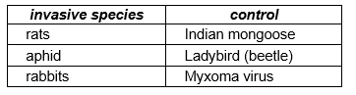
22a. [1 mark]
State the depth range showing the most Bythotrephes during the night.

Markscheme
0–10 meters
22b. [2 marks]
Describe the distribution of Bythotrephes during the day.

Markscheme
a. Bythotrephes found at all depths down to 20–30 m/none below 30 m;b. greatest number/density (of organisms) at 10–20 m;c. least number/density (of organisms) at 0–10 m;
22c. [2 marks]
Deduce the responses of Bythotrephes to temperature and light.

Markscheme
a. avoids/driven away by light (to colder water);b. in absence of light attracted to warmer water;c. can tolerate a wide range of temperature (accept numbers in range of 4/5–20/25°C);
22d. [2 marks]
Explain the change in distribution of Bythotrephes between day and night in terms of its position in the lake food chain.

Markscheme
a. zooplankton found in (warmer) surface water where small plants / algae/phytoplankton are found due to light;b. as predator, Bythotrephes moves up to the surface to feed on zooplankton at night;c. as prey, Bythotrephes moves to lower/darker depths during the day to avoid being (easily) seen by predators/fish;
23a. [2 marks]
Distinguish between the use of a quadrat and a transect in gathering field data.

Markscheme
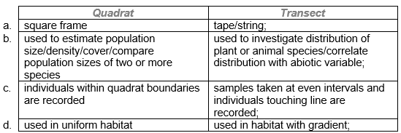
Accept any horizontal set of ideas, up to two sets.
23b. [1 mark]
State the change in species diversity and the change in production during primary succession.
Species diversity: ...............................................Production: ........................................................

Markscheme
Species diversity: risesProduction: risesBoth needed for [1].
23c. [1 mark]
State one difficulty in classifying organisms into trophic levels.

Markscheme
an organism can occupy/feed at more than one trophic level
24a. [1 mark]
Identify the site with the lowest average CFU of E. coli in the water samples.

Markscheme
(site) 1
24b. [2 marks]
Distinguish between the trends in the survival of E. coli on mat samples and in water samples over time.

Markscheme
a. (CFU of) E. coli on mats remains higher/almost 10 more than in the water samples;b. over time in mats the values do not change much while in water they decrease/disappear;
24c. [2 marks]
Scientists formerly related the population of Cladophora to changes in phosphorous levels in the lake. However, phosphorous quantities have decreased but Cladophora has recently increased along the shore. Suggest two reasons, other than phosphorous, for the change in population growth of Cladophora in the lake.

Markscheme
a. excess nitrogen from fertilizers as run-off from agricultural lands;b. excess organic matter from sewage overflow;c. change in temperature/global warming;d. change in pH; Do not accept a general statement of minerals or fertilizers in the water.
24d. [2 marks]
Discuss the possible ecological relationships between E. coli and Cladophora.

Markscheme
a. Cladophora provide a habitat for E. coli so more E. coli/CFUs (in mats);b. Cladophora provide more food for E. coli so more E. coli/CFUs (in mats);c. Cladophora in mats are dead and decomposed by E. coli /Cladophora in water are alive so not decomposed by E. coli;
25a. [3 marks]
(i) Label the diagram to complete the food web for the organisms in the table above.
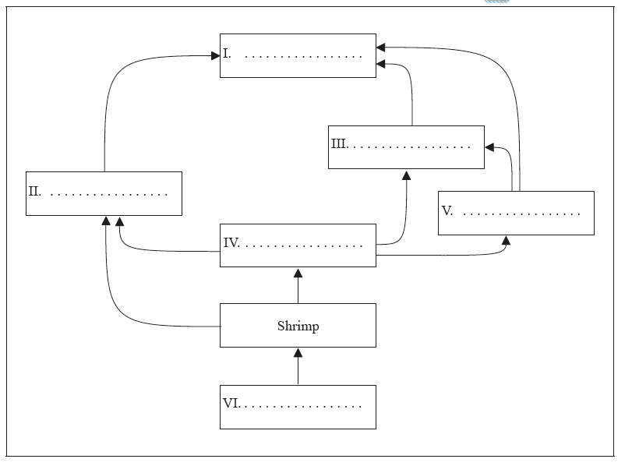
(ii) Deduce the trophic level of Artic cod.

Markscheme
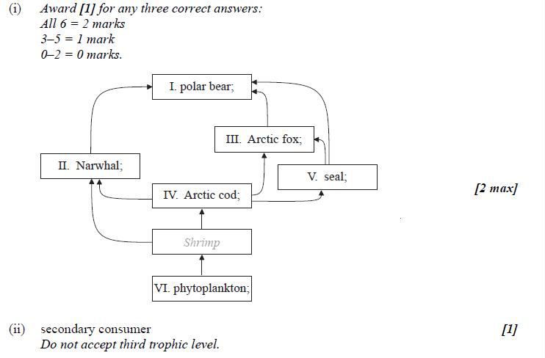
25b. [2 marks]
Distinguish between the movement of energy and nutrients in an ecosystem.

Markscheme
energy moves through/enters and leaves ecosystems / need a constant source of energy;
nutrients cycled between biotic and abiotic environment/in cycles such as C/N;
26a. [1 mark]
State the grass species that is most abundant in plant community 1.

Markscheme
4
26b. [1 mark]
Analyse the graph to find whether species 45 has a broad or narrow realized niche.

Markscheme
broad (realized niche as present in many communities)
26c. [1 mark]
Suggest a reason for this in community 1.

Markscheme
lack of water
26d. [1 mark]
Suggest a reason for this in community 17.

Markscheme
shading from trees / lack of light /competition from trees and shrubs
26e. [3 marks]
Evaluate the conclusion that there are trends in the distribution of plants along the transect of Serengeti grass communities.

Markscheme
communities have different species present;
grass species 1 to 15 more common in communities 1 to 7/dry south east boundary; (accept values within 3 of the upper and lower values given in the marking point)
grass species 32 to 45 more common in communities 13 to 17/woodlands; (accept values within 3 of the upper and lower values given in the marking point)
pattern linked to variation in rainfall/abiotic factors;
appears to have clusters of distinct plant species with little overlap;
species are found in certain areas only;
27. [6 marks]
Eight sub-species of tigers existed in 1950, but three of these former sub-species have now become extinct. Discuss the role of active management techniques to prevent the extinction of the remaining tiger species.

Markscheme
Award [1] for one argument for each of the following aspects:
identification/monitoring of tiger populations;
creation of in situ/nature reserves;
provision of corridors between nature reserves;
hunting/poaching;
development of ecotourism;
impact on local economy;
ban on tiger products trade / development of synthetic alternatives;
increase of public awareness;
need for international cooperation/funds to implement measures;
ex situ/captive breeding programs;
extraction of DNA for gene bank;
28a. [2 marks]
List two factors that could cause an increase in the size of an animal population.
1. ..................................................................2. ..................................................................

Markscheme
a. natality / increased birth rate;b. immigration;c. extra food/water / breeding sites;d. expanding habitat;e. lack of predators/disease/parasites / reduced death rate;
28b. [4 marks]
Outline how overpopulation of a species in a given environment may lead to evolution.

Markscheme
a. more are born than can survive;b. there is variety/variability in the offspring;c. competition for resources / struggle for survival / selection pressure;d. only the most able/adapted survive / survival of the fittest;e. the survivors reproduce and pass on genes;f. genes of less able/adapted are eliminated / change in the gene pool;g. natural selection occurs;
29. [4 marks]
Explain the consequences of releasing raw sewage and nitrate fertilizer into rivers.

Markscheme
a. raw sewage contains pathogens;b. can contaminate drinking water / cause disease/death;c. nitrate fertilizers cause algal blooms/(aquatic) plant development;d. algae release toxins that can contaminate drinking water;e. more organic matter results / eutrophication;f. more oxygen required to decompose organic matter / increase in BOD;g. (leading to) death of aquatic animals/organisms;h. recovery follows since algae/plants release more oxygen;
30a. [2 marks]
Discuss the difficulties of classifying organisms into trophic levels.

Markscheme
a. consumer may have more than one food source;b. organisms eaten may be at different trophic levels;c. may change their trophic level over time;d. different stages in life cycle might exist in different trophic level (eg frog);e. example of organism (presenting such a difficulty);
30b. [4 marks]
Explain the cause and consequences of biomagnification, using a named example.

Markscheme
a. a process in which chemical substances become more concentrated at each trophic level;b. valid named example (for example mercury, organophosphorous pesticides, DDT, TBT);c. these substances cannot be broken down / are broken down slowly by metabolism;d. are often stored in (adipose) tissues;e. each organism consumes large quantities of the trophic level below it;f. so substance accumulates/increases to reach toxic levels; If no example is given award [3 max].
31. [1 mark]
State one soil condition that favours denitrification.

Markscheme
a. lack of oxygen / anaerobic conditions;b. excess water / bog/marsh conditions;
32a. [1 mark]
Identify the primary food for all grasshoppers without predators.

Markscheme
grasses
32b. [1 mark]
Deduce, using the data, how the feeding behaviour of instar larvae changes if without predators, conditions change from cool to warm.

Markscheme
feeding time on grasses (slightly) reduces / feeding time on bushes increases
32c. [1 mark]
Deduce, using the data, how the feeding behaviour of instar larvae changes if in warm conditions, predators are introduced.

Markscheme
feeding time on grasses (greatly) reduces / feeding time on bushes increases
32d. [2 marks]
Compare adult feeding to instar larval feeding.

Markscheme
feeding is similar without predators;more feeding on grass by adults with predators;
32e. [1 mark]
Suggest why adult feeding differs from instar larval feeding when predators are present.

Markscheme
a. instars are more protected from predators/camouflaged when feeding in bushes;b. adults can escape predator attacks more easily/camouflaged when feeding in grasses;c. adults are bigger and less easily captured; Accept other reasonable responses.
33a. [3 marks]
Explain the niche concept.

Markscheme
a. niche is an organism’s ecological role/mode of existence;b. niche is how organism uses abiotic and biotic resources;c. depends on where organism lives/habitat;d. depends on organism’s nutrition/feeding activities;e. depends on interactions (competition/herbivory/predation/mutualism) with other organisms;
33b. [1 mark]
Outline one reason for the extinction of a named animal species

Markscheme
name of species and what caused it to become extinct (both needed)The named species must be extinct and not endangered.eg:passenger pigeon (became extinct when) hunted as a source of foodNote: dinosaur is not a named species.
34. [2 marks]
Discuss how an understanding of biomagnification could help these human populations reduce their risk of mercury poisoning while maintaining their traditional diet.

Markscheme
a. (recognize that) some fish are more contaminated than others;b. identify and eat fish that are close to the start of a food chain;c. avoid eating piscivores/omnivores/highly polluted species;d. eat only piscivores that feed close to the start of a food chain;
35a. [1 mark]
Calculate the decrease in mass of food foraged by fed sand gobies when a predator was introduced, giving the units.

Markscheme
2.6 mg (units required) (accept answers in the range of 2.5 mg to 2.7 mg) No working required.
35b. [2 marks]
Compare the effect that starvation had on both species of goby when no predator was present.

Markscheme
both foraged more after starvation;black goby increased the amount of food foraged more than the sand goby;
35c. [2 marks]
Describe the effect the predator had on the foraging of the gobies.

Markscheme
a. predator present causes both to forage for less food;b. fed black gobies showed little change in foraging (with predator present);c. starved gobies foraged more than fed gobies (with predator present);d. relative foraging remains similar between the two species / black goby always forages less than sand goby;
35d. [1 mark]
Suggest a reason for the effect of the predator.

Markscheme
a. gobies may feed on smaller mud shrimps when predator present;b. gobies may hide rather than forage when predator present / gobies may feed less efficiently if they are watching out for predators;c. predator may also eat shrimp so less for gobies;d. if predator eats gobies the total mass of food foraged is less / OWTTE;
36a. [2 marks]
Explain the principal of competitive exclusion.

Markscheme
no two species can occupy the same niche/role in an ecosystem;too much competition occurs until one is eliminated / one out-competes the other;competition is for habitat/nutrition/relationships/space/limited resources;
36b. [2 marks]
Using a named example, explain a consequence of biomagnification.

Markscheme
name of chemical and top consumer affected; (both needed)consequence;eg:DDT, affecting bird of prey;fragile egg shells which did not hatch affecting population size;
37. [3 marks]
Water is one factor that affects the distribution of plant species. Outline three other factors that can also affect plant distribution.

Markscheme
temperature affects metabolism/enzyme activity/transpiration rate/germination / each plant species has an optimum temperature range;light affects rate of photosynthesis/(time of) flowering;soil pH affects absorption of minerals/enzyme activity / each plant has an optimum pH range / some plants require acid soil / some plants require alkaline;salinity affects the osmotic potential / most plants function in narrow range of salinity / salts affect the water uptake by the plants;mineral nutrients required for synthesis of organic molecules;presence of (suitable) pollinator/dispersal organisms to aid reproduction;distribution (number and type) of predators/herbivores/diseases/pathogenic organisms which harm plants;competition from other plants (for resources);other valid factor with brief outline; Accept examples for each factor eg nitrates are necessary for protein synthesis.Award [0] for a list of factors.
38a. [1 mark]
Define the term biomagnification.

Markscheme
Process by which chemical substances become more concentrated at each trophic level.
38b. [1 mark]
Define the term biomass.

Markscheme
total dry mass of organic matter in organisms/trophic level
39a. [3 marks]
Explain the principles involved in the generation of methane from biomass.

Markscheme
organic matter/manure/waste/agricultural material/seaweed used;bacteria in digester transform biomass/raw material;anaerobic conditions / constant temperature / neutral pH in the digester;bacteria convert organic material to organic acids/alcohol;other bacteria convert organic acids/alcohols into acetate;methanogenic bacteria convert acetate to methane
39b. [1 mark]
State the role of Rhizobium in the nitrogen cycle.

Markscheme
nitrogen fixation / changes (free) nitrogen to ammonia
40a. [2 marks]
Biotic factors involve the other organisms in the environment of an animal species. List two biotic factors that could affect the distribution of an animal species.
1. ..................................................................
2. ..................................................................

Markscheme
predation;competition;disease;food supply;
40b. [2 marks]
Research into a river ecosystem produced these approximate values: 25, 300, 6000 and 36 000 kJ m yr. Using this data, construct a pyramid of energy showing four named trophic levels, each with their corresponding energy value.

Markscheme
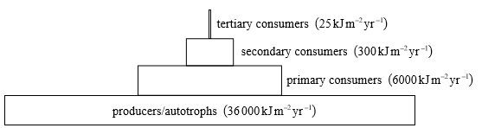
bars of decreasing size going upwards at least a third of the bar below; the trophic level on each bar labelled correctly;
41a. [3 marks]
Explain how living organisms can affect the abiotic environment during primary succession.

Markscheme
remains/debris/litter from growth/death of plants can increase soil depth;remains/debris/litter from growth/death of plants can increase soil mineral content;remains/debris/litter from growth/death of plants can alter soil pH;remains/debris/litter from growth/death of plants can improve soil water retention and reduce drainage;growth of (larger) plants can reduce erosion though binding action of roots;
41b. [1 mark]
State one example of biological control of an invasive species.
Invasive species: ......................................................
Biological control: ......................................................

Markscheme
example of invasive species and an example of its biological controle.g.:prickly pear cactus is controlled by moth (Cactoblastis cactorum)Accept other suitable example.
41c. [1 mark]
Define biomagnification.

Markscheme
a process when chemical substances become more concentrated at each trophic level
42a. [2 marks]
Outline changes in species diversity during primary succession.

Markscheme
few colonizing species establish themselves in harsh conditions/volcanic ash/ sand/areas devoided of life/bare rock;e.g. moss/lichens/marram grass/bacteria;more organic material accumulates/soil develops;increasing species diversity;
42b. [2 marks]
(i) Describe the environmental impact of a named invasive alien species.
(ii) State an example of biological control of the invasive alien species named above.

Markscheme
(i) name of invasive alien species and impact e.g.:water hyacinth is an invasive plant with explosive growth that blocks waterways/kills other aquatic organisms
(ii) example of biological control organism e.g.: weevils/moths/fungus/mites have been used to control the water hyacinth growth Do not award the mark if the example of the control does not correspond to the species named.

Printed for Highland High School
© International Baccalaureate Organization 2017
International Baccalaureate® - Baccalauréat International® - Bachillerato Internacional®

