Biology / Agricultural Science
Soil
4 Points x 2
Something is wrong with our soil. Thigs aren’t growing. What should we do? Maybe the following questions will help you.

What is the different between soil and dirt?
What is soil?
Why is soil important?
What is in soil?
How is soil made?
What are the five components of soil?
What are the three layers of soil?
What is the A horizon?
What is the B horizon?
What is the C horizon?
What things do we need to test for?
Choose three things we need to test for and explain how we are going to test them.
So, what things in the soil do tomatoes like?
What are the characteristics of soil that will make tomatoes grow the best?
What are nutrients in the soil that will help butternut squash grow the best?
Please look up a quick and easy soil test that we can do as a starting point to let us know if we have sandy soil or clay-like soil or a good balanced soil.
Go ahead and do that test. I have the tubes you need.
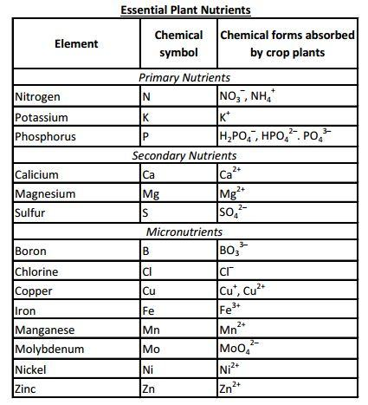
What is the function of each nutrient?
How much of each nutrient should be in the soil?
How do you test for each nutrient?

